**INDEX**

|  |  |  |
| --- | --- | --- |
| No | Particulars | Page no |
| 1 | Project Profile |  |
| 2 | Introducation |  |
| 3 | System Analysis |  |
| 4 | Identification of need   * Preliminary Investigation |  |
| 5 | Feasibility Study   * Technical Feasibility * Economical Feasibility * Operational Feasibility |  |
| 6 | Cost Estimation |  |
| 7 | Project Analysis   * Data Dictionary * Data Flow Diagram   + 0 Level Diagram   + 1 Level Diagram   + 2 Level Diagram |  |
| 8 | S/W Engineering Paradigm applied |  |
| 9 | S/W & H/W Requirement Specification |  |
| 10 | PERTT Chart |  |
| 11 | Time Line / GANIT Chart |  |
| 12 | Testing |  |
| 13 | Implemetaion |  |
| 14 | Limitation |  |
| 15 | Layouts   * Client Side * Admin Side * Staff Side * Student Side |  |
| 16 | Coding   * Login Page * Staff Page * Student Page * Profile Page * Notification Page * Fees Page * Attendance Page * Result Page * Bin Page * Master Page * Global Page * Web Config |  |
| 17 | Bibliography / References Glossary |  |

**PROJECT PROFILE**

|  |  |
| --- | --- |
| Title | Details |
| Project name | School Management System |
| Developer by | Dhaduk Parth J. |
| Class | BCA sem – 6th |
| Year | 2021 – 2022 |
| Font end | Html, css, js, bootstrap, jquery |
| Back end | Asp.net |
| Database | Microsoft SQL Server |
| Time duration | December – 2021 to February – 2022 |
| Project evaluator | Ms. Dhaval |
| Guided by | Mr. Milind Anandpara |
| Project submitted to | SSSDIIT College – junagadh |

**INTRODUCTION**

* The main purpose using computerized system is to avoid manual problems and also documentation storage problem we can’t maintain long period data that’s why we used computerized system to overcome all problem related to school’s data storing and other arias.
* This website handles online student admission procedure.
* Patel school is a web based project that maintains all the activity related to school. This project works on dynamic website handling.
* Hillfort project show time to time event information related to school.
* The proposed website controls student information and faculty details.
* This is web based project it’s provide privilege facility for security purpose and provide login facility according to designation and restrict unauthorized used, if user is not admin then it can’t access everything, this project provide four type of designation facility and access permission.
* This web site reduces the time & cost and provides the facility to retrieve student all information according to requirement.
* School event and all activity related information display on this web site, the school related latest news display on this site
* School related all information display on this project.

**OBJECTIVE**

* Patel School is web based project that is maintain all the activity related to School, it store all the information of student.
* Patel School project show time to time event information related to school.
* Patel School project provide the facility for suggestion regarding school rules and regulation and student complaint.
* To provide student detailed information and faculty details.
* To make admission procedure fast and easy.
* To inform student with time to time event information and notices.
* To generate separate student and faculty login Id and password.
* Emails are sent to new students and staff

**SYSTEM ANALYSIS**

* System analysis helps in discovering means to design systems where sub-system may have apparently conflicting.
* It helps in achieving inter compatibility and unity of purpose of sub-systems. ADVERTISEMENTS: It offers a means to create understanding of the complex structures.
* System analysis helps in placing each sub-system in its proper perspective and context, so that the system as a whole System analysis means to tradeoff between functional requirements of a sub-system.
* It is a process of collecting and interpreting facts, identifying the problems, and decomposition of a system into its components.
* System analysis is conducted for the purpose of studying a system or its parts in order to identify its objectives.
* It is a problem solving technique that improves the system and ensures that all the components of the system work efficiently to accomplish their purpose.
* This project is used by the three types of users :
* Admin
* Staff
* Student

**PRELIMINARY INVESTIGATION**

* The purpose of the preliminary investigation is to evaluate the project requests.
* It is not a design study, not does it include the collection of details to completely describe the bussiness system.
* Rather, it is the collecting of information that permits committee members to evaluate the merits the project request and make an informed judgment about the feasibility of the proposed Project.
* I collection the information in this phase through Personal interviews.
* When that request is made, the first System activity, the preliminary investigation begins.
* The following is the questionnaire and the answers of the personal interview that I taken.

Question 1: Which type of application you want to develop?

Answer : web Application

Question 2 : Do you have any this type of running web Application?

Answer : No, we have no and this type of running web Application.

**FEASIBILITY STUDY**

* A procedure that identifies, describes, and evaluates candidate systems and selects the best system for the job is called as Feasibility study.
* Three key considerations are involved in the feasibility analysis:

1. Technical Feasibility
2. Economic Feasibility
3. Operational Feasibility

* **Technical Feasibility :-**

The use of CSS and .NET makes form design easy and convenient. The project can be run on any system with minimum requirements.

It reduces data entry errors because of data entry validation, it can be easily handled by any user, and it also helps in faster data updations.

Also the project though developed in GUI, it is very easy to operate. Hence the project is technically feasible.

* Hardware :
* 1GB HDD (Hard Disk)
* 2GB RAM (Random Access Memory)
* Software :
* Microsoft Windows
* Microsoft Visual Studio 2017
* Micosoft SQL Server 2014
* Any Browser
* **Economic Feasibility :-**

Cost benefit analysis is very important in deciding whether the project is economically feasible or not. Itis alone sufficient to save our time and money.

It is one time investment and does not require regular maintenance.

Through cost benefit analysis it was concluded that the benefits outweigh costs and thus the project is economically feasible.

As the requirement there is must be the cost of the following things.

|  |  |
| --- | --- |
| TITLE | PRICES |
| Development Cost | Rs. 7000 |
| Light Bil | Rs. 2000 |
| Software | Rs. 2000 |
| Other | Rs. 1500 |
| TOTAL | **Rs. 12,500** |

* **Operational Feasibility :-**

Behavioral feasibility determines how much effort will go into educating, selling and training the user staff on a candidate system.

The project was also evaluated to be behaviorally feasible as it is very user-friendly and hardly needs any extra efforts to educate user for its utility and functioning.

**COST ESTIMATION**

* There are many methods available to get the Size of the project.
* I have use two methods to estimate the size of the project. Those methods. are Loc (line of Code) and FP (function Point) with these both methods.
* I can get approximate size of the project.
* There are two methods available in “Software engineering” to get the approximate cost of the Project.
* These methods are COCOMO (COnstructive COst MOdel) and empirical method. with these both methods I can get approximate cost of the project.
* I have gone through LOC method to get the approximate size of this software project and COCOMO method to gate the approximate cost of the Software project.
* Here I have done all the calculations to get the approximate Size and cost of this website project.

|  |  |  |  |
| --- | --- | --- | --- |
| Code for | Best | Most likely | worst |
| Design | 2000 | 2100 | 2200 |
| Database | 1000 | 1500 | 1400 |
| Coding | 5000 | 4000 | 4700 |
|  |  |  |  |
| Total | **9000** | **7600** | **8300** |

**DATA DICTIONARY**

* Data Dictionary set of information describing, the contents, format and structure of database and the relationship between its elements, used access to and manipulate to control of the database.
* **DATABASE NAME :** MainSchoolDB
* **TABLES - 1**
* **Name :-** AttendanceTB
* **Description :-** This table will store the details of the Students Attendance.

|  |  |  |  |
| --- | --- | --- | --- |
| Field Name | Datatype | Constraint | Comments |
| Aid | Int | Primary Key (Auto Increment) | Null |
| SRNO | Int | - | Null |
| ADate | Varchar(50) | - | Null |
| AAttendance | Varchar(50) | - | Null |
| remove_status | Int | - | Null |

* **TABLES - 2**
* **Name :-** FeesTB
* **Description :-** This table will store the details of the Students Fees.

|  |  |  |  |
| --- | --- | --- | --- |
| Field Name | Datatype | Constraint | Comments |
| FId | Int | Primary Key (Auto Increment) | Null |
| SRNO | Int | Primary Key | Null |
| FMoney | Int | - | Null |
| FDate | Varchar(50) | - | Null |
| remove_status | Int | - | Null |

* **TABLES - 3**
* **Name :-** NotificationTB
* **Description :-** This table will store the details of the Notification.

|  |  |  |  |
| --- | --- | --- | --- |
| Field Name | Datatype | Constraint | Comments |
| NId | Int | Primary Key (Auto Increment) | Null |
| NTitle | Varchar(50) | - | Null |
| NDate | Varchar(50) | - | Null |
| NDescription | Varchar(100) | - | Null |
| remove_status | Int | - | Null |

* **TABLES - 4**
* **Name :-** ResultTB
* **Description :-** This table will store the details of the Students Result.

|  |  |  |  |
| --- | --- | --- | --- |
| Field Name | Datatype | Constraint | Comments |
| RId | Int | Auto Increment | Null |
| SRNO | Int | Primary Key | Null |
| Total | Int | - | Null |
| Percentage | Int | - | Null |
| Grade | Varchar(50) | - | Null |
| Status | Varchar(50) | - | Null |
| remove_status | Int | - | Null |

* **TABLES - 5**
* **Name :-** StaffTB
* **Description :-** This table will store the details of the All Staff Records.

|  |  |  |  |
| --- | --- | --- | --- |
| Field Name | Datatype | Constraint | Comments |
| EId | Int | Primary Key(Auto Increment) | Null |
| EName | Varchar(50) | - | Null |
| ECourse | Varchar(50) | - | Null |
| EEmail | Varchar(50) | - | Null |
| EMobile | Bigint | - | Null |
| EPassword | Varchar(50) | - | Null |
| role | Varchar(50) | - | Null |
| remove_status | Int | - | Null |

* **TABLES - 6**
* **Name :-** StudentTB
* **Description :-** This table will store the details of the All Students Records

|  |  |  |  |
| --- | --- | --- | --- |
| Field Name | Datatype | Constraint | Comments |
| SId | Int | Auto Increment | Null |
| SRNO | Int | Primary Key | Null |
| SName | Varchar(50) | - | Null |
| SEmail | Varchar(50) | - | Null |
| SMobile | Bigint | - | Null |
| SDOB | Varchar(50) | - | Null |
| SCourse | Varchar(50) | - | Null |
| SPassword | Varchar(50) | - | Null |
| remove_status | Int | - | Null |

**DATA FLOW DIAGRAM (DFD)**

* A Data Flow Diagram (DFD) is a graphical representation of the "flow" of the data through an information system, modeling its Process aspects.
* A DED is often used as a preliminary steps to create an overview of the system without going into great detail, which be can later be elaborated.
* DED is process graphical view of all System process and transactions with the DFD an end - user also can easily understand the system in a short time Period.
* Also it is userfoed to find out problems or any Complications with the out Problems of System we are going to develop.
* We can easily get that whether we have understood the system as per the requirements of the customer or not by showing them this diagram. Thus DED is necessary phase while developing software.
* DFD use a number of symbols to represent system. most data flow modeling methods. use four kinds of symbols these symbols these symbols are used to represent four kinds of system components.
* Processes
* Data Stores
* Data Flows
* External Entities
* Explanation of main symbols which are used in data flow diagram is given below:

1. Processes

* This shape is used data flow diagram for represent Particular Database.

1. Data Stores

* This shape is used in data flow diagram for represent input/output process.

1. Data Flows

* This arrow shape is used in data flow diagram for represent a flow of data.

1. External Entities

* This shape is used in data flow diagram for represent particular process.

**0 LEVEL DIAGRAM**

STUDENTS

STAFFS

ADMIN

USERS

**1 LEVEL DIAGRAM**

**2 LEVEL DIAGRAM (ADMIN)**

Result

LogOut

Bin

Notification

Fees

Attendance

Profile

Staff

Student

Dashboard

ADMIN

LogOut

Attendance

Notification

Profile

Student

Dashboard

STAFF

**2 LEVEL DIAGRAM (STAFF)**

Result

Attendance

Fees

Notification

Profile

Dashboard

STUDENT

LogOut

**2 LEVEL DIAGRAM (STUDENT)**

**S / W ENGINEERING PARADIGM**

* System Development Life Cycle is process of development of software. These are Some Steps to follow to create a System.
* In SDLC Steps follows reguisement gathering. In requirement gathering questionnaire, personal inkoviec etc. are the method for gathering information.
* Analysis Phase includes creating software requirement specification and analyze the gathered data. In design phase, design of software application i.e. database design and GUI design have to be prepared.
* In conding Phase, coding is done of different modules and forms. In testing phase, the different type of testing is done like integration testing, unit testing, system testing and at last the created website is implemented and maintained.
* Following are the different life cycle model example :
* Waterfall model
* Iterative waterfall Model
* Prototyping Model
* Evolutionary Model
* Spiral Model
* RAD Model

**WATERFALL MODEL**

Implimentation

System Analysis

System Design

Coding

Testing

Requirement gathering

* **Requisement Gathering and Analysis :**

All possible requirements of the system to be developed are captured in this phase and documented in a requidement specific doc.

* **System Design :**

The requirement specification from first phase is shidied in this phase and system design in prepared, system design help in defining overall System architecture.

* **Implementation :**

With inputs from system design the system is small programs called nits which are intergrated in the next phase, each unit is developed and tested for its functionality which referred to as unit testing.

* **Integration and Testing :**

All the units develops in the implementation phase are integrated into a system after testing of each unit post integration the entide system is tested for and failures.

* **Deployment Of System :**

once the functional and non - functional testing is done the product is develdeployed in the customer environment or released into the market.

* **Maintenance :**

There are some issues which commune in the environment to fix those issue patches are released, also to enhance the product Some better version are released.

**S/W & H/W REQUIREMENT SPECIFICATION**

* **H / W Requirement Specification :**
* 500 MB HDD (Hard Disk)
* 4 GB RAM (Random Access Memory)
* Display (Monitor)
* CPU (Center Processing Unit)
* Mouse / Keywoard
* **S / W Requirement Specification :**
* Windows Operating System
* Microsoft Visual Studio
* Microsoft SQL Server
* Any Browser

**PERT CHART**

* The purpose of controlling a project is to monitor the progress of the activities against the plans, in order to ensure that the goals are being approached and, eventually, will be achieved. Another aspect of control is to detect, as soon as possible, when deviations from the plan are occurring, so that corrective action may be taken.

Start

Client side module design

Client side module design

Client side module design

Requirement Gathering

Coding

Implementation

END

Testing

Database Design

System Analysis

**GANTT CHART**

* A Gantt chart is a special type of bar chast where each bar represents an activity.
* The burs are drawn along a time line.
* The length of each bar is proportional to the duration of time planned for the corresponding activity.
* Gantt charts are developed by Henry L. Gantt.
* Gantt chart is project control technique that can be used for several purposes, including scheduling, budgeting, and resource planning.
* A Gantt chart is a bar chart, with each bar representing an activity.
* The bars are drawn against a timeline.
* The length of each bar is proportional to the length of time planned for the activity.

|  |  |  |  |  |
| --- | --- | --- | --- | --- |
| NO | Task Name | Start | Finish | Duration |
| 1 | Requirement Gathering | 10 / 12 / 2021 | 20 / 12 / 2021 | 10D |
| 2 | System Analysis | 21 / 12 / 2021 | 27 / 12 / 2021 | 1W |
| 3 | Client Module Design | 28 / 12 / 2021 | 31 / 12 / 2022 | 4D |
| 4 | Admin Module Design | 01 / 01 / 2022 | 07 / 01 / 2022 | 1W |
| 5 | Database Design | 08 / 01 / 2022 | 11 / 01 / 2022 | 4D |
| 6 | Coding | 12 / 01 / 2022 | 18 / 01 / 2022 | 1W |
| 7 | Testing | 19 / 01 / 2022 | 23 / 01 / 2022 | 5D |
| 8 | Implementation | 24 / 01 / 2022 | 29 / 01 / 2022 | 6D |
| 9 | Documentation | 30 / 02 / 2022 | 03 / 02 / 2022 | 5D |

**TESTING**

* **Unit Desting :**

Unit testing is under taken when a module has been coded and successfully reviewed.

These are some methods for unit testing are as follows:

* **Black Box Testing :**
* Equivalence class partition
* Boundary value analisis.
* **White Box Testing :**
* Statement Coverige
* Branch coverage
* Condition Colchade
* Path Coverage
* Linearls independent Path
* Dataflow based desting
* Mutation testing
* **Integration Testing :**

The primary objective of the integrationn testing is to test the module interface in order to ensure that there are no error in Parameter Passing When one module invokes another module.

During integration Plan Specify the steps and the order which module are combine to realize the full System.

After each integration test the practical integration is tested.

Following are the integration testing method & approaches:

* Big band approach
* Top down approach
* Bottom up approach
* Mixed approach
* **System Testing :**

In the system testing the whole application is tested and the error and possibility is cassied out in it.

Following are the method & approaches of the system testing:

* Alpha Testing
* Beta Testing
* Acceptance Testing

**IMPLEMETAION**

A Software implementation method is Systematically Structured approach to effectively integrated a software based services or component into workflow of into workflow of an organization structure or an individual end - user.

There are four (4) method to implementation :

* Direct cutover
* Paralled ranning
* Phased
* Pilot

**LIMINITATION**



**CLIENT LAYOUTS**



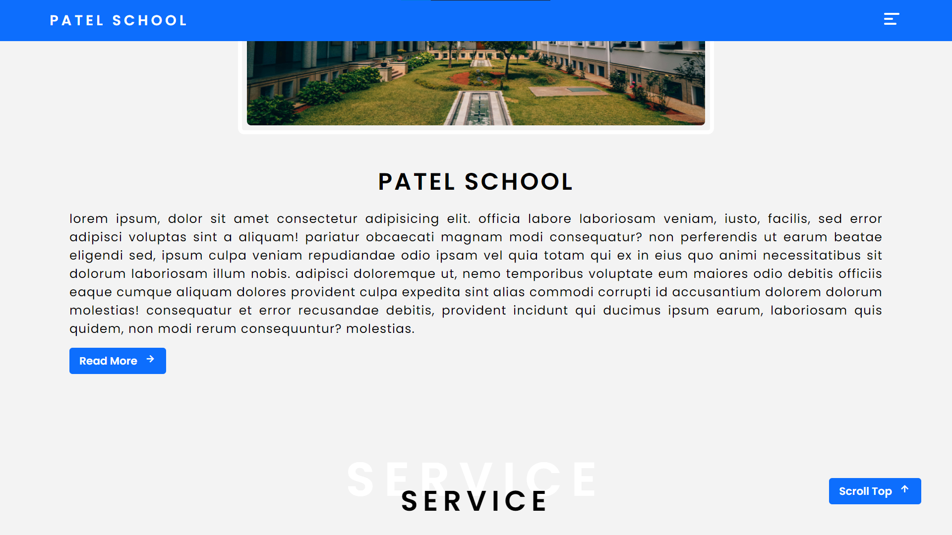





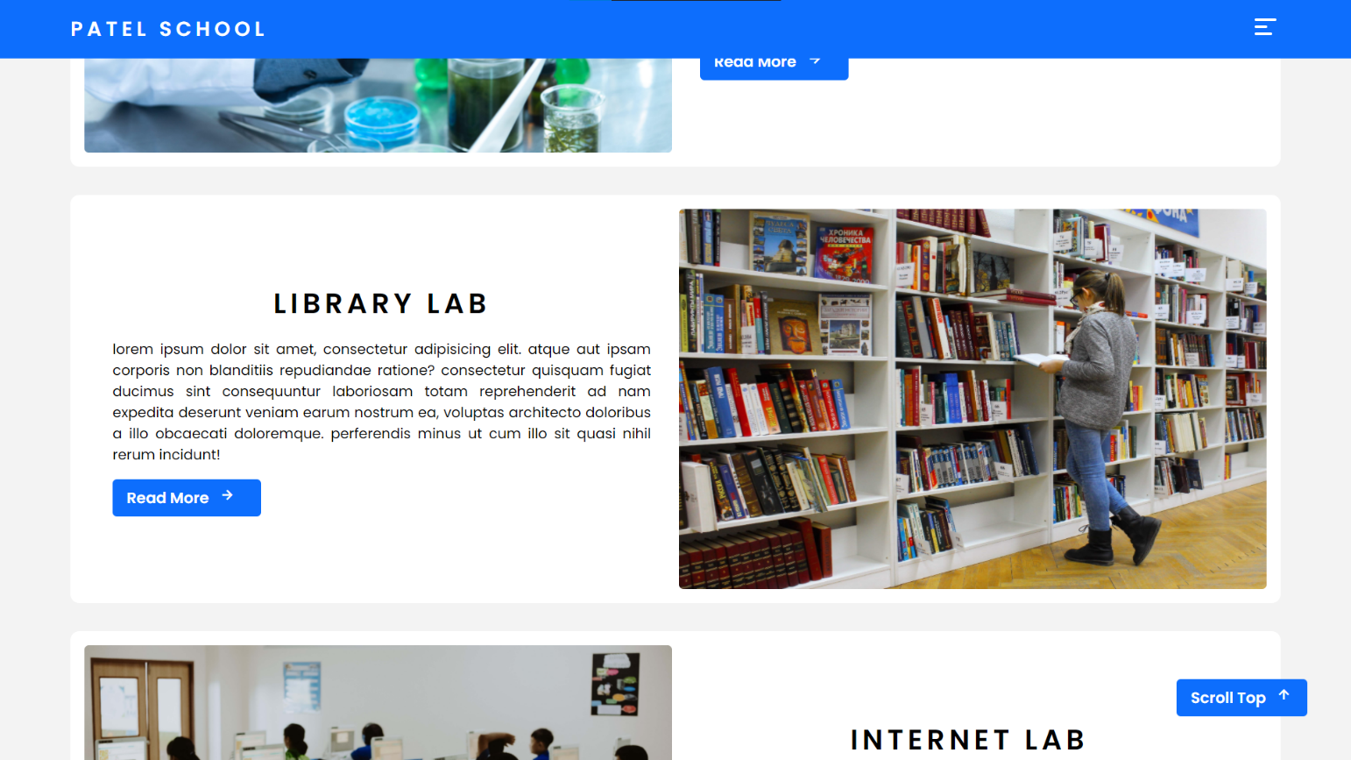

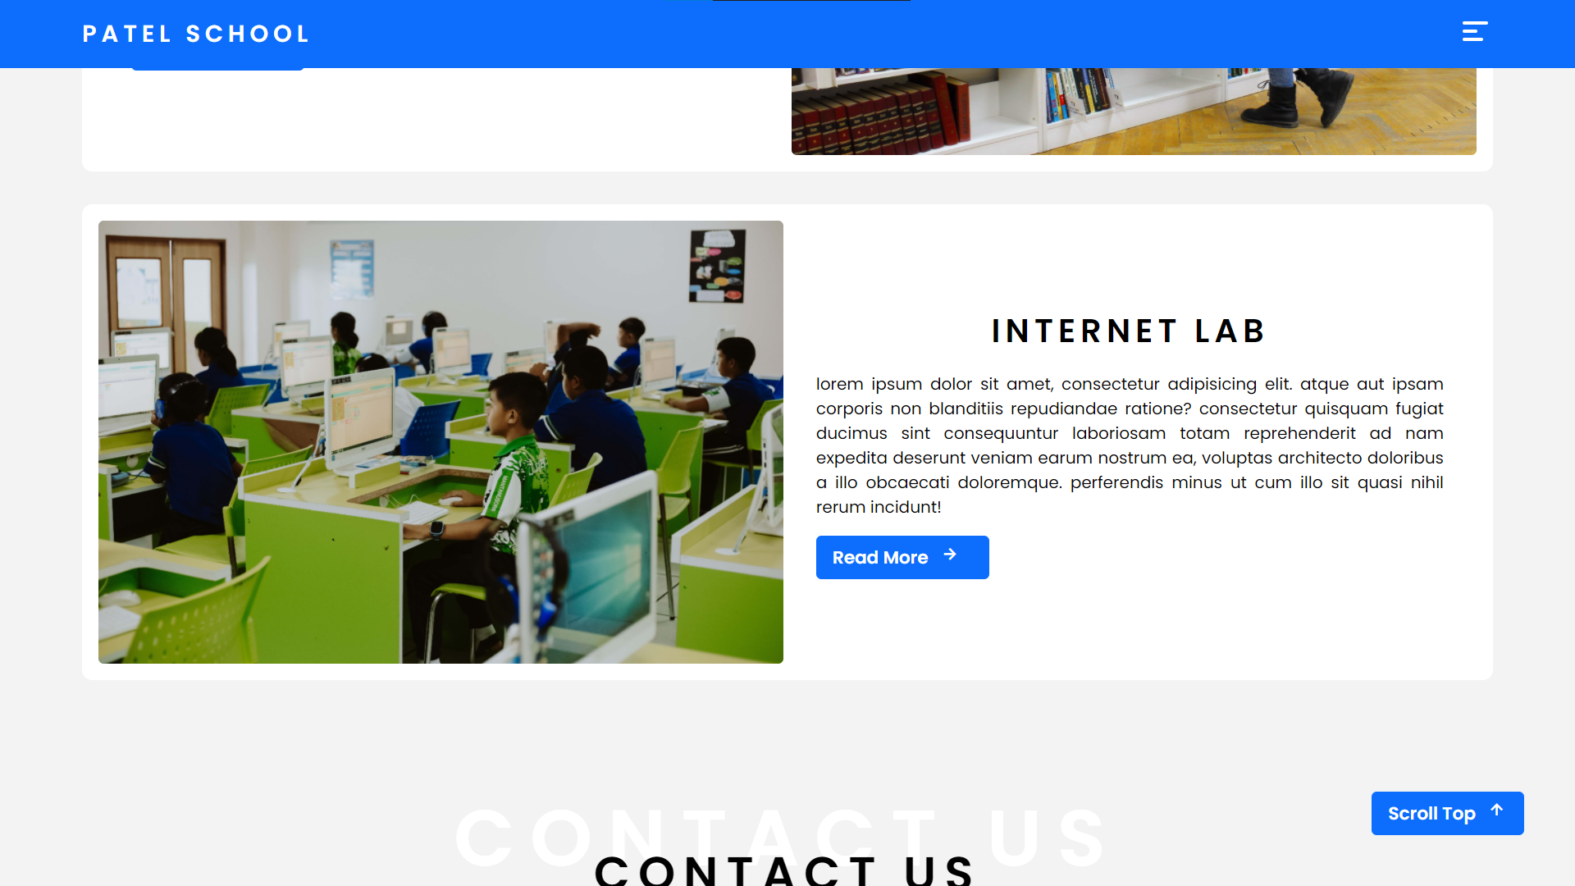

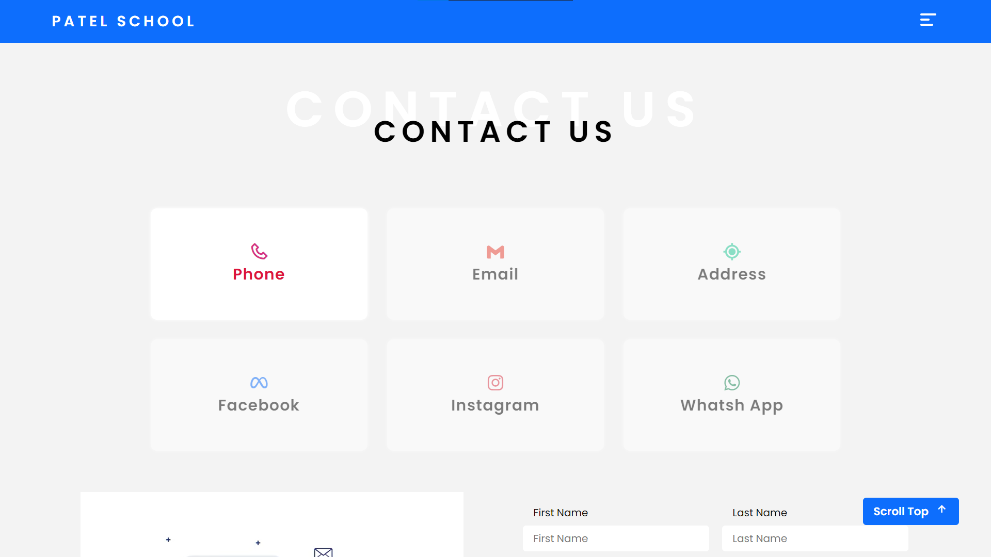

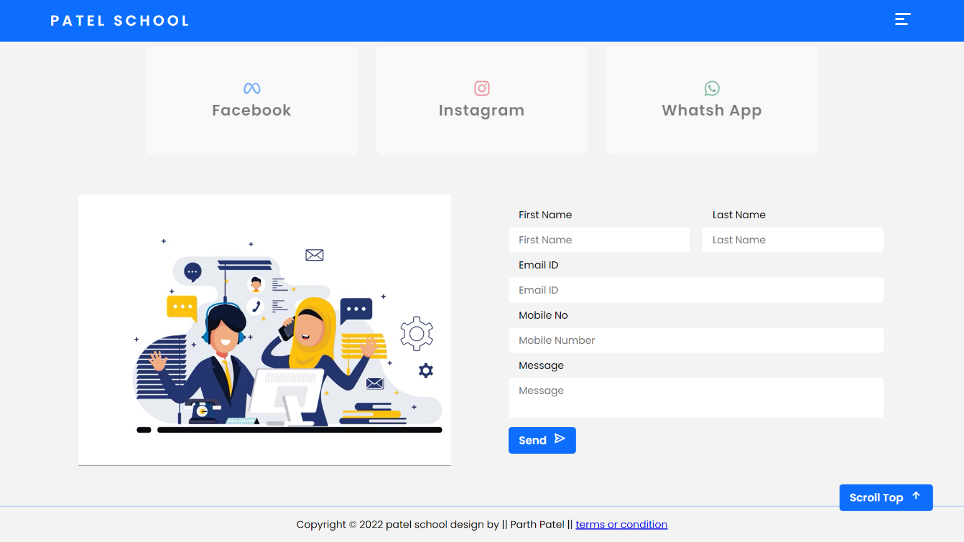

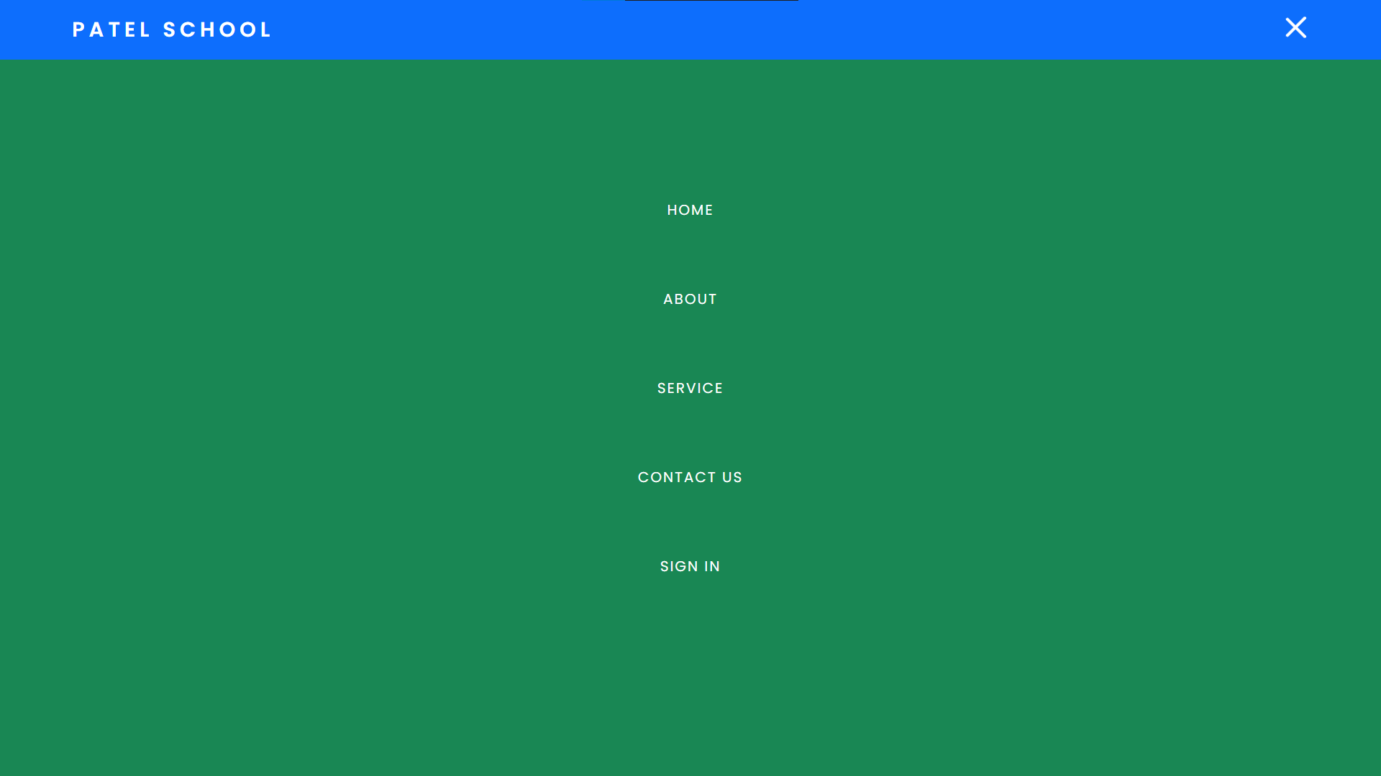

**ADMIN LAYOUTS**

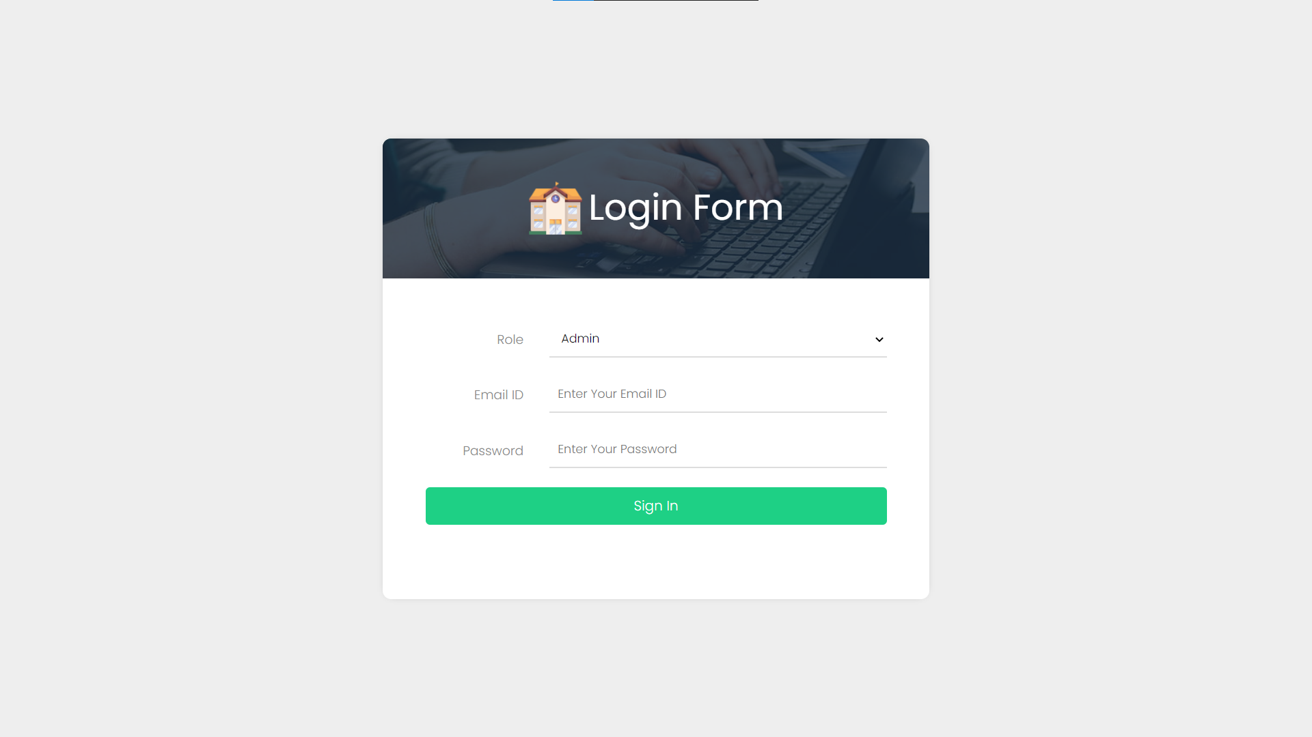

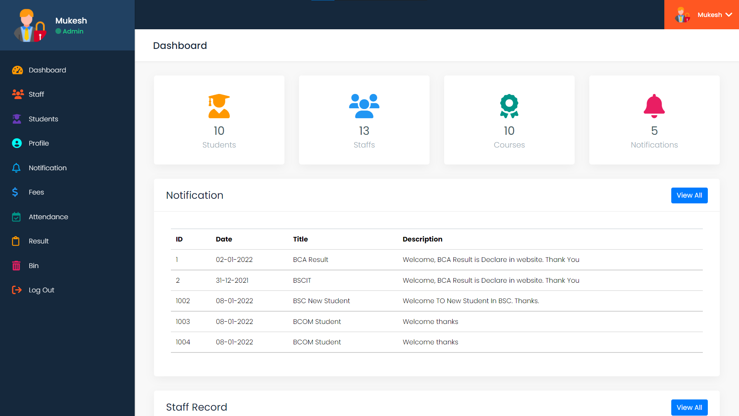

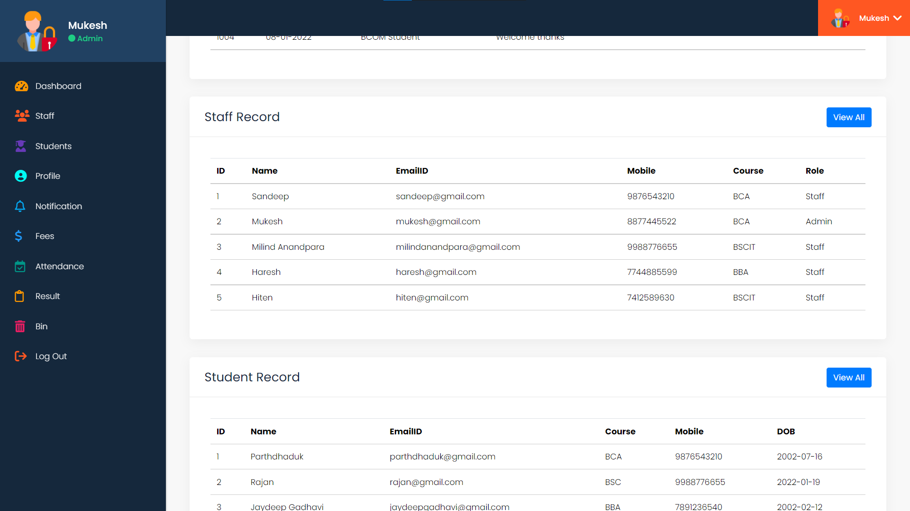

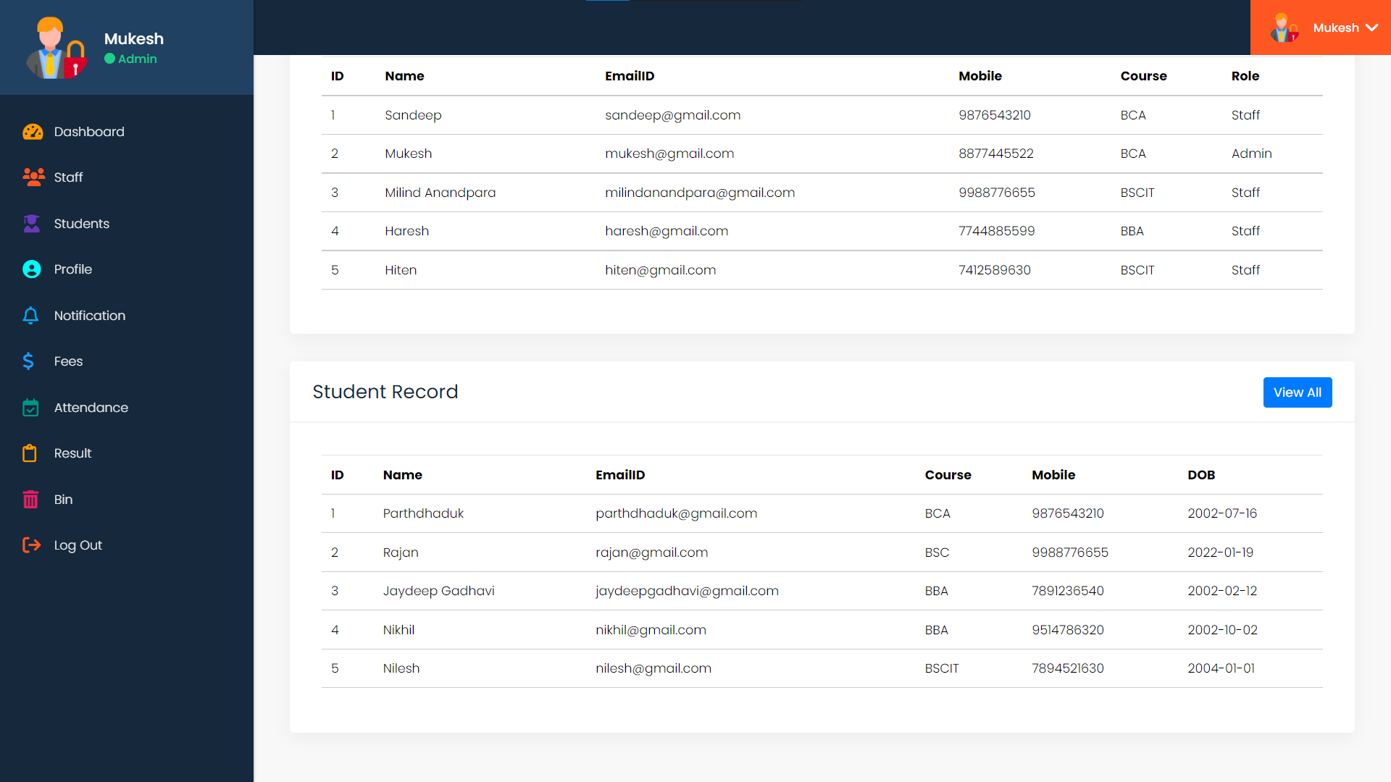

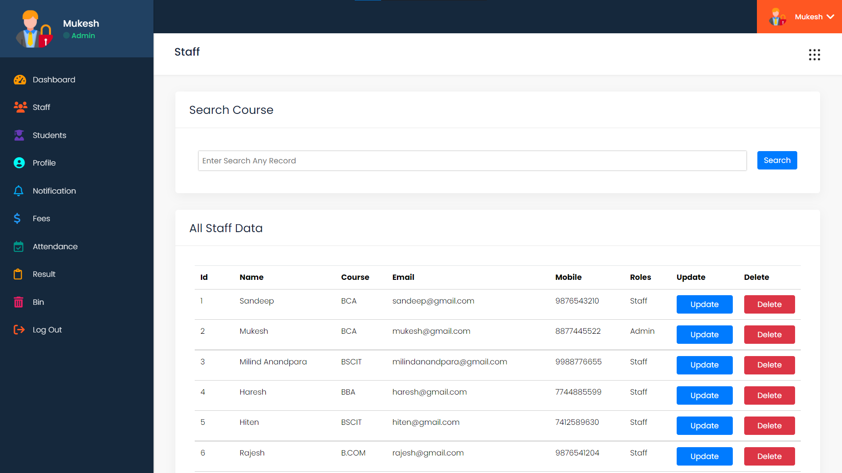

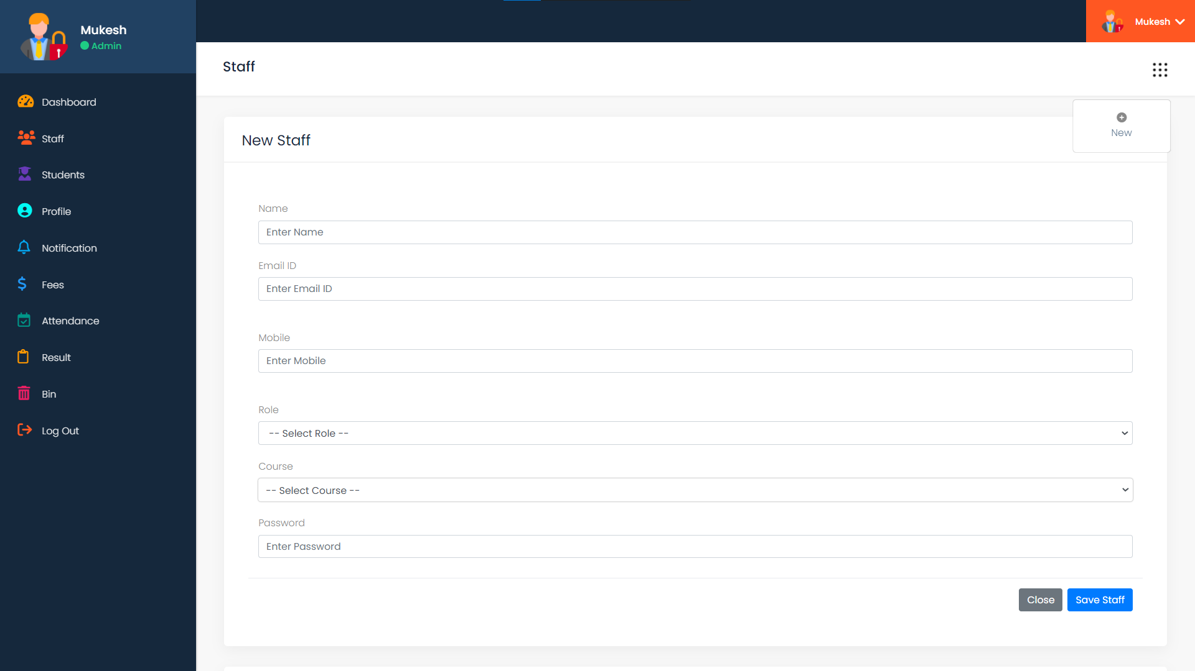

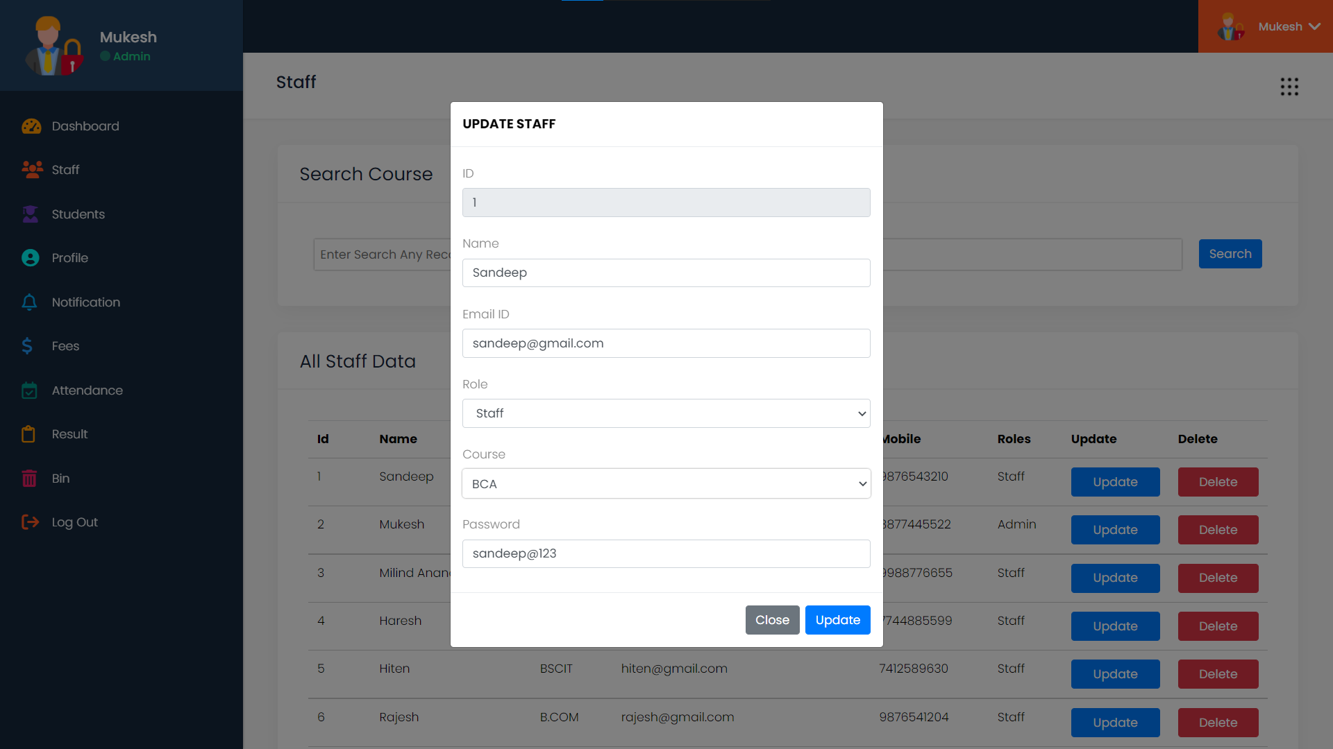

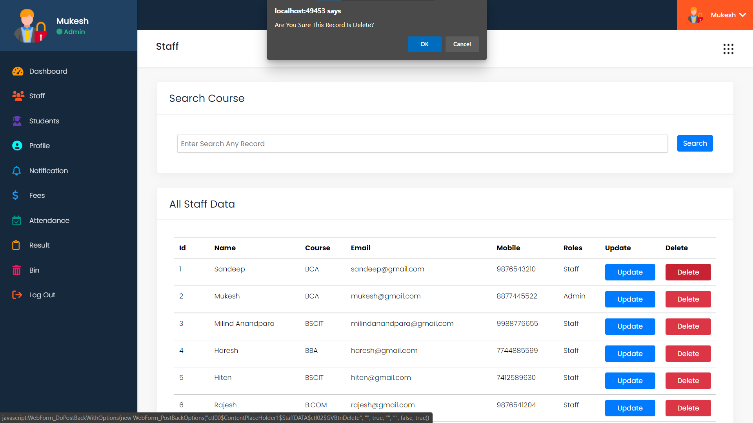

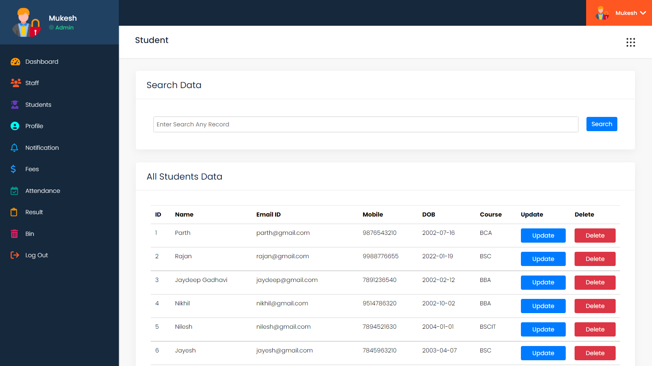

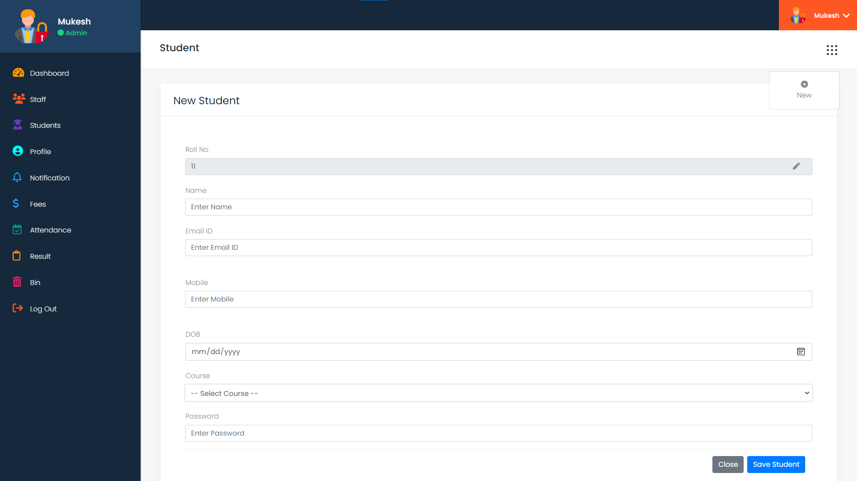

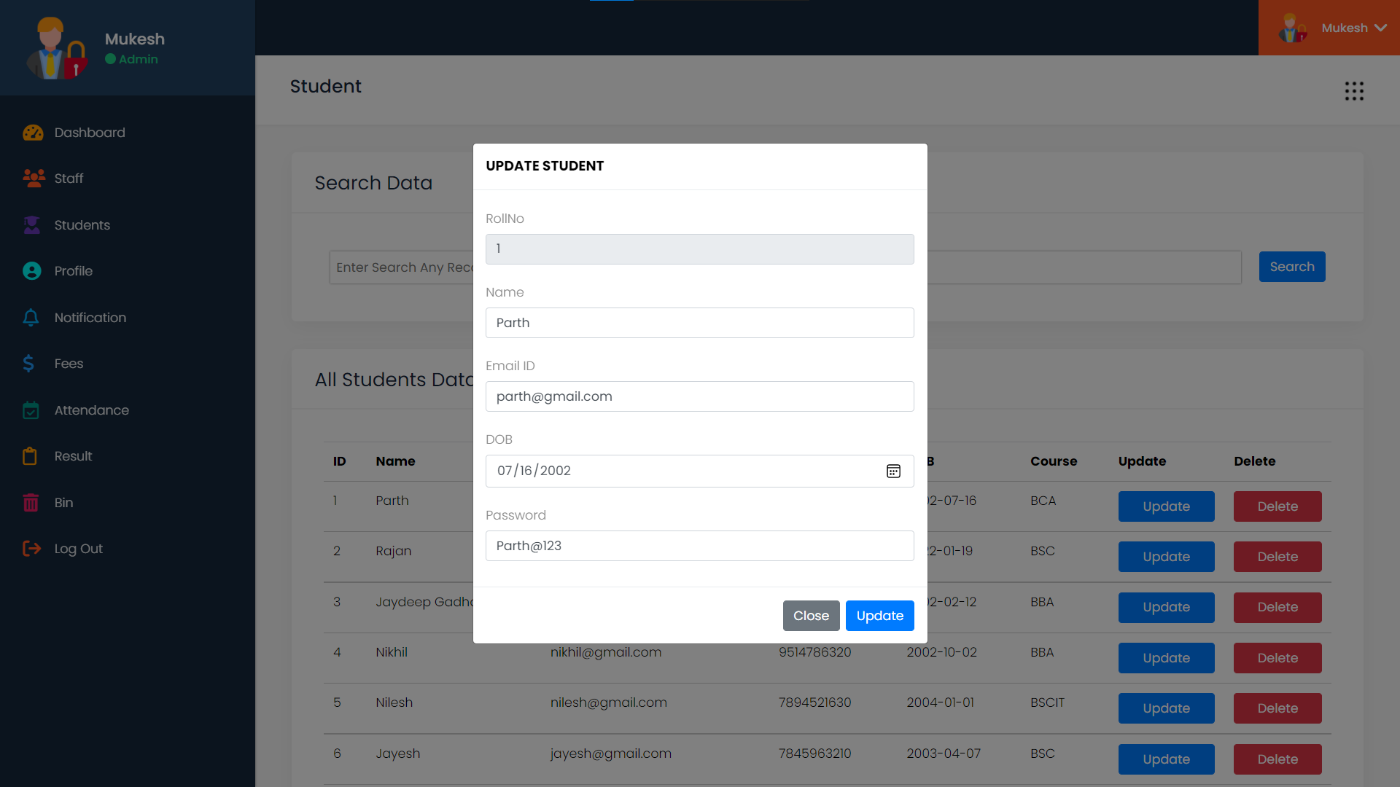

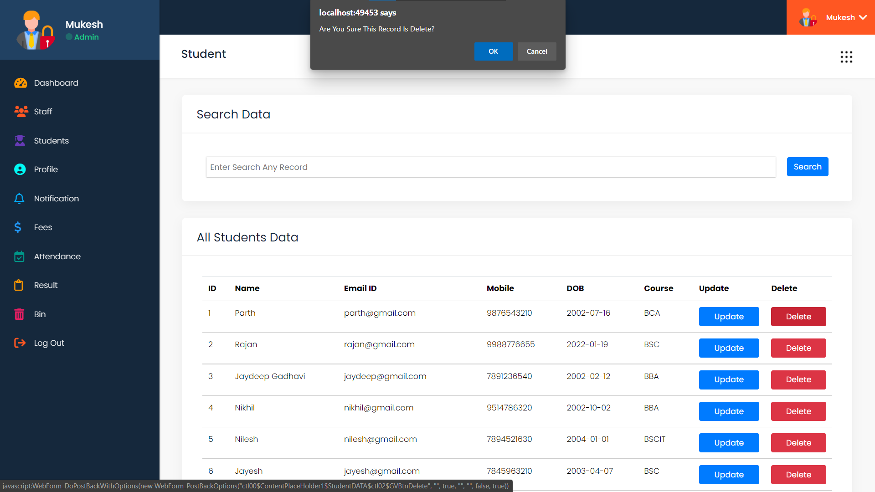

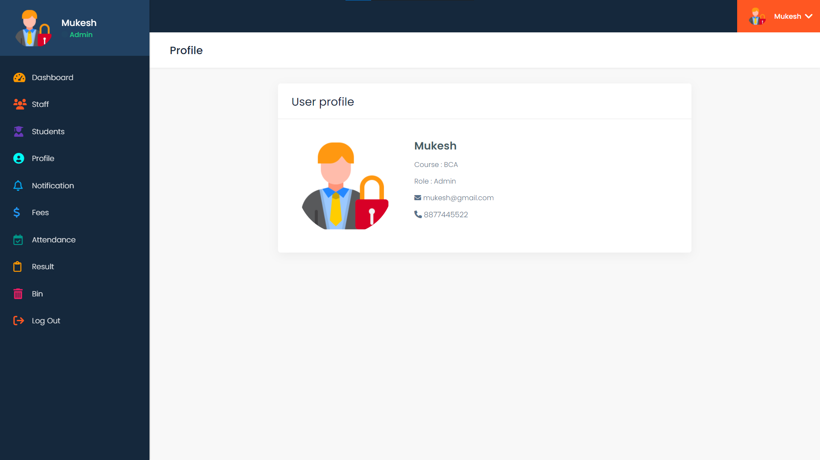

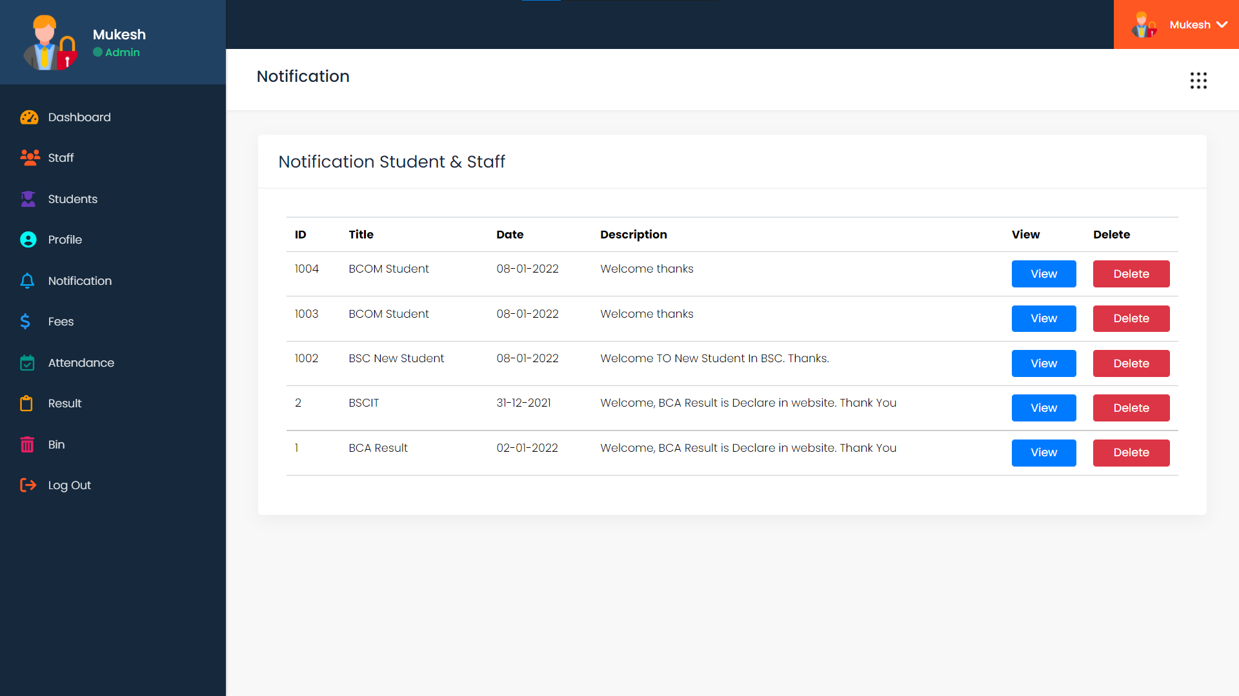

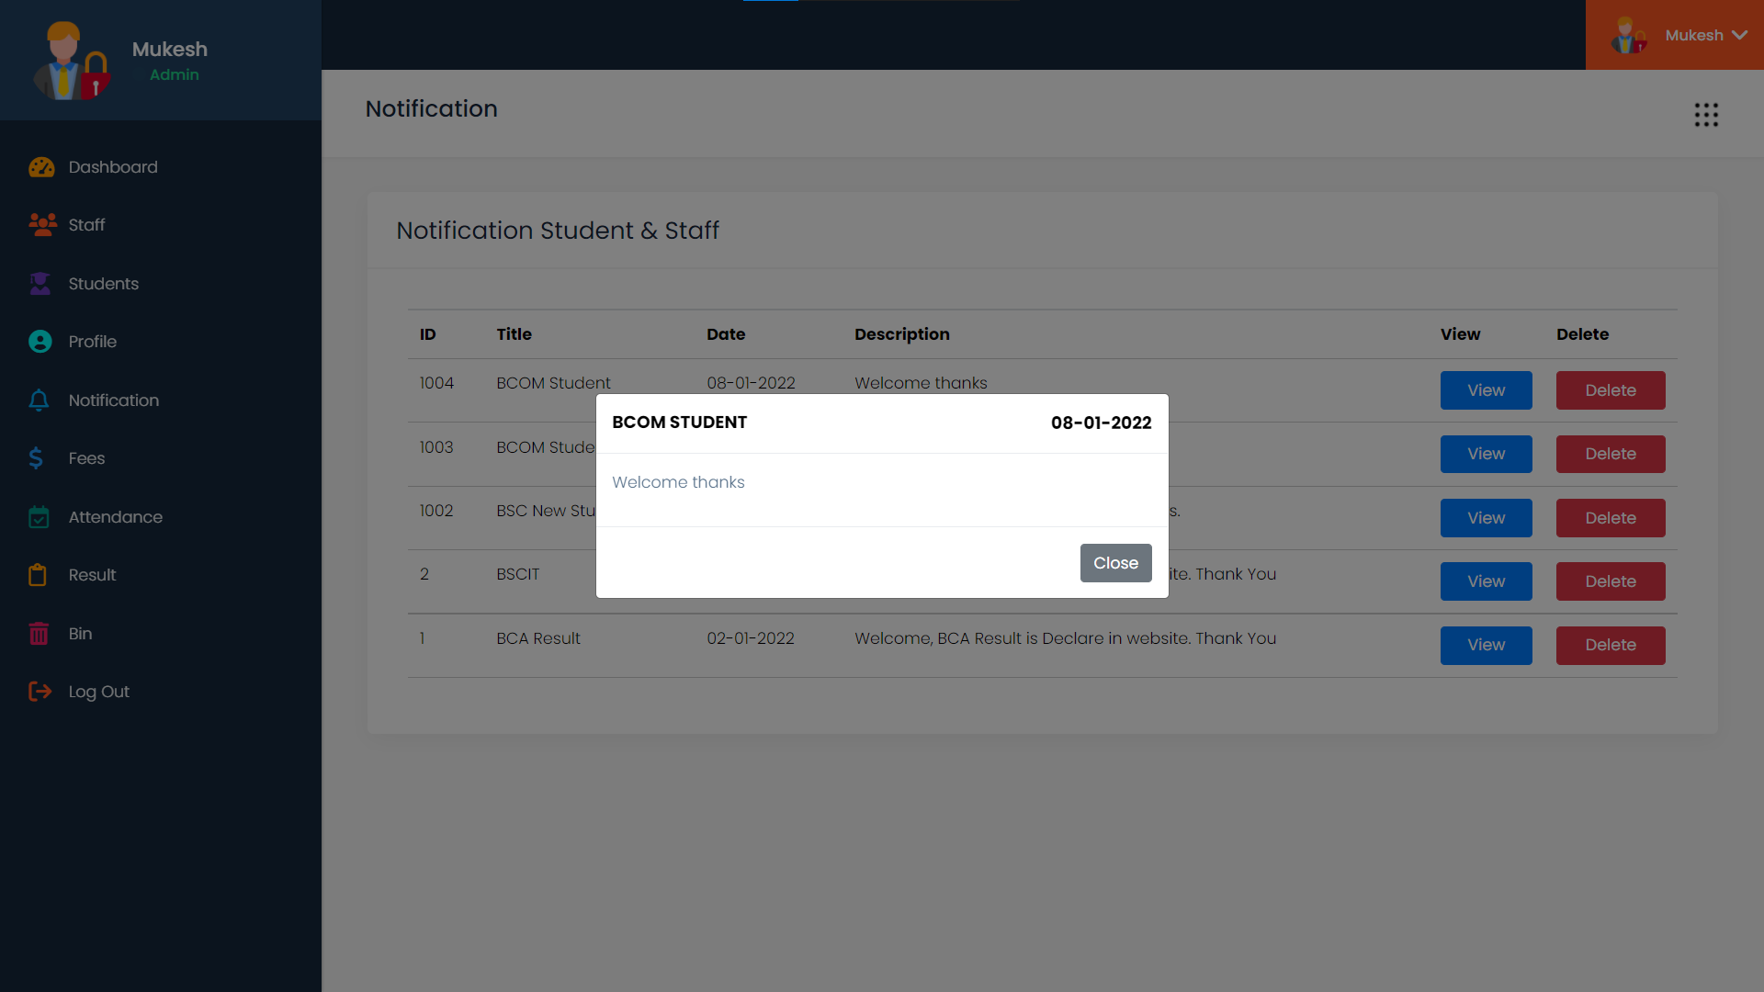

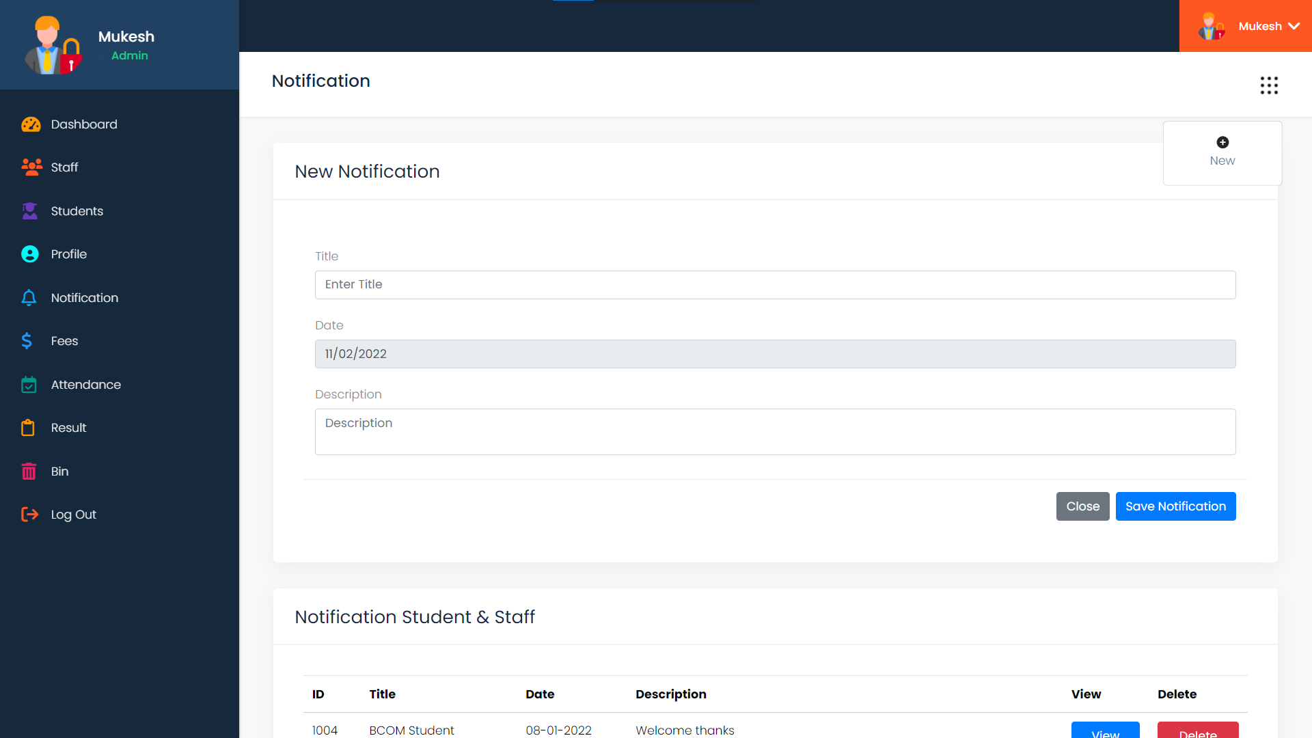

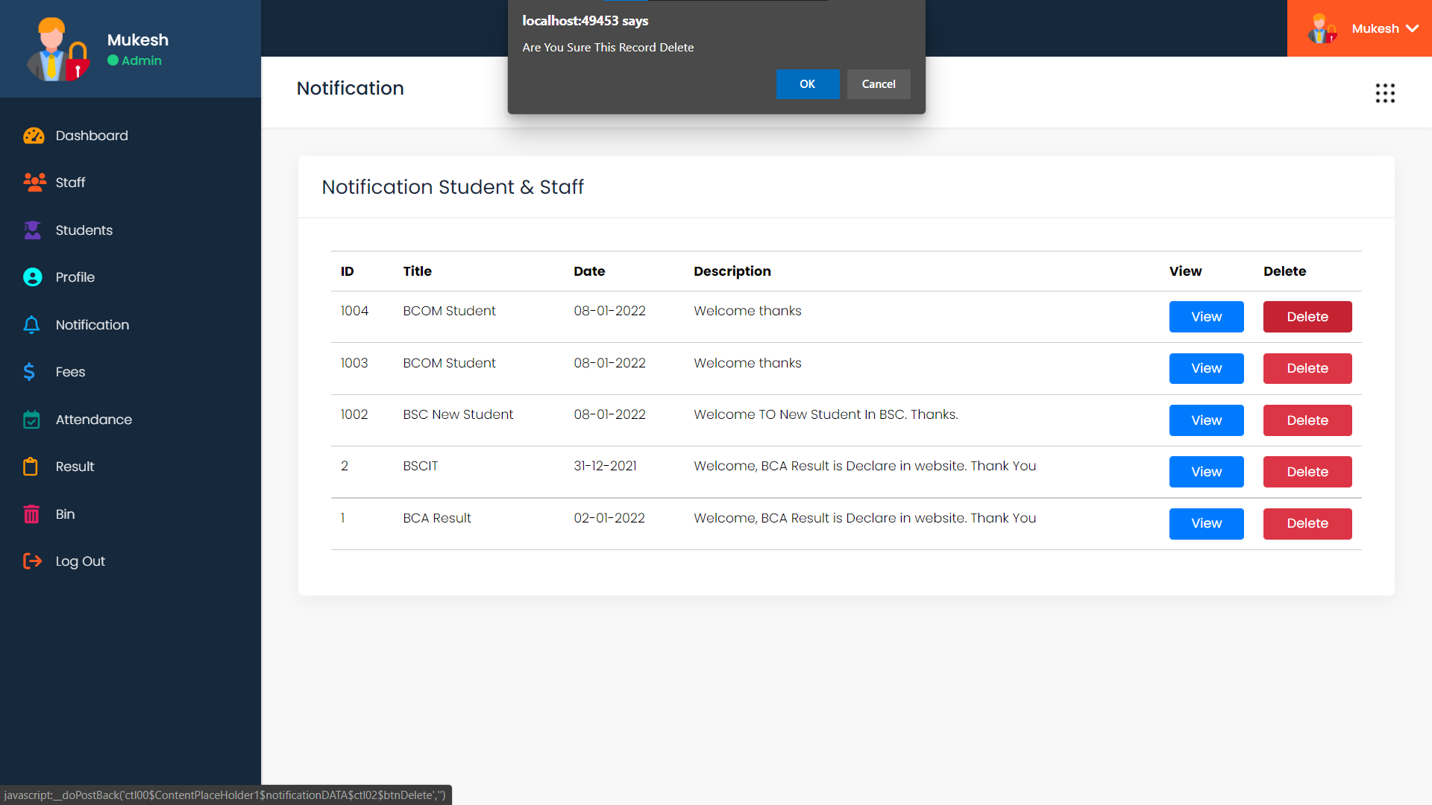

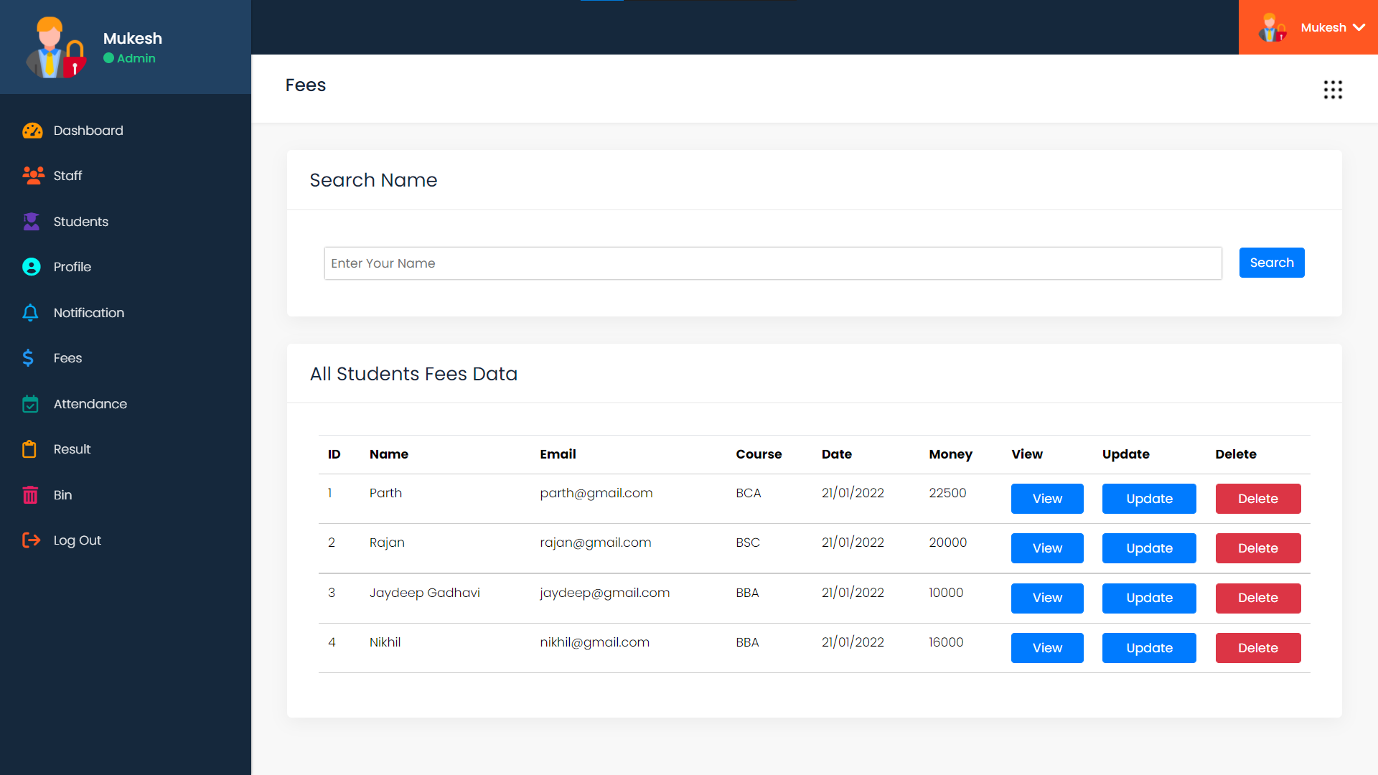

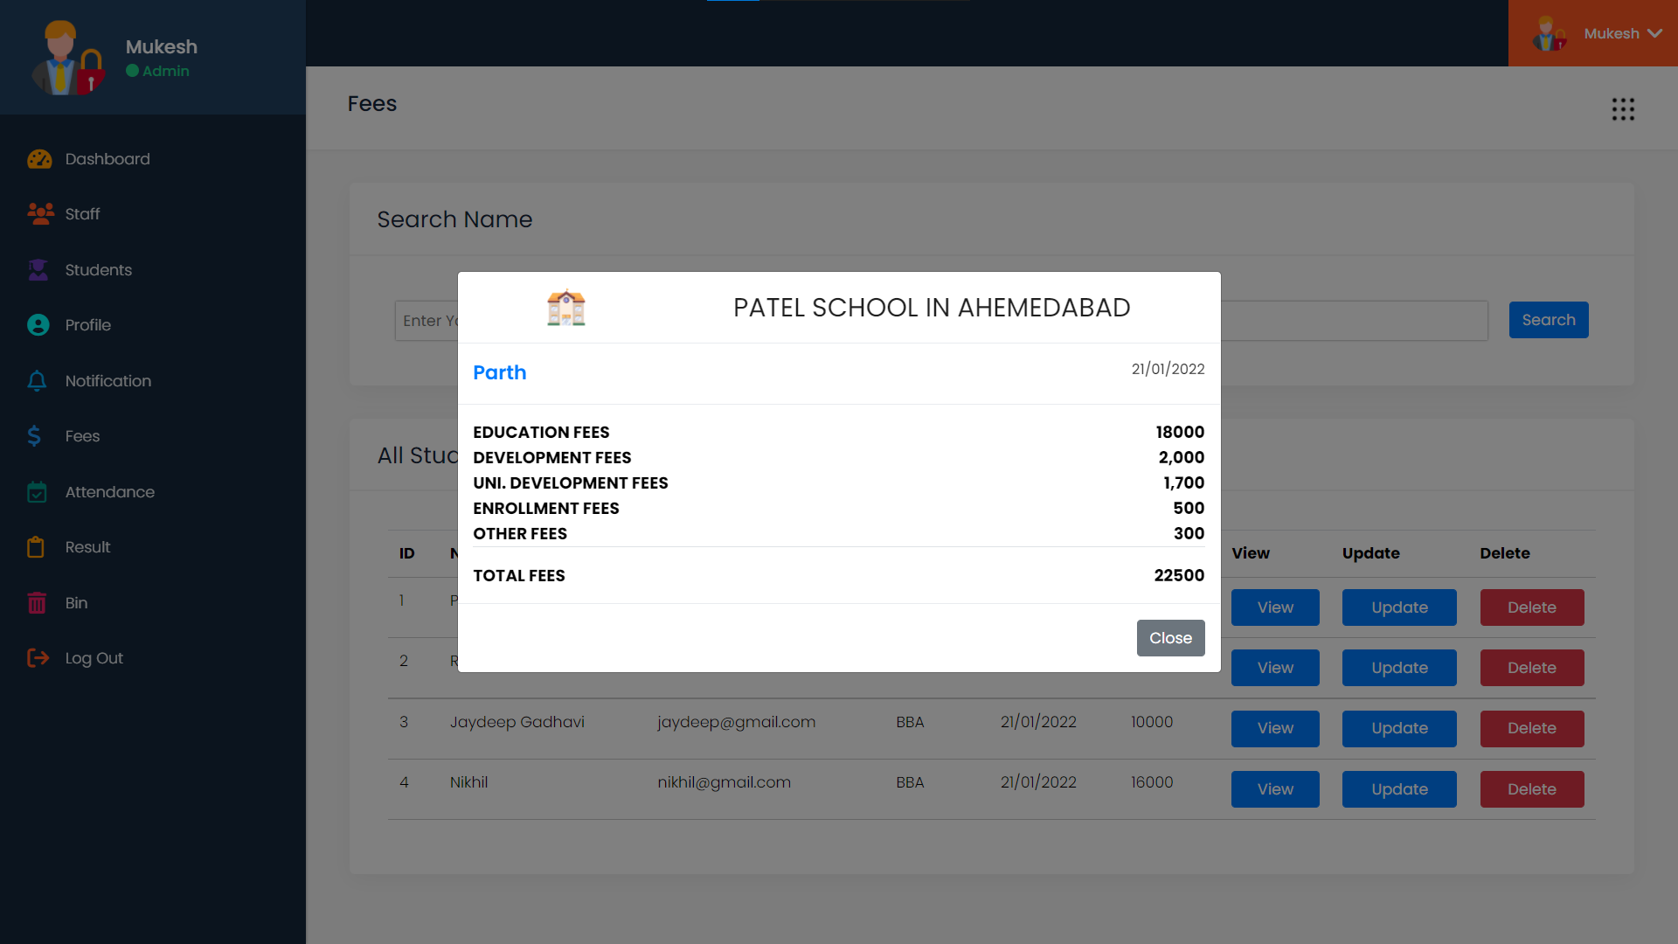

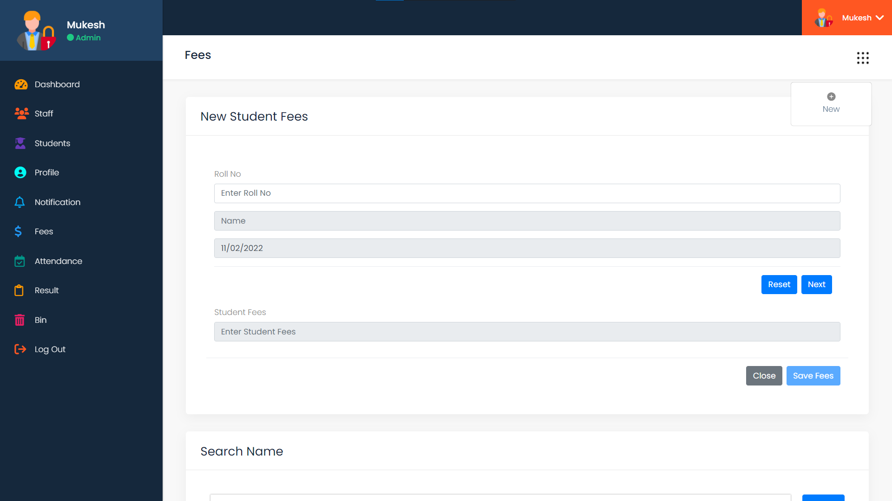

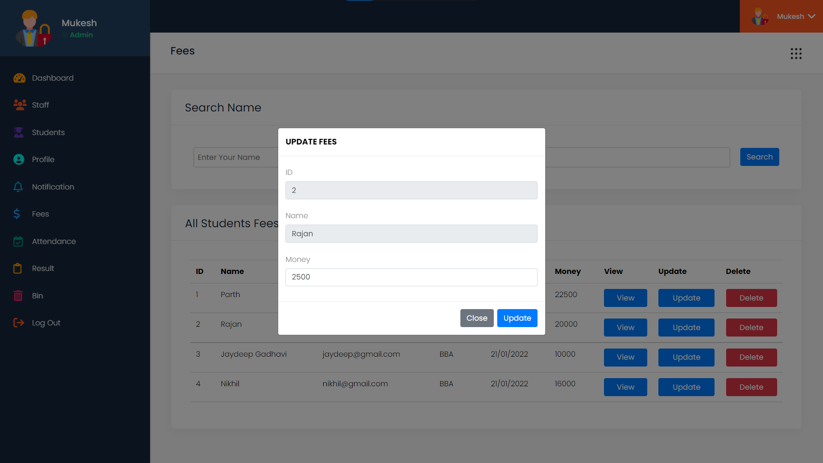

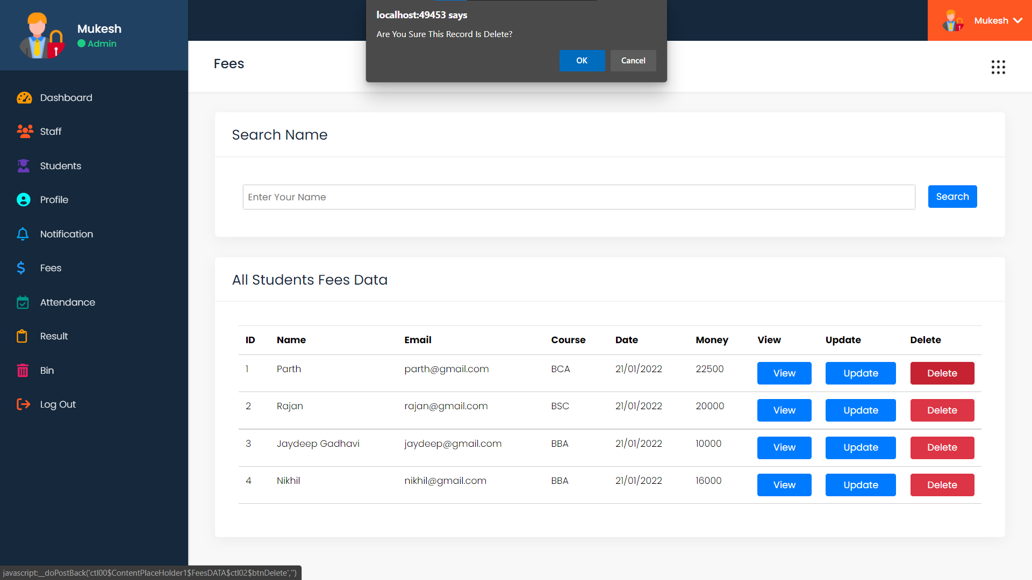

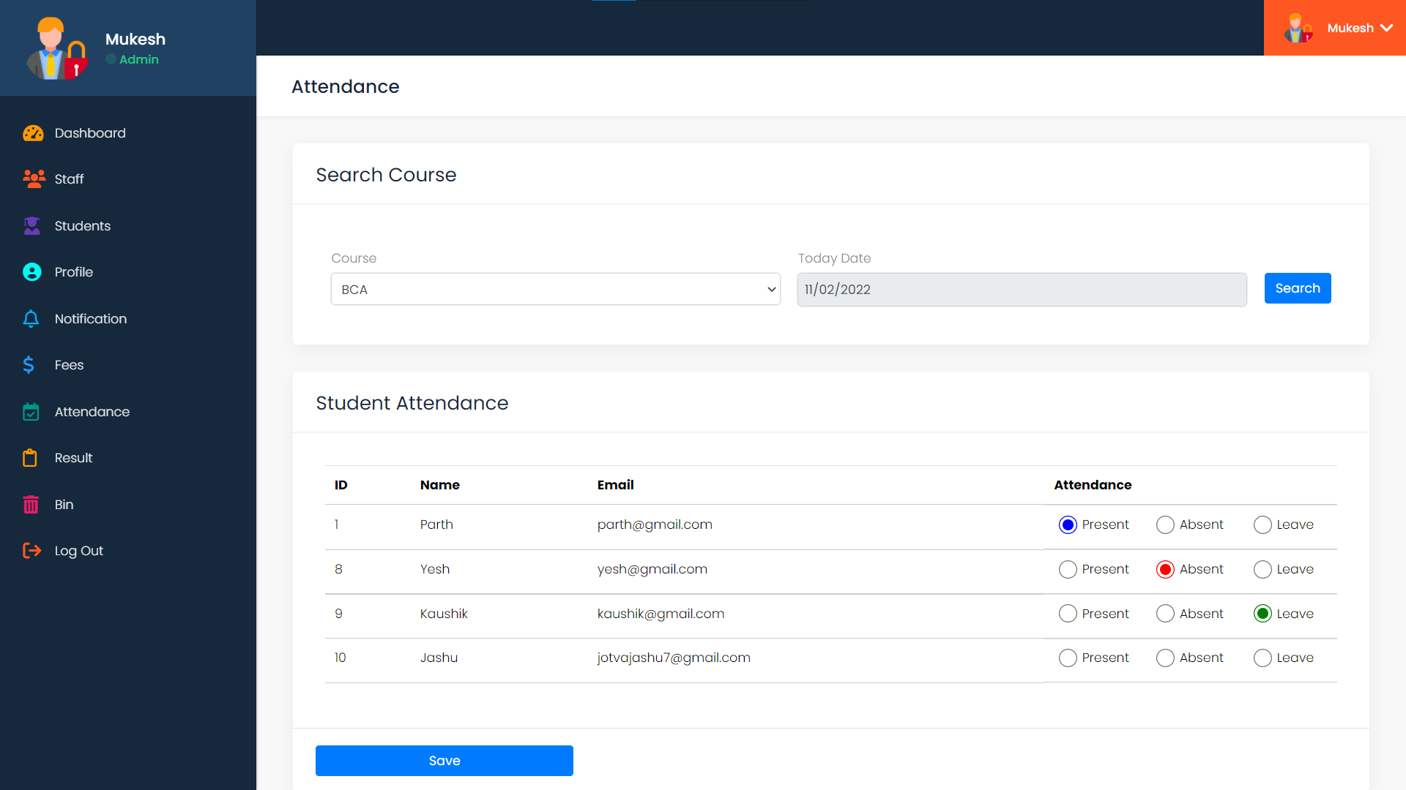

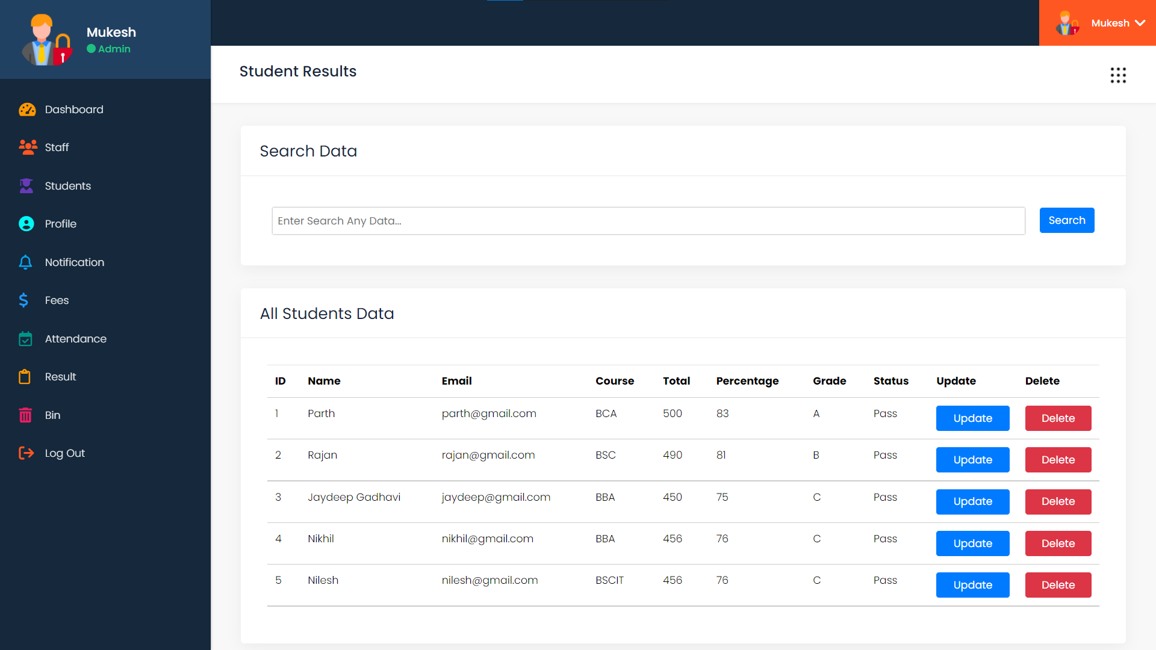

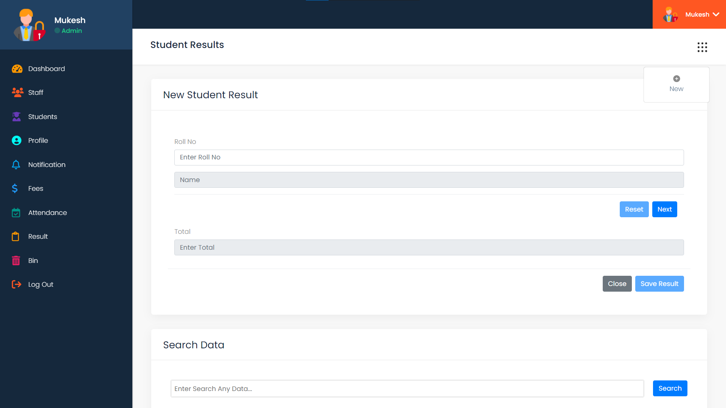

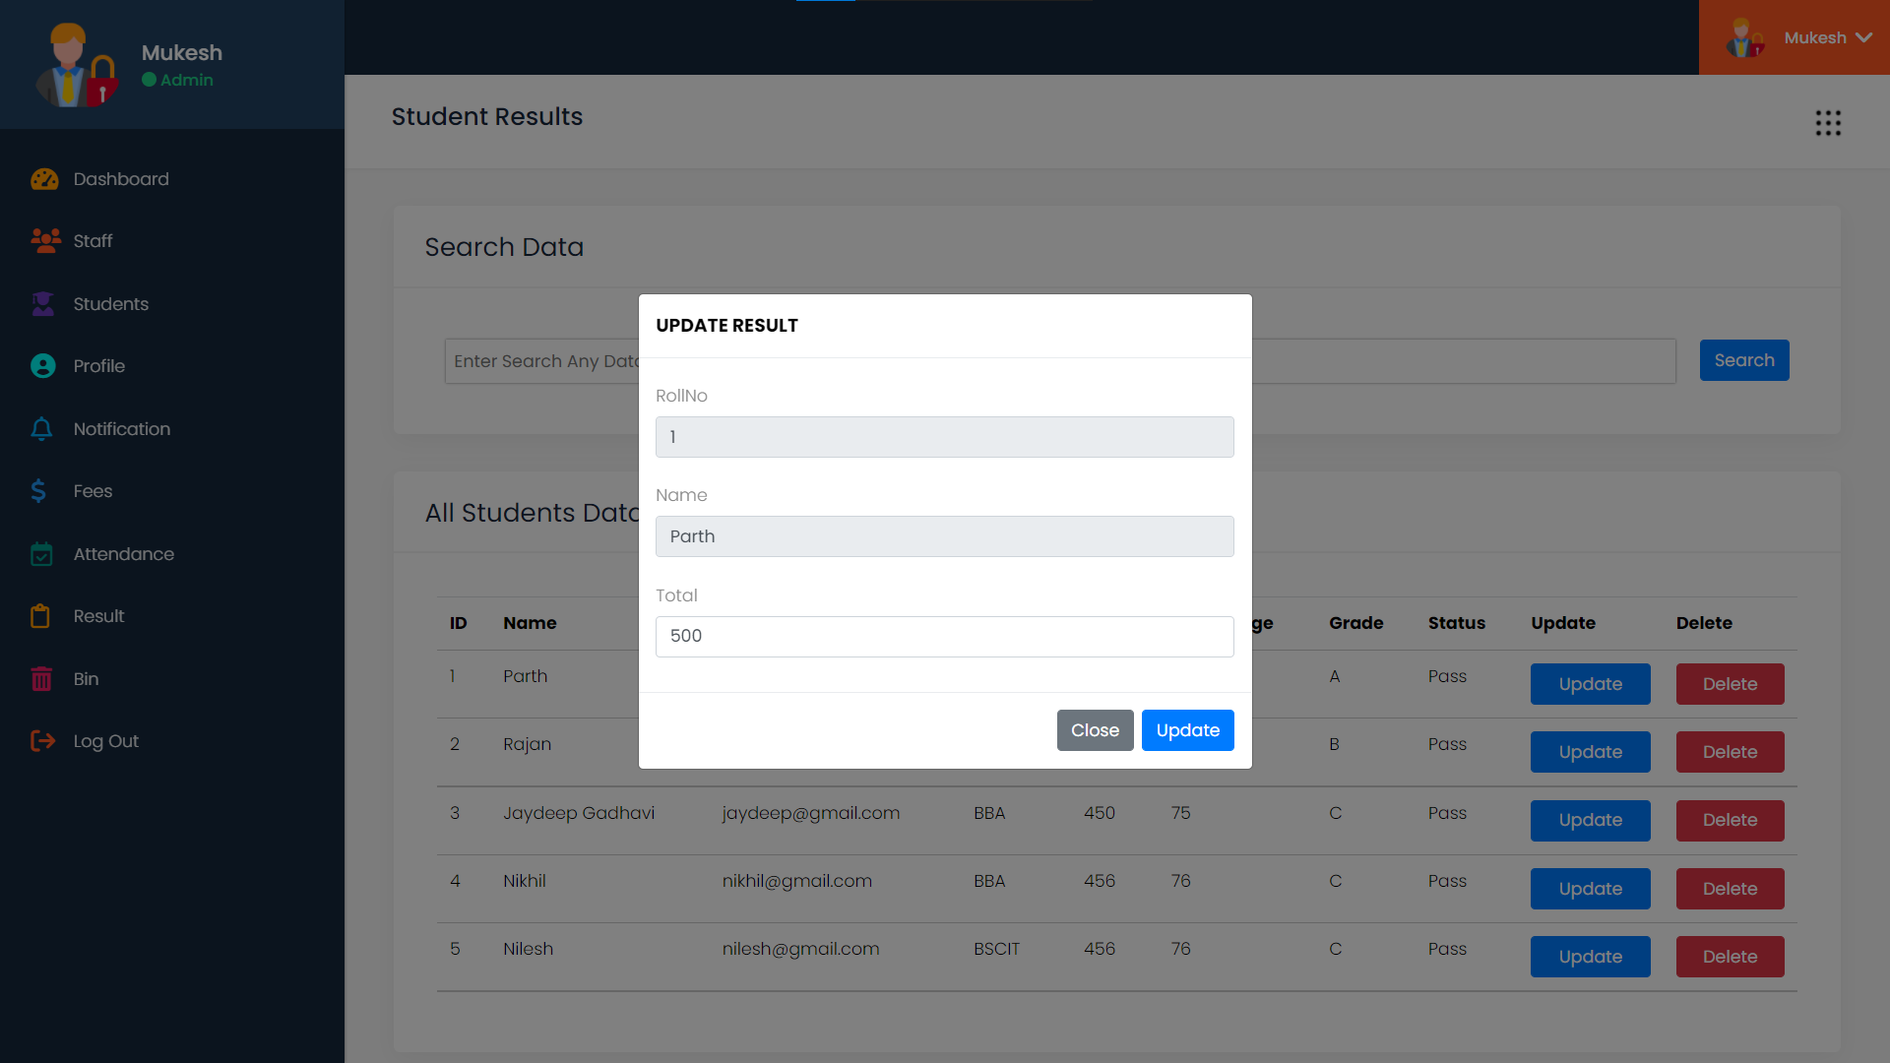

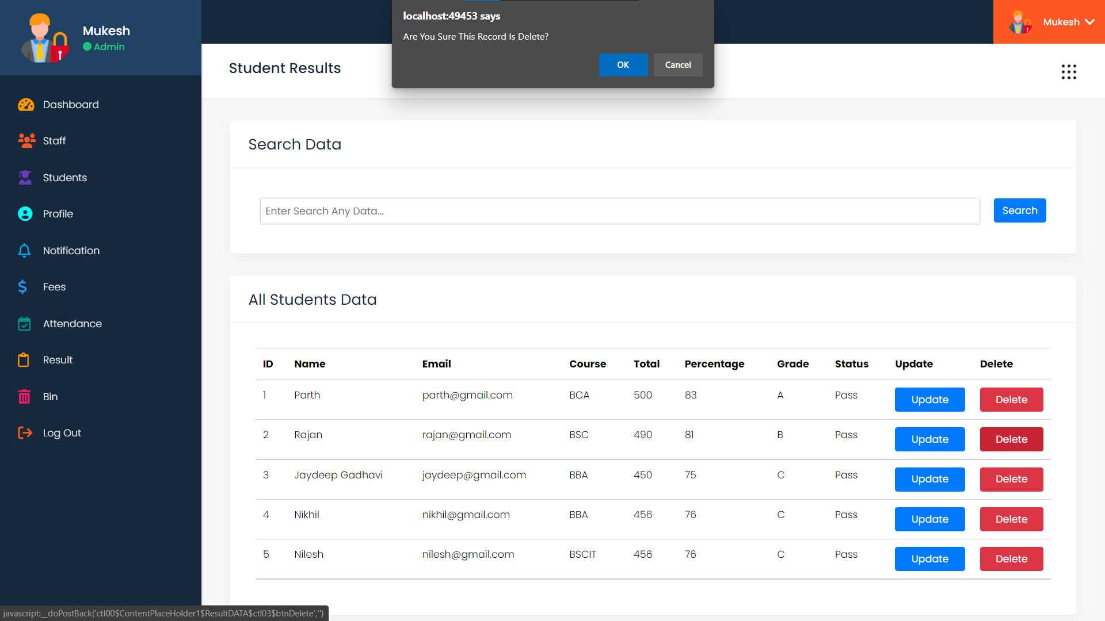

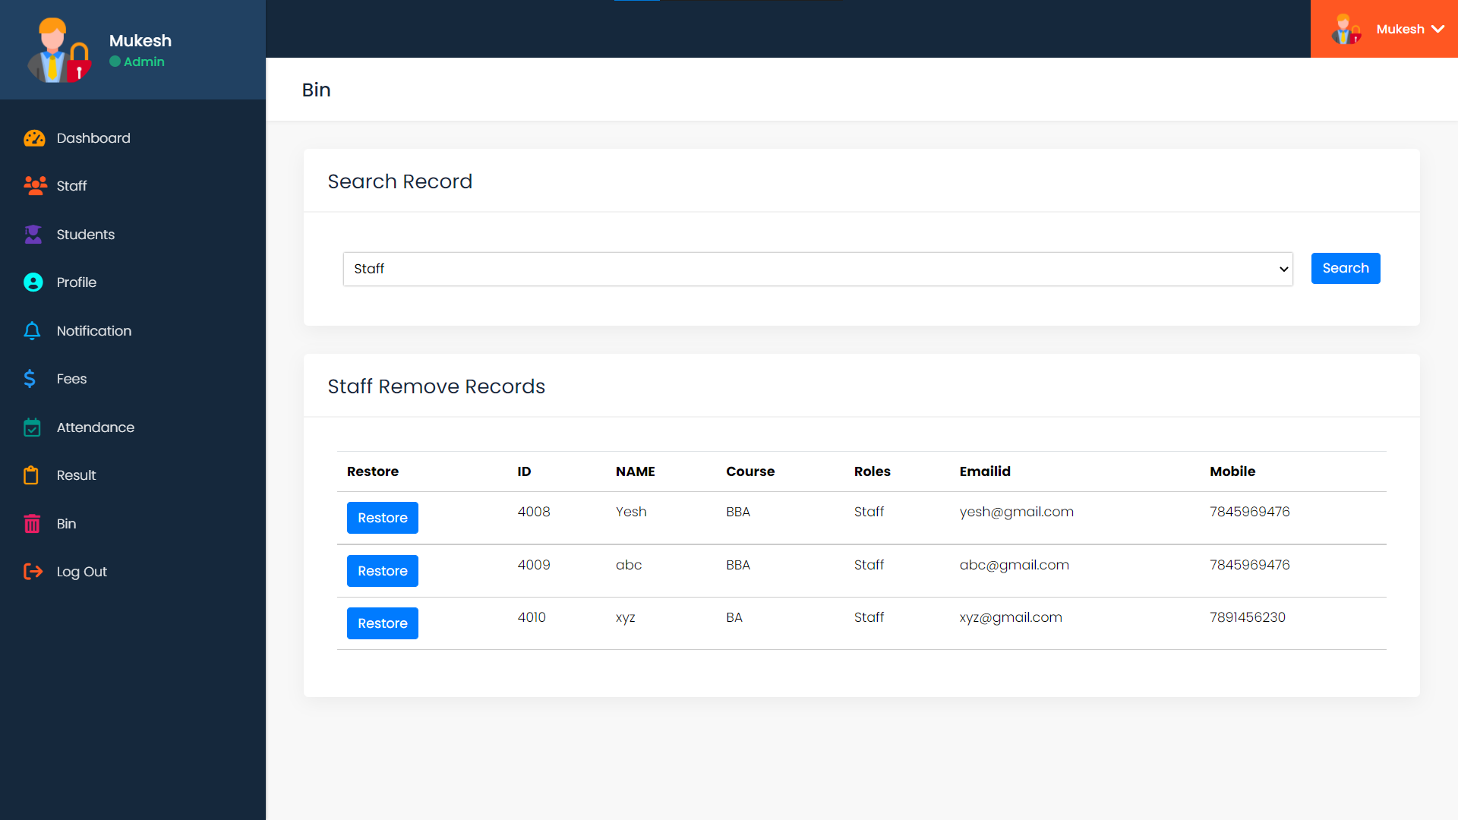

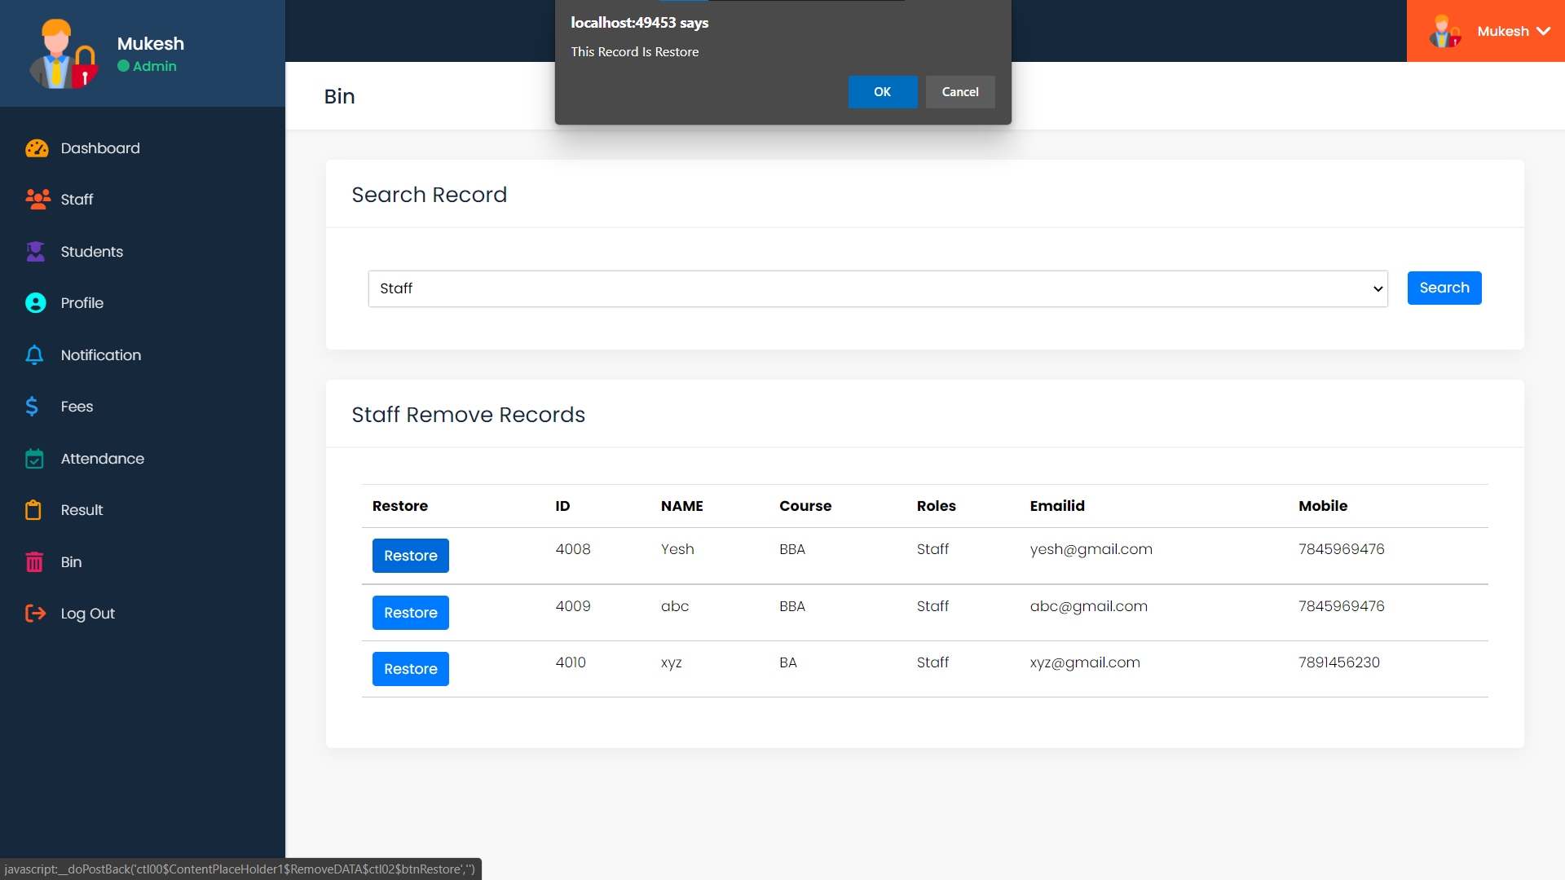

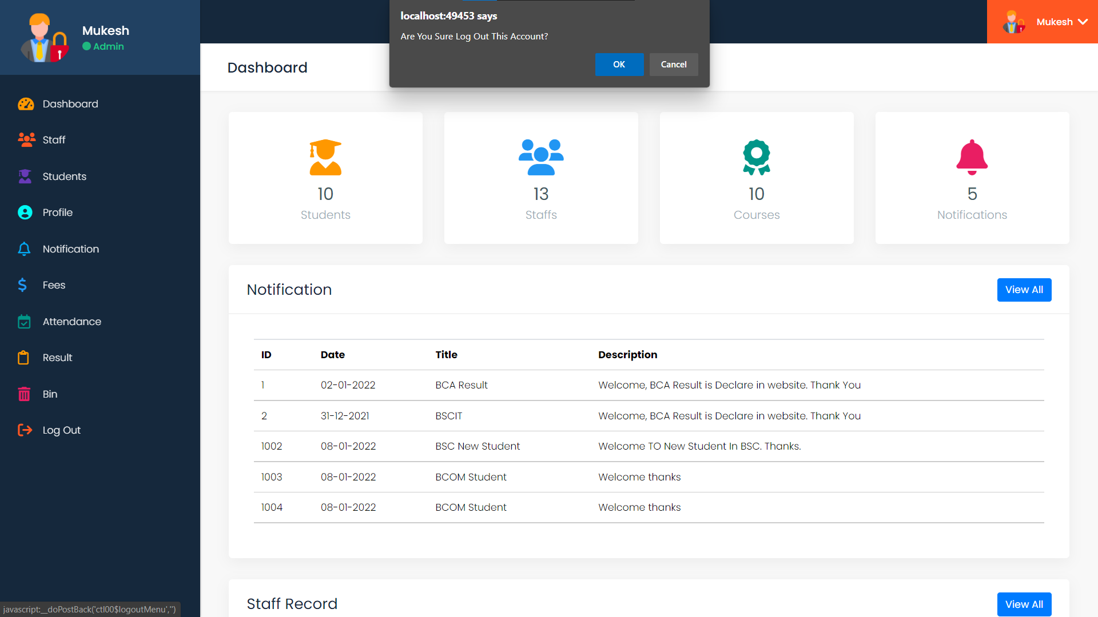

**STAFF LAYOUTS**

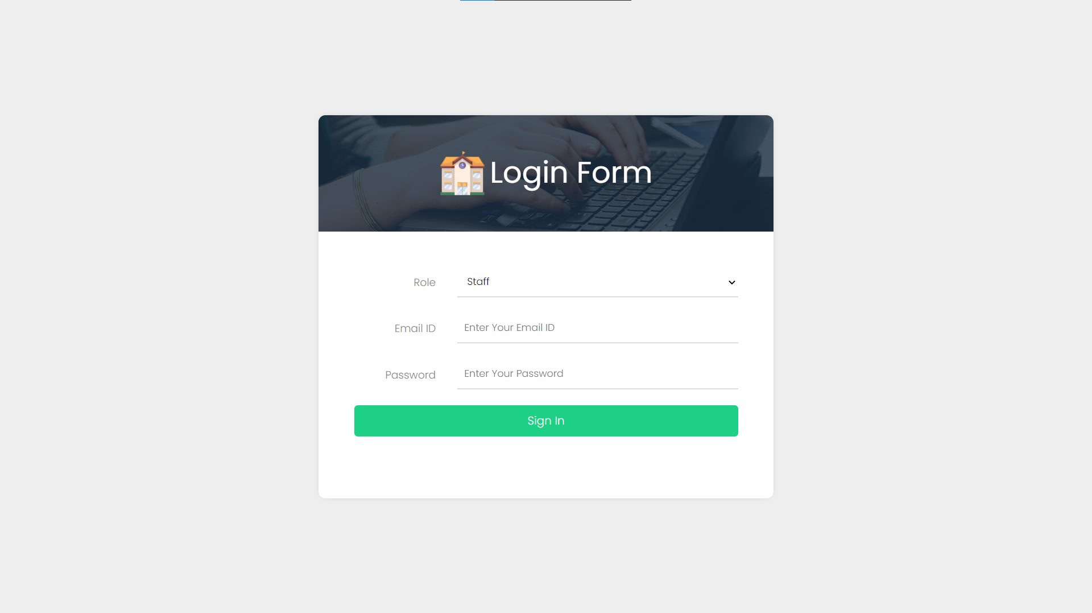

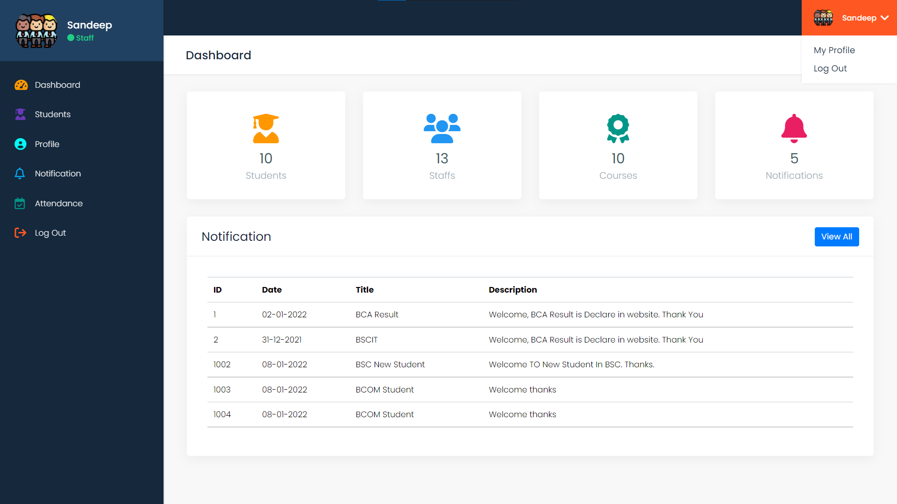

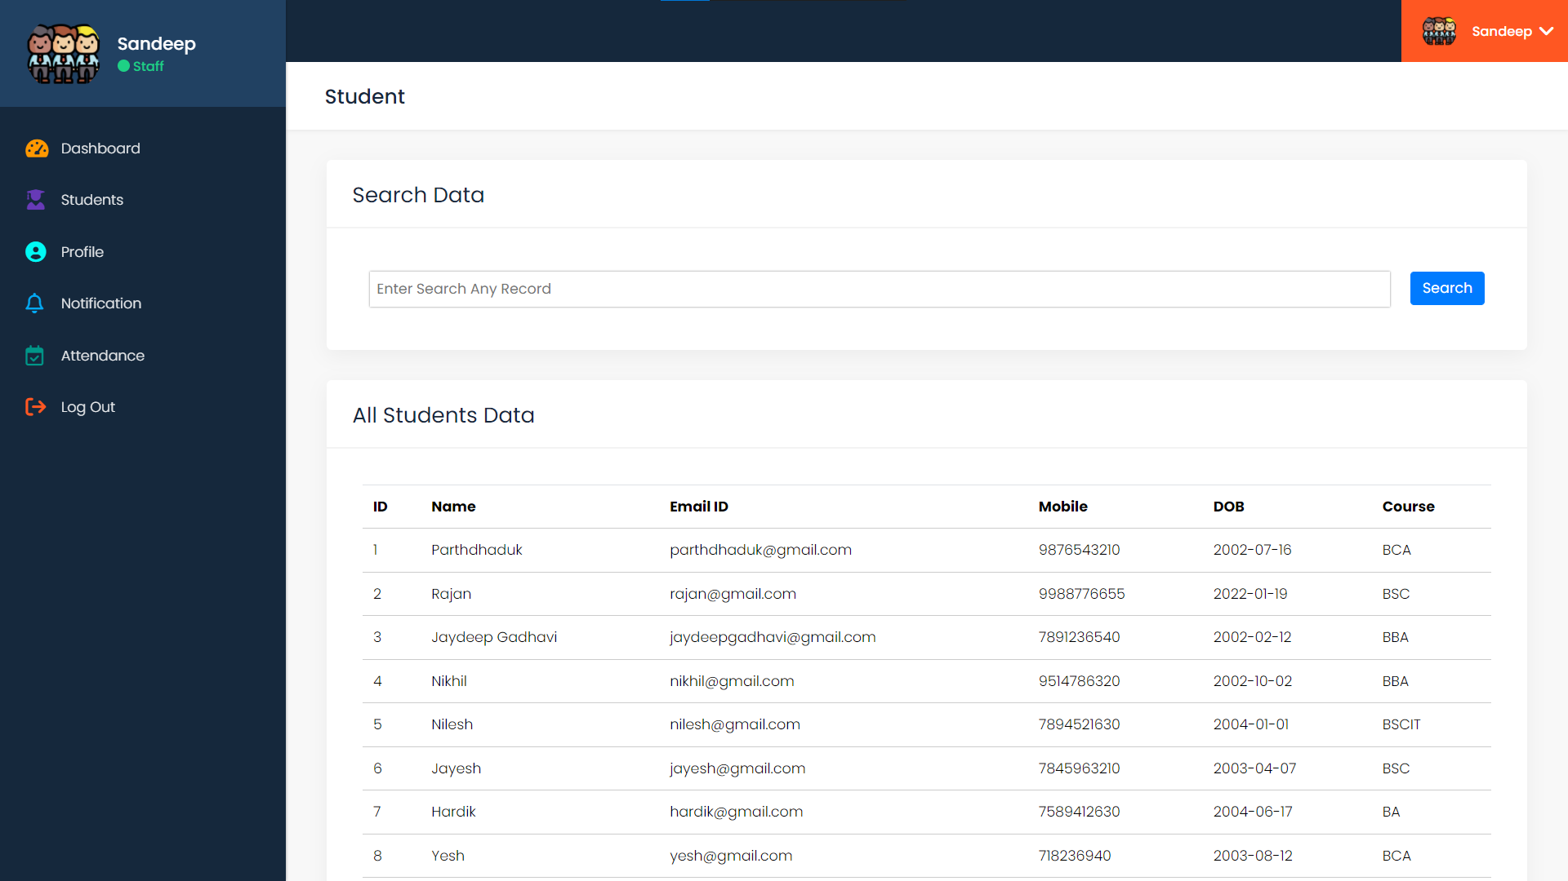

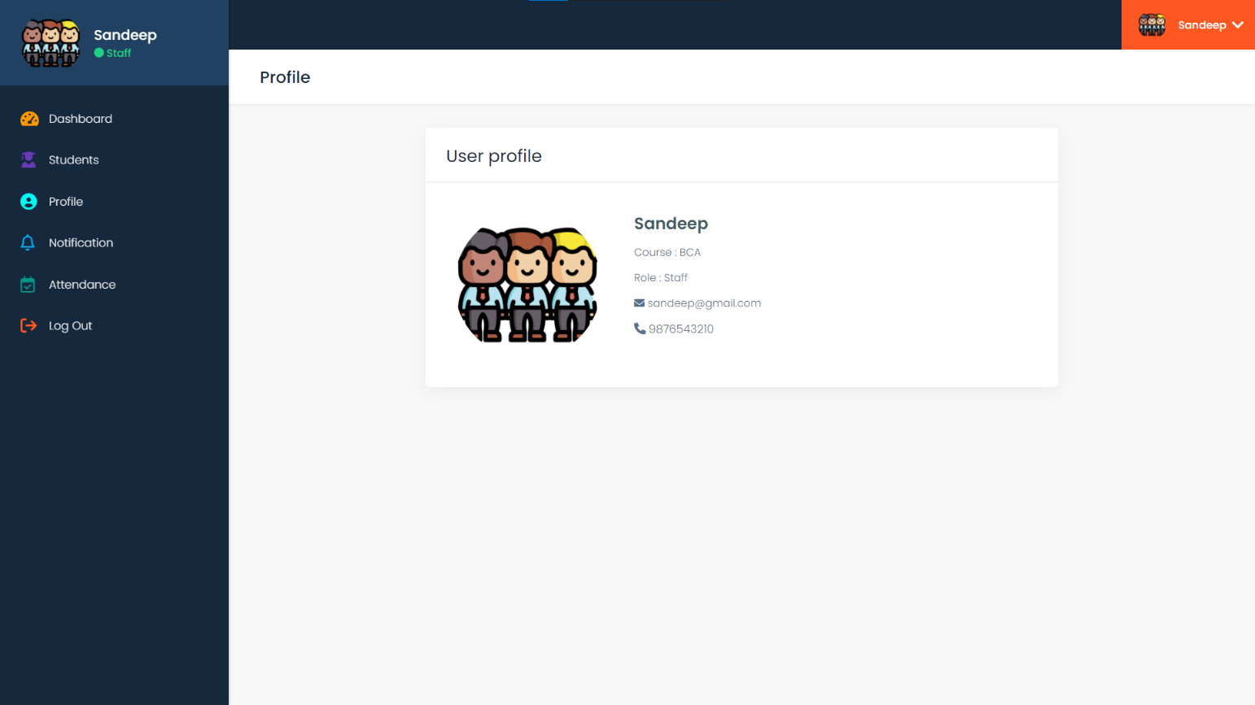

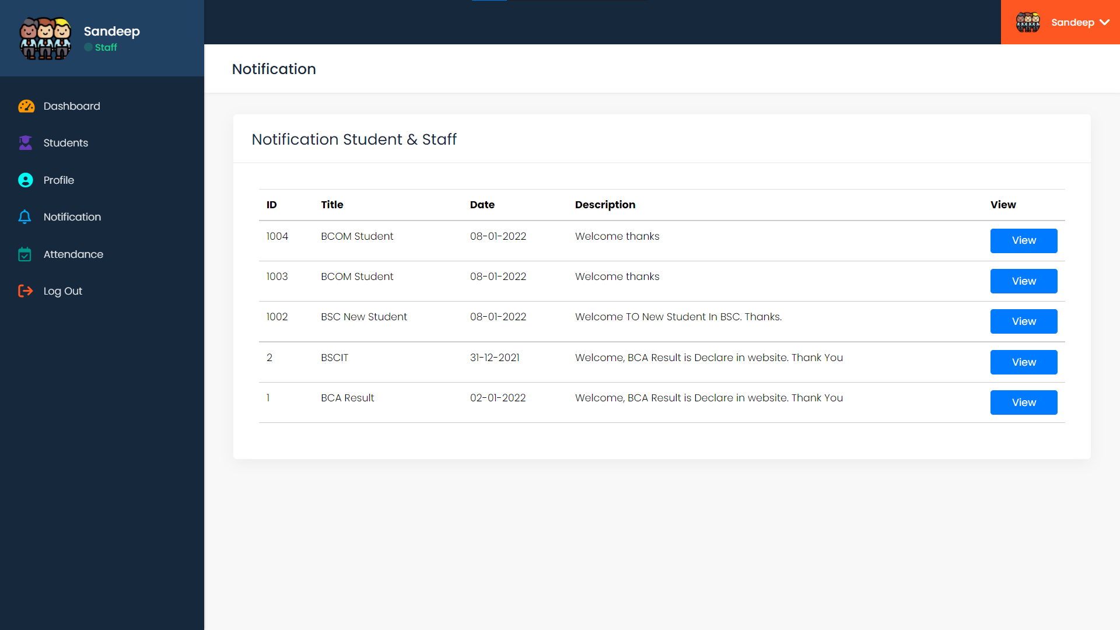

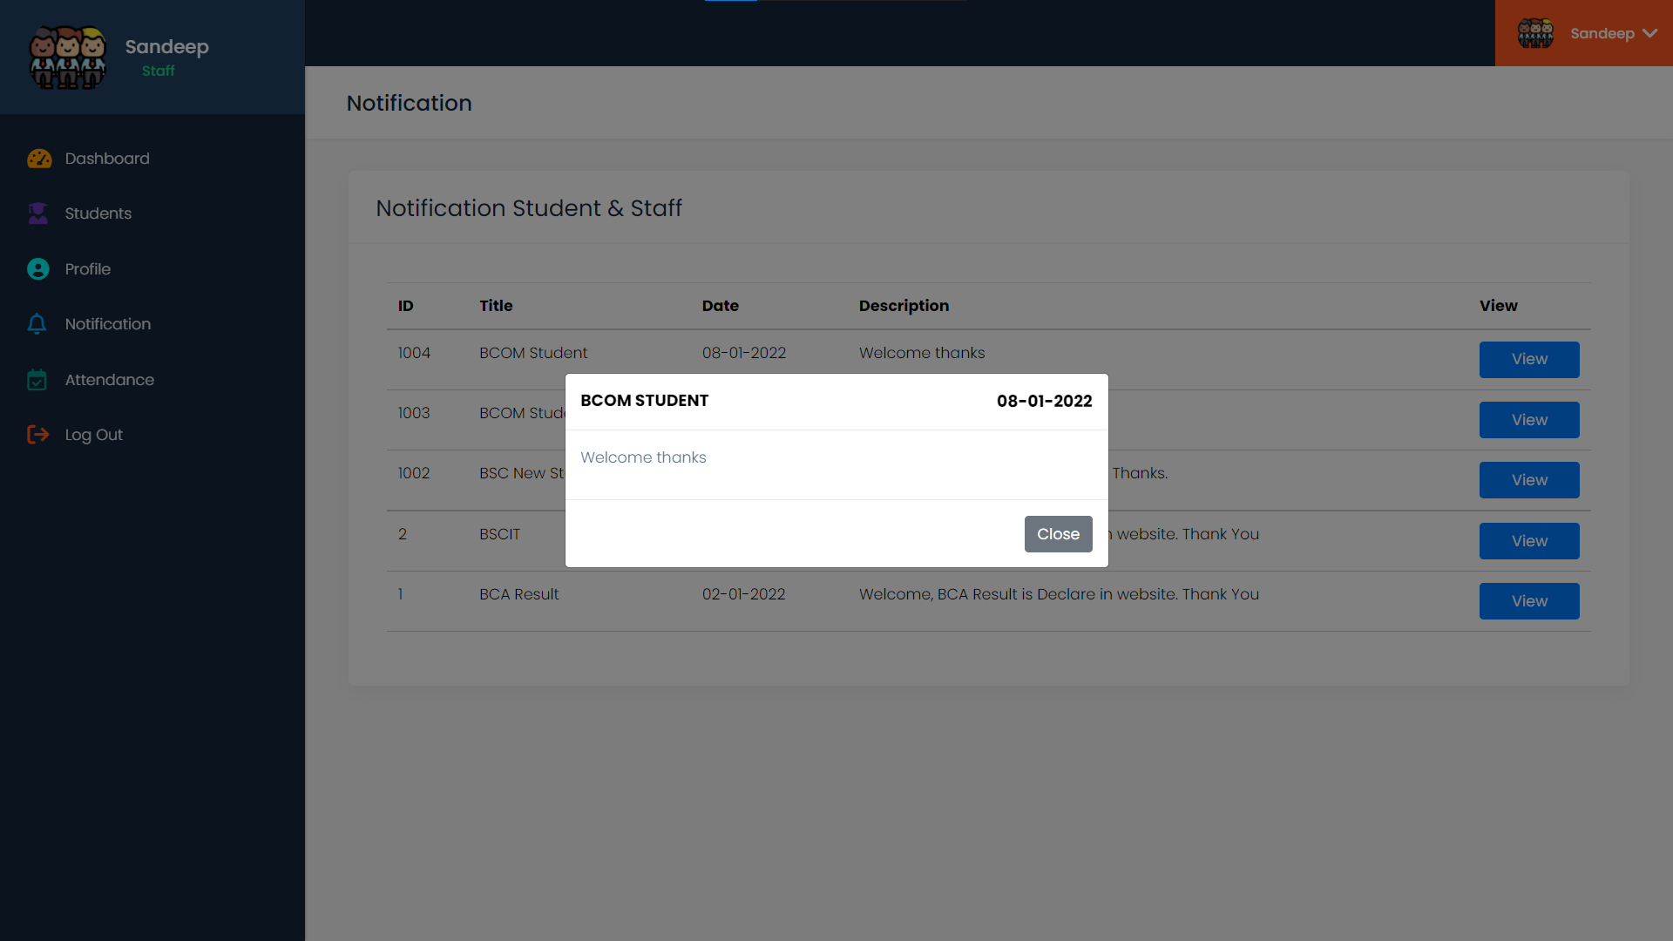

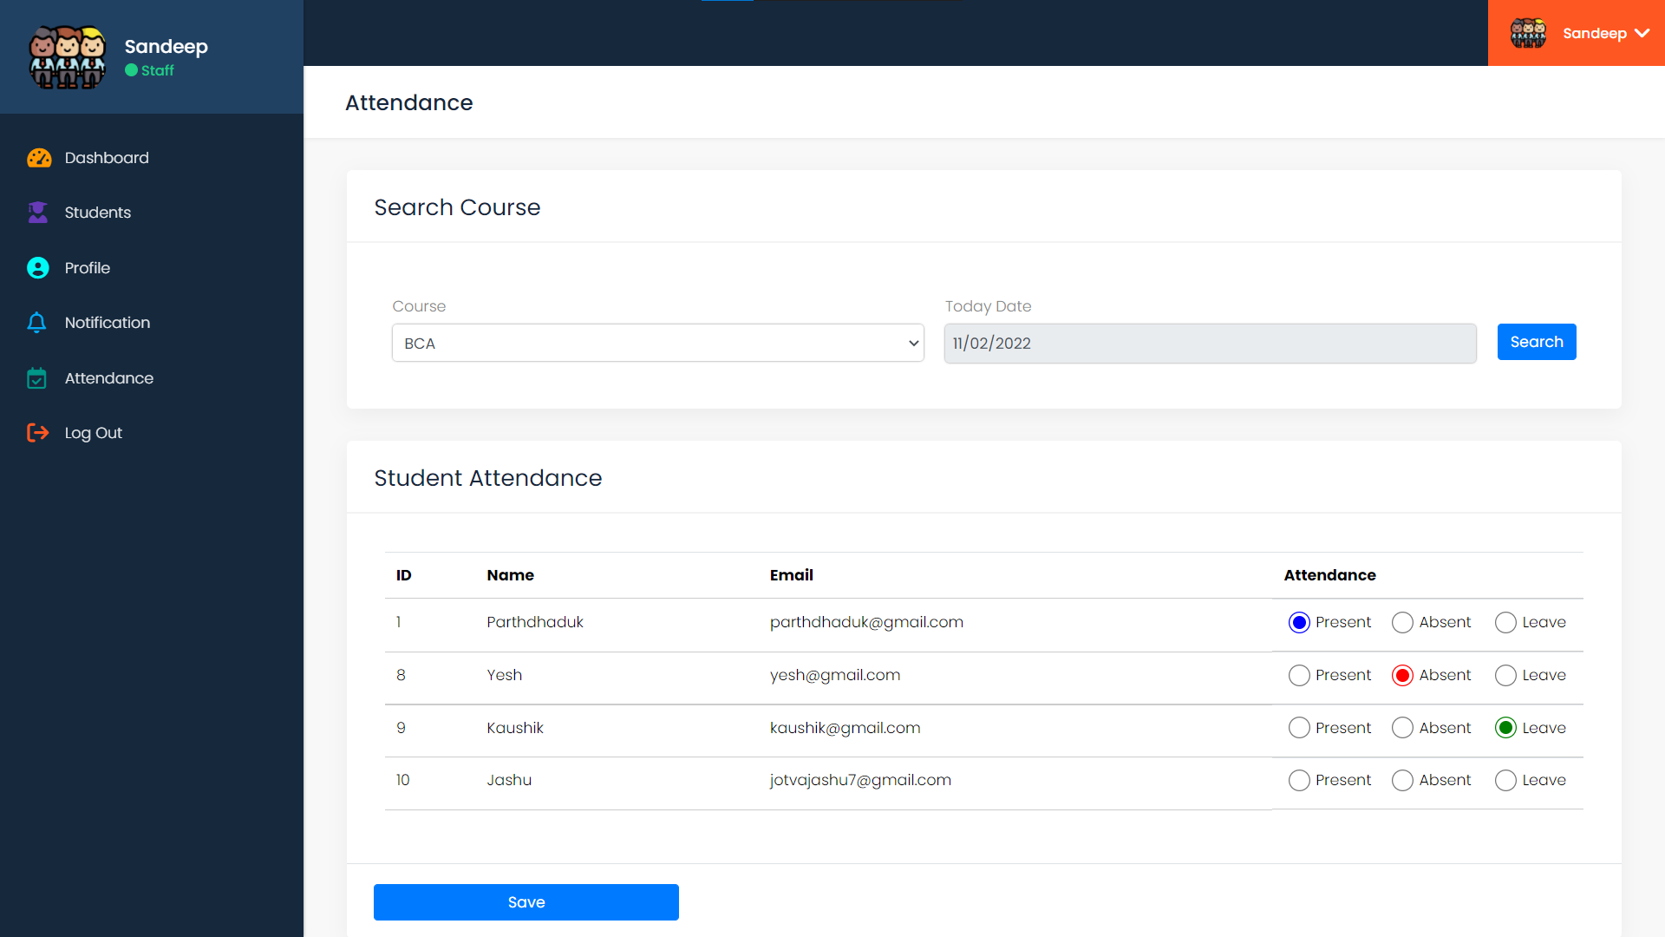

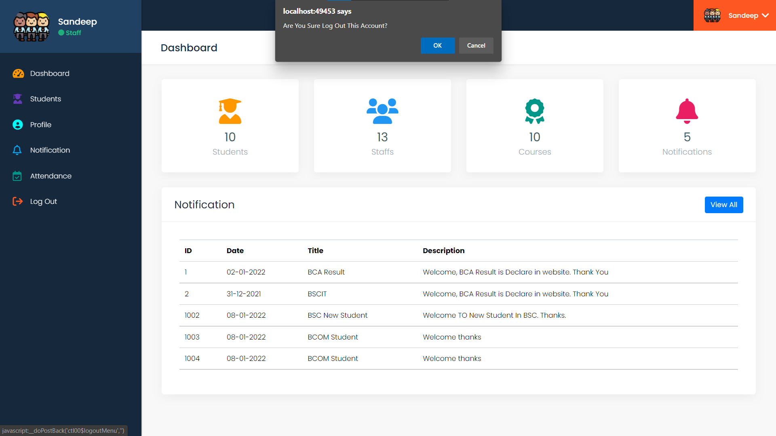

**STUDENT LAYOUTS**

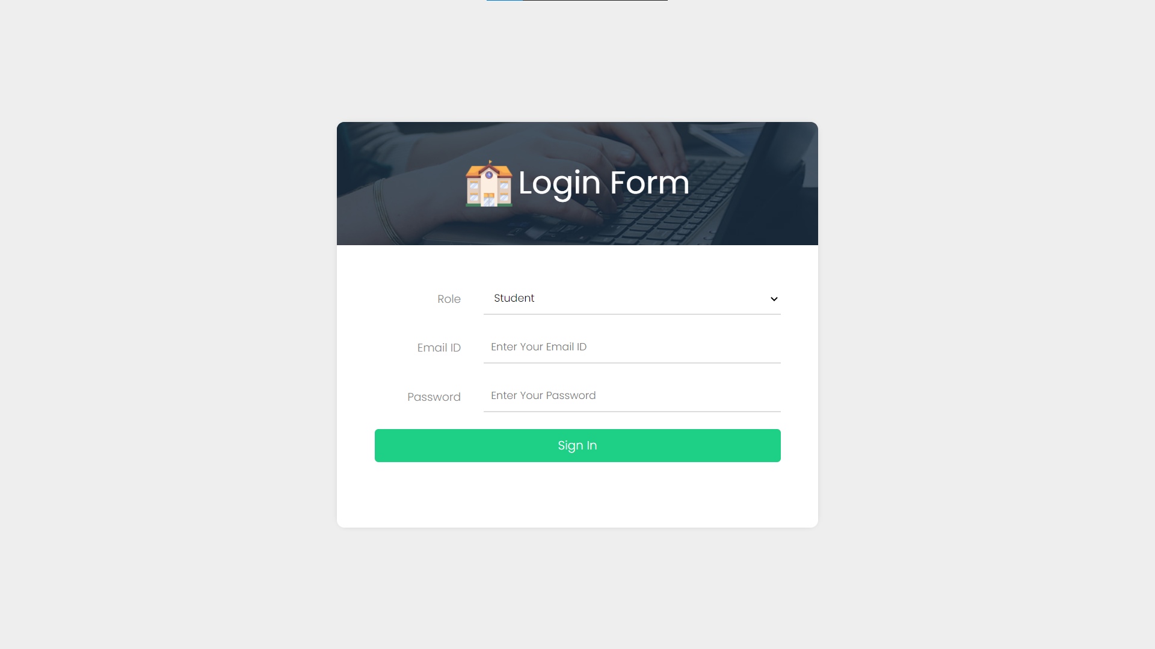

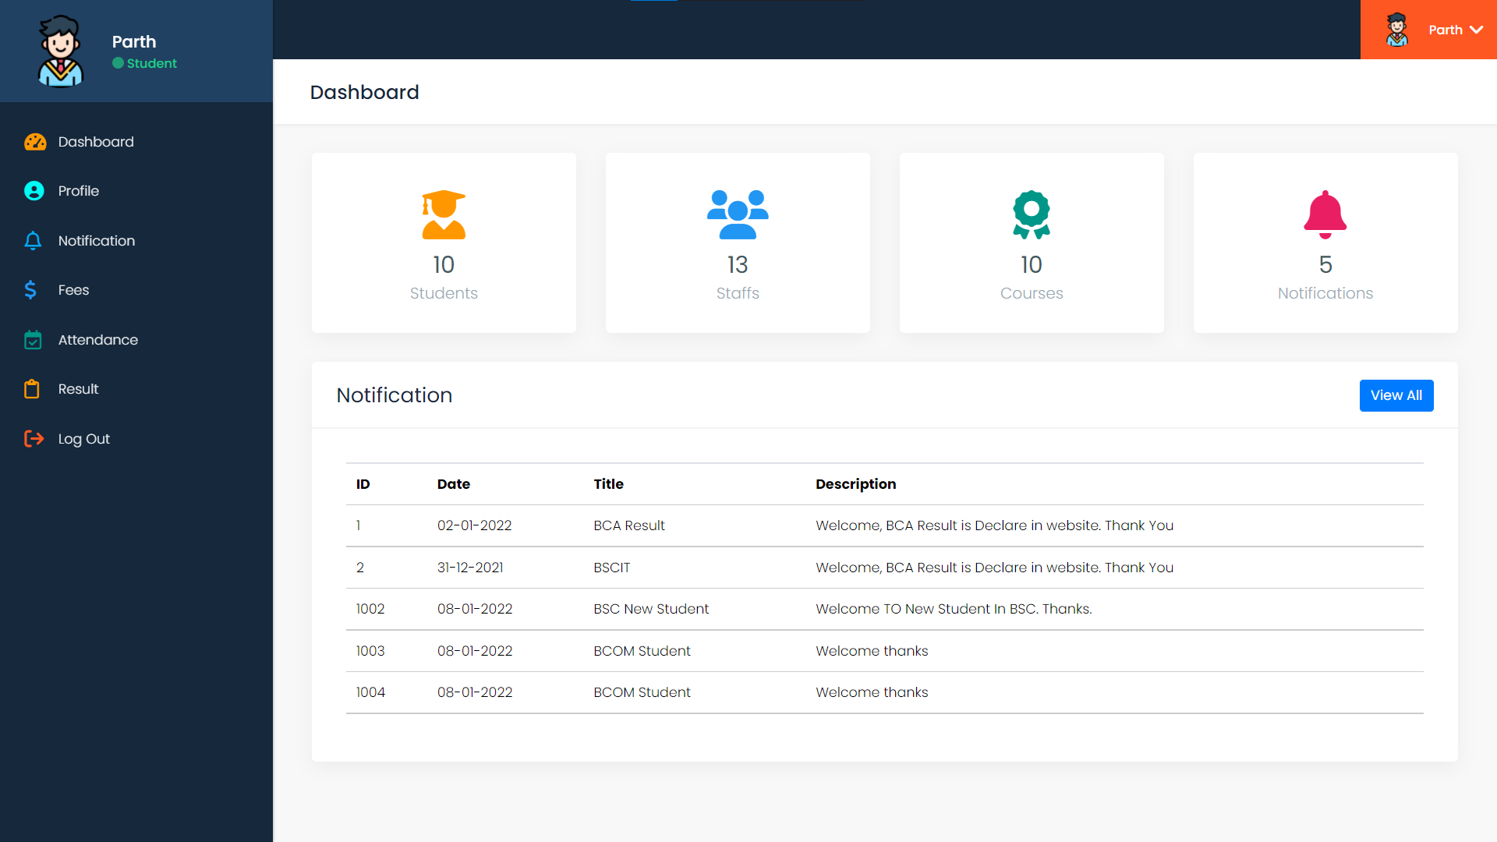

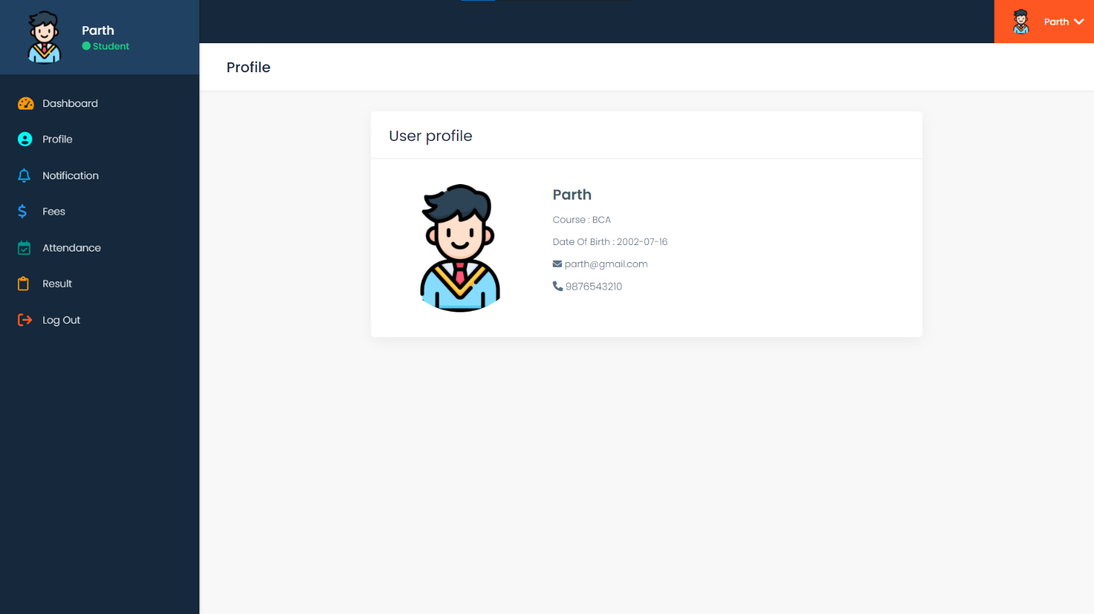

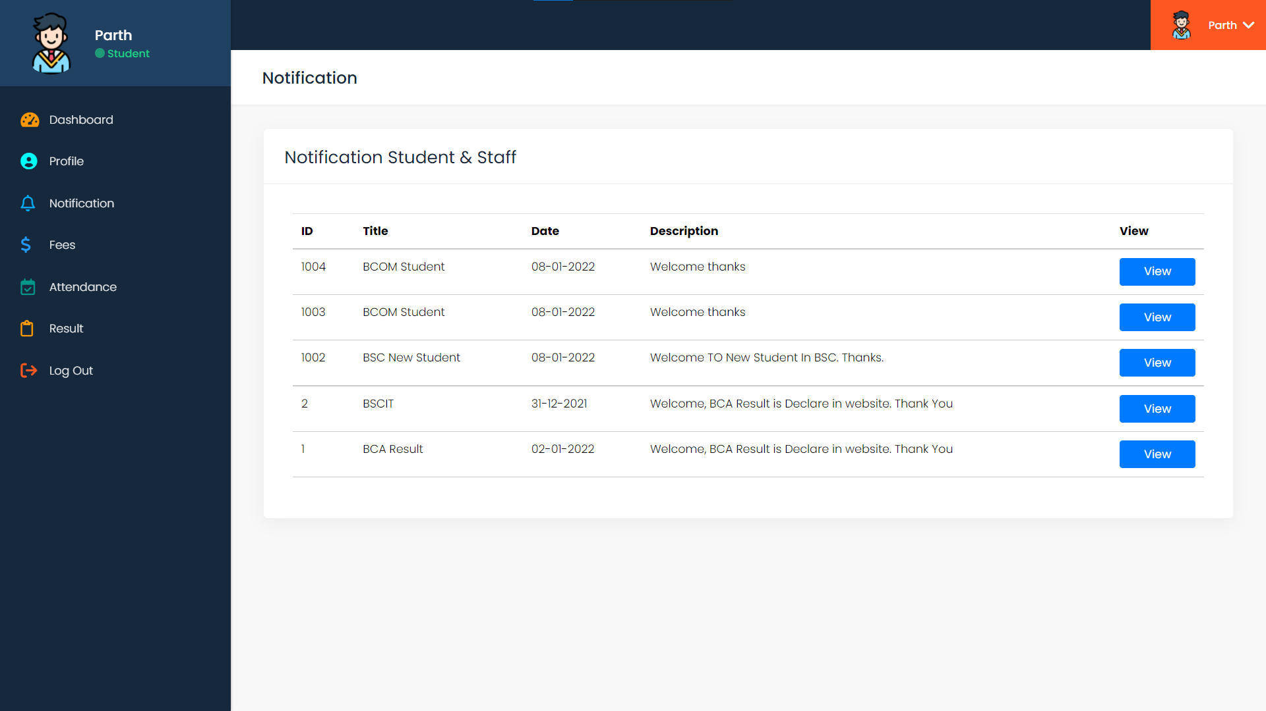

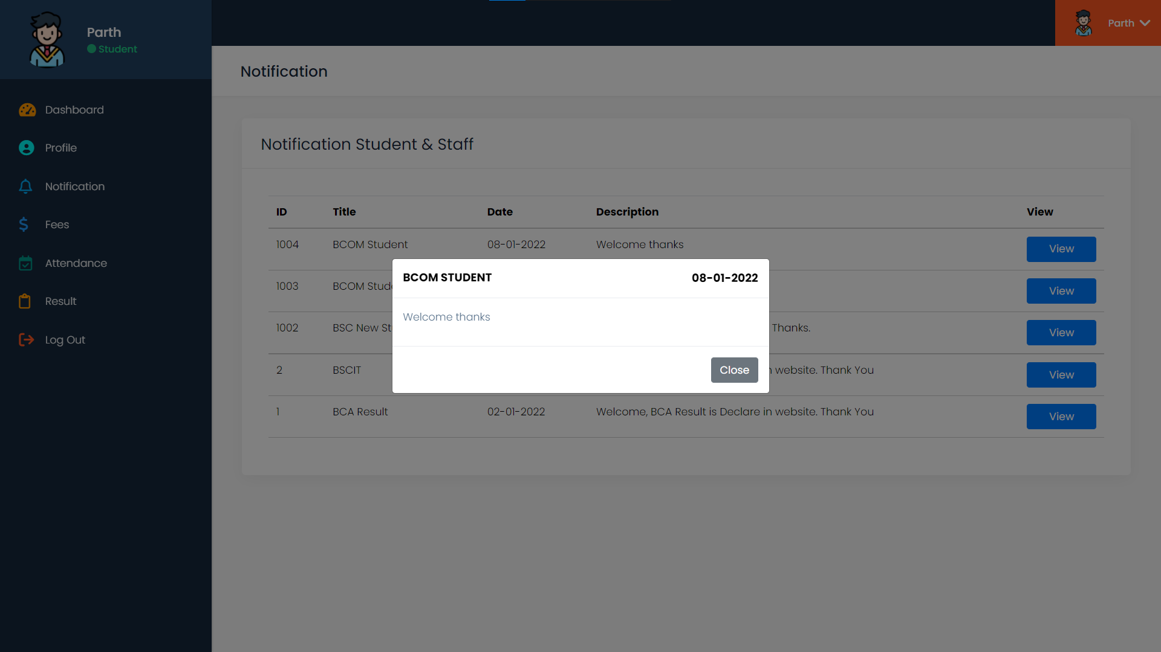

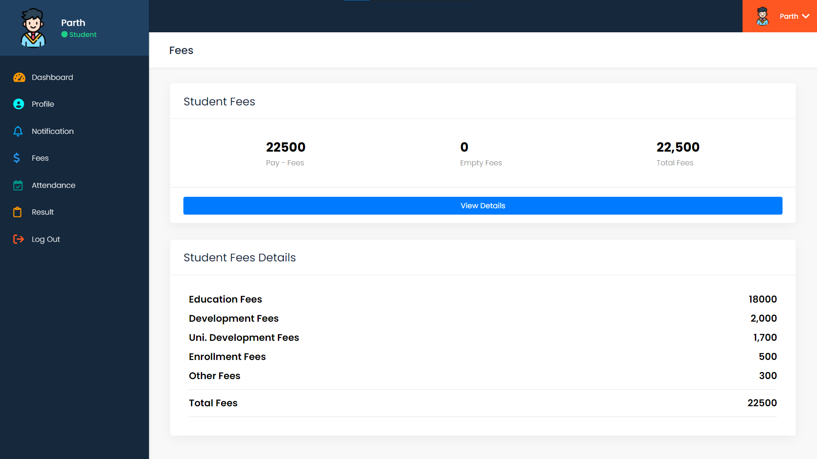

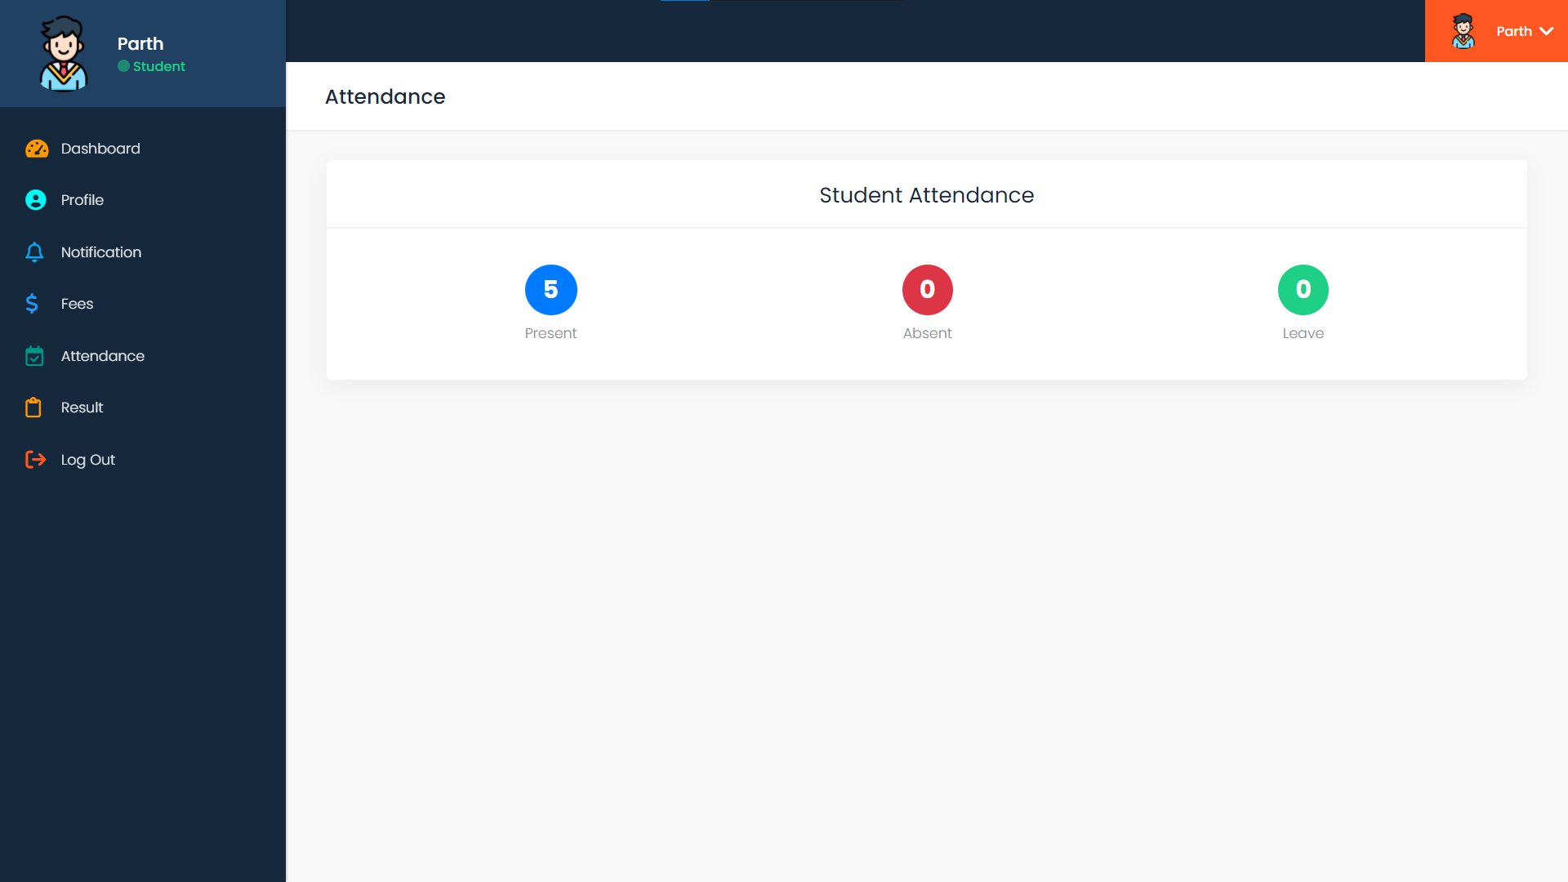

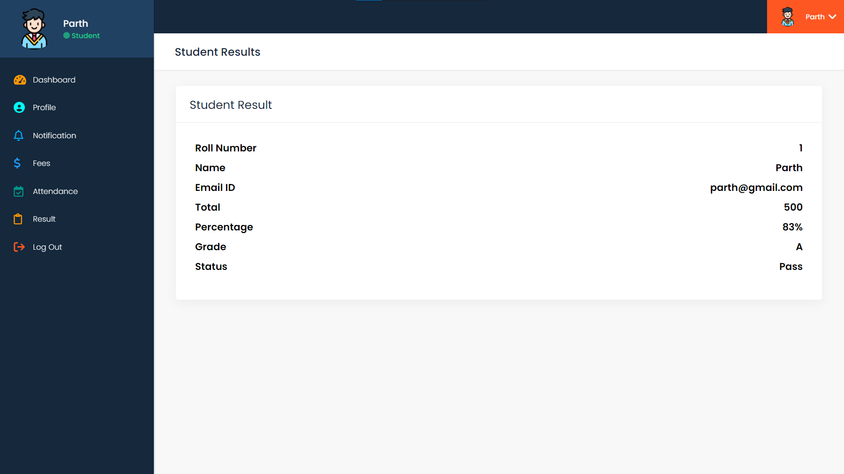

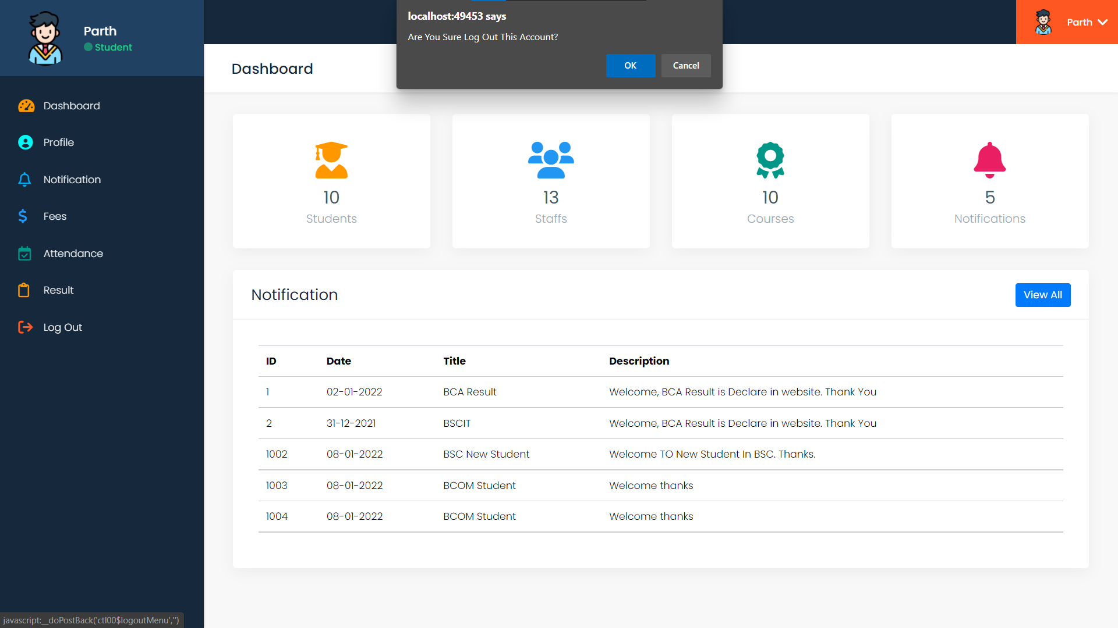

**LOGIN PAGE**

**CODING**

using System;

using System.Collections.Generic;

using System.Linq;

using System.Web;

using System.Web.UI;

using System.Web.UI.WebControls;

using System.Web.Configuration;

using System.Data;

using System.Data.SqlClient;

public partial class loginPage : System.Web.UI.Page {

SqlConnection con;

SqlCommand cmd;

SqlDataReader dr;

protected void Page_Load(object sender, EventArgs e) {

con = new SqlConnection(WebConfigurationManager.ConnectionStrings["conn"].ToString());

}

/* =============== LOGIN BUTTON CLICK EVENT =============== */

protected void btnLogin_Click(object sender, EventArgs e) {

con.Open();

if(loginRole.Text=="" || loginEmail.Text=="" || loginPassword.Text=="") {

Response.Write("<script>alert('Please Enter Values In Fills');</script>");

}

else {

if (loginRole.Text == "Staff")

{

String checkLoginQuery = "SELECT * FROM StaffTB WHERE EEmail='" + loginEmail.Text + "' AND EPassword='" + loginPassword.Text + "' AND roles = 'Staff' AND remove_status='0'";

cmd = new SqlCommand(checkLoginQuery, con);

dr = cmd.ExecuteReader();

if (dr.Read()) {

String username = dr["EName"].ToString();

Session["username"] = username;

Session["userrole"] = "Staff";

Response.Redirect("Default.aspx");

}

else {

Response.Write("<script>alert('Please! Current Username And Password???');</script>");

}

loginRole.Text = "";

loginEmail.Text = "";

loginPassword.Text = "";

con.Close();

}

else if(loginRole.Text == "Student") {

String checkLoginQuery = "SELECT * FROM StudentTB WHERE SEmail='" + loginEmail.Text + "' AND SPassword='" + loginPassword.Text + "' AND remove_status='0'";

cmd = new SqlCommand(checkLoginQuery, con);

dr = cmd.ExecuteReader();

if (dr.Read()) {

String username = dr["SName"].ToString();

Session["username"] = username;

Session["userrole"] = "Student";

Response.Redirect("Default.aspx");

}

else {

Response.Write("<script>alert('Please! Current Username And Password???');</script>");

}

loginRole.Text = "";

loginEmail.Text = "";

loginPassword.Text = "";

con.Close();

}

else if(loginRole.Text == "Admin") {

String checkLoginQuery = "SELECT * FROM StaffTB WHERE EEmail='" + loginEmail.Text + "' AND EPassword='" + loginPassword.Text + "' AND roles = 'Admin' AND remove_status='0'";

cmd = new SqlCommand(checkLoginQuery, con);

dr = cmd.ExecuteReader();

if (dr.Read()) {

String username = dr["EName"].ToString();

Session["username"] = username;

Session["userrole"] = "Admin";

Response.Redirect("Default.aspx");

}

else {

Response.Write("<script>alert('Please! Current Username And Password???');</script>");

}

loginRole.Text = "";

loginEmail.Text = "";

loginPassword.Text = "";

con.Close();

}

Else {

loginRole.Text = "";

loginEmail.Text = "";

loginPassword.Text = "";

con.Close();

Response.Write("<script>alert('Please! Enter The Current Value In Fills...');</script>");

}

}

}

}

**DASHBOARD PAGE**

using System;

using System.Collections.Generic;

using System.Linq;

using System.Web;

using System.Web.UI;

using System.Web.UI.WebControls;

using System.Web.Configuration;

using System.Data;

using System.Data.SqlClient;

public partial class _Default : System.Web.UI.Page {

SqlConnection con;

SqlCommand cmd;

SqlDataReader dr;

DataTable dt;

protected void Page_Load(object sender, EventArgs e) {

if (Session["username"] == null || Session["userrole"] == null) {

Response.Redirect("loginPage.aspx");

}

else {

con = new SqlConnection(WebConfigurationManager.ConnectionStrings["conn"].ToString());

AllCount();

displayStaffData();

displayNotificationData();

displayStudentData();

String userrole = Session["userrole"].ToString();

if(userrole == "Staff" || userrole == "Student") {

deshboardStaff.Visible = false;

deshboardStudent.Visible = false;

}

}

}

/* ===== TOP 5 NOTIFICATION RECORD IN GRIDVIEW IN DASHBORD =====*/

private void displayNotificationData()

{

con.Open();

String displayDataQuery = "SELECT TOP 5 NId AS ID,NDate AS Date, NTitle AS Title, NDescription AS Description FROM NotificationTB WHERE remove_status='0'";

cmd = new SqlCommand(displayDataQuery, con);

dr = cmd.ExecuteReader();

dt = new DataTable();

dt.Load(dr);

notificationDATA.DataSource = dt;

notificationDATA.DataBind();

con.Close();

}

/* ===== TOP 5 STAFF RECORD IN GRIDVIEW IN DASHBORD =====*/

private void displayStaffData() {

con.Open();

String displayDataQuery = "SELECT top 5 EId AS ID, EName AS Name,EEmail AS EmailID,EMobile AS Mobile, ECourse AS Course, roles AS Role FROM StaffTB WHERE remove_status='0'";

cmd = new SqlCommand(displayDataQuery, con);

dr = cmd.ExecuteReader();

dt = new DataTable();

dt.Load(dr);

StaffDATA.DataSource = dt;

StaffDATA.DataBind();

con.Close();

}

/* ===== TOP 5 STUDENT RECORD IN GRIDVIEW IN DASHBORD ===== */

private void displayStudentData()

{

con.Open();

String displayDataQuery = "SELECT TOP 5 SRNo AS ID, SName AS Name, SEmail AS EmailID, SCourse AS Course, SMobile AS Mobile, SDOB AS DOB FROM StudentTB WHERE remove_status='0'";

cmd = new SqlCommand(displayDataQuery, con);

dr = cmd.ExecuteReader();

dt = new DataTable();

dt.Load(dr);

StudentDATA.DataSource = dt;

StudentDATA.DataBind();

con.Close();

}

/* ===== ALL STAFF STUDENT AND NOTIFICATION RECOND COUNT METHOD =====*/

private void AllCount() {

con.Open();

String stuCountQuery = "SELECT count(*) FROM StudentTB WHERE remove_status='0'";

cmd = new SqlCommand(stuCountQuery, con);

int CStuNo = (int)cmd.ExecuteScalar();

StuNO.InnerText = CStuNo.ToString();

String stfCountQuery = "SELECT count(*) FROM StaffTB WHERE remove_status='0'";

cmd = new SqlCommand(stfCountQuery, con);

int CStfNo = (int)cmd.ExecuteScalar();

StaNo.InnerText = CStfNo.ToString();

String notiCountQuery = "SELECT count(*) FROM NotificationTB WHERE remove_status='0'";

cmd = new SqlCommand(notiCountQuery, con);

int CNotNo = (int)cmd.ExecuteScalar();

NotiNO.InnerText = CNotNo.ToString();

con.Close();

}

}

**STAFF PAGE**

using System;

using System.Collections.Generic;

using System.Linq;

using System.Web;

using System.Web.UI;

using System.Web.UI.WebControls;

using System.Web.Configuration;

using System.Data;

using System.Data.SqlClient;

using System.Net;

using System.Net.Mail;

public partial class staffPage : System.Web.UI.Page {

SqlConnection con;

SqlCommand cmd;

SqlDataReader dr;

DataTable dt;

protected void Page_Load(object sender, EventArgs e) {

if (Session["username"] == null || Session["userrole"] == null) {

Response.Redirect("loginPage.aspx"); }

else {

String userrole = Session["userrole"].ToString();

newBox.Visible = false;

if(userrole == "Staff" || userrole == "Student") {

Response.Redirect("404Page.aspx");

}

con = new SqlConnection(WebConfigurationManager.ConnectionStrings["conn"].ToString());

FetchStaffData();

}

}

/* ===== NEW STUDENT FORM SHOW NEW BUTTON CLICK EVENT =====*/

protected void newBtn_Click(object sender, EventArgs e) {

newBox.Visible = true;

}

/* ===== NEW STUDENT FORM SHOW CLOSE BUTTON CLICK EVENT ===== */

protected void close_Click(object sender, EventArgs e) {

newBox.Visible = false;

}

/* ===== FETCH ALL STAFF GRID VIEW DATA =====*/

private void FetchStaffData() {

con.Open();

String Gridviewstring = "select * from StaffTB where remove_status = '0'";

cmd = new SqlCommand(Gridviewstring, con);

dr = cmd.ExecuteReader();

dt = new DataTable();

dt.Load(dr);

StaffDATA.DataSource = dt;

StaffDATA.DataBind();

con.Close();

}

/* ===== SAVE BUTTON CLICK EVENT ===== */

protected void SaveStaff_Click(object sender, EventArgs e) {

if (EditSName.Text == "" || EditSEmail.Text == "" || EditSMobile.Text == "" || EditSRoles.SelectedItem.Text == "" || EditSCourse.SelectedItem.Text == "" || EditSPassword.Text == "")

{

ClientScript.RegisterStartupScript(this.GetType(), "randomtext", "alertEmpty()", true);

}

else {

con.Open();

String CheckEmailQuery = "SELECT * FROM StaffTB WHERE EEmail='" + EditSEmail.Text + "'";

cmd = new SqlCommand(CheckEmailQuery, con);

dr = cmd.ExecuteReader();

if (dr.Read()) {

dr.Close();

Response.Write("<script>alert('"+EditSEmail.Text+" is All Ready Exists!!!');</script>");

}

else {

dr.Close();

String saveQuery = "INSERT INTO StaffTB(EName,ECourse,EEmail,EMobile,EPassword,roles,remove_status) VALUES('" + EditSName.Text + "','" + EditSCourse.SelectedItem.Text + "','" + EditSEmail.Text + "','" + EditSMobile.Text + "','" + EditSPassword.Text + "','" + EditSRoles.Text + "','0')";

cmd = new SqlCommand(saveQuery, con);

int res = cmd.ExecuteNonQuery();

if (res > 0) {

con.Close();

FetchStaffData();

SendEmail();

ClientScript.RegisterStartupScript(this.GetType(), "randomtext", "alertSuccess(),Hide()", true);

}

else {

FetchStaffData();

ClientScript.RegisterStartupScript(this.GetType(), "randomtext", "alertError(),Hide()", true);

con.Close();

FetchStaffData();

}

EditSName.Text = "";

EditSCourse.Text = "";

EditSEmail.Text = "";

EditSMobile.Text = "";

EditSPassword.Text = "";

EditSRoles.Text = "";

}

}

}

/* ===== EMAIL SEND METHOS ===== */

private void SendEmail() {

String mailBody = "<!DOCTYPE html>" + "<html>" + "<body>" +

"<span style='font-size: 20px'>PATEL School In Ahemadabad</span>" + "<hr>" +

"<h4>Welcome To '" + EditSName.Text + "'</h4>" +

"<h4>Your Name Is '" + EditSName.Text + "'</h4>" +

"<h4>Your EmailID / Username Is '" + EditSEmail.Text + "'</h4>" +

"<h4>Your Mobile Is '" + EditSMobile.Text + "'</h4>" +

"<h4>Your Role Is '" + EditSRoles.Text + "'</h4>" +

"<h4>Your Course Is '" + EditSCourse.Text + "'</h4>" +

"<h4>Your Password Is '" + EditSPassword.Text + "'</h4>" +

"</body>" + "</html>";

SmtpClient smtp = new SmtpClient();

smtp.Host = "smtp.gmail.com";

smtp.Port = 587;

smtp.Credentials = new System.Net.NetworkCredential("Your Email ID", "Email ID Password");

smtp.EnableSsl = true;

MailMessage msg = new MailMessage();

msg.Subject = "New Staff Letter";

msg.Body = mailBody;

msg.IsBodyHtml = true;

string toaddress = EditSEmail.Text;

msg.To.Add(toaddress);

String fromaddress = "Patel School <parthdhaduk2456@gmail.com>";

msg.From = new MailAddress(fromaddress);

try {

smtp.Send(msg);

}

catch {

throw;

}

}

/* ===== SEARCH BUTTON CLICK EVENT ===== */

protected void SearchBtn_Click(object sender, EventArgs e)

{

if (Searchtxt.Text == "") {

FetchStaffData();

}

else {

con.Open();

String searchQuery = "SELECT * FROM StaffTB WHERE EName='"+Searchtxt.Text+"' OR EEmail = '"+Searchtxt.Text+"' OR ECourse='"+Searchtxt.Text+"' OR roles='"+Searchtxt.Text+"' AND remove_status='0'";

cmd = new SqlCommand(searchQuery, con);

dr = cmd.ExecuteReader();

dt = new DataTable();

dt.Load(dr);

StaffDATA.DataSource = dt;

StaffDATA.DataBind();

Searchtxt.Text = "";

con.Close();

}

}

/* ===== GRID VIEW DELETE BUTTON CLICK EVENT ===== */

protected void GVBtnDelete_Click(object sender, EventArgs e)

{

int rowIndex = ((GridViewRow)(sender as Control).NamingContainer).RowIndex;

int i = Convert.ToInt32(StaffDATA.Rows[rowIndex].Cells[0].Text);

con.Open();

String deleteQuery = "UPDATE StaffTB SET remove_status='1' WHERE EId='" + i + "'";

cmd = new SqlCommand(deleteQuery, con);

int res = cmd.ExecuteNonQuery();

if (res > 0)

{

ClientScript.RegisterStartupScript(this.GetType(), "random", "alertSuccess()", true);

con.Close();

FetchStaffData();

}

else

{

ClientScript.RegisterStartupScript(this.GetType(), "random", "alertError()", true);

con.Close();

FetchStaffData();

}

}

/* ===== GRID VIEW UPDATE BUTTON CLICK EVENT ===== */

protected void GVBtnUpdate_Click(object sender, EventArgs e)

{

newBox.Visible = false;

ClientScript.RegisterStartupScript(this.GetType(), "random", "modelShow()", true);

int rowIndex = ((GridViewRow)(sender as Control).NamingContainer).RowIndex;

int i = Convert.ToInt32(StaffDATA.Rows[rowIndex].Cells[0].Text);

con.Open();

String updateQuery = "SELECT * FROM StaffTB WHERE EId='" + i + "' AND remove_status='0'";

cmd = new SqlCommand(updateQuery, con);

dr = cmd.ExecuteReader();

if (dr.Read()) {

viewID.Text = dr["EId"].ToString();

viewName.Text = dr["EName"].ToString();

viewEmail.Text = dr["EEmail"].ToString();

viewRole.Text = dr["roles"].ToString();

viewCourse.Text = dr["ECourse"].ToString();

viewPassword.Text = dr["EPassword"].ToString();

con.Close();

}

}

/* ===== VIEW MODEL UPDATE BUTTON CLICK EVENT ===== */

protected void btnViewUpdate_Click(object sender, EventArgs e)

{

if (viewID.Text == "" || viewName.Text == "" || viewEmail.Text == "" || viewRole.Text == "" || viewCourse.Text==""|| viewPassword.Text == "")

{

ClientScript.RegisterStartupScript(this.GetType(), "random", "alertEmpty()", true);

}

else{

con.Open();

String updateQuery = "UPDATE StaffTB SET EName='" + viewName.Text + "', EEmail='" + viewEmail.Text + "', ECourse='" + viewCourse.Text + "',roles='" + viewRole.Text + "', EPassword='" + viewPassword.Text + "' WHERE EId='" + viewID.Text + "' AND remove_status='0'";

cmd = new SqlCommand(updateQuery, con);

int res = cmd.ExecuteNonQuery();

if (res > 0){

ClientScript.RegisterStartupScript(this.GetType(), "random", "alertSuccess()", true);

con.Close();

FetchStaffData();

}

else{

ClientScript.RegisterStartupScript(this.GetType(), "random", "alertError()", true);

con.Close();

FetchStaffData();

}

viewName.Text = "";

viewEmail.Text = "";

viewRole.Text = "";

viewCourse.Text = "";

viewPassword.Text = "";

}

}

}

**STUDENT PAGE**

using System;

using System.Collections.Generic;

using System.Linq;

using System.Web;

using System.Web.UI;

using System.Web.UI.WebControls;

using System.Data;

using System.Data.SqlClient;

using System.Web.Configuration;

using System.Net;

using System.Net.Mail;

public partial class studentPage : System.Web.UI.Page {

SqlConnection con;

SqlCommand cmd;

SqlDataReader dr;

DataTable dt;

protected void Page_Load(object sender, EventArgs e) {

if (Session["username"] == null || Session["userrole"] == null) {

Response.Redirect("loginPage.aspx");

}

else {

con = new SqlConnection(WebConfigurationManager.ConnectionStrings["conn"].ToString());

FetchSDisplayData();

String userrole = Session["userrole"].ToString();

newBox.Visible = false;

getRollno();

if(userrole=="Staff") {

menuIcon.Visible = false;

StudentDATA.Columns[6].Visible = false;

StudentDATA.Columns[7].Visible = false;

}

else if(userrole == "Student") {

Response.Redirect("404Page.aspx");

}

}

}

/* ===== GET THE ROLL NO IN NEXT ROLL NO ===== */

private void getRollno() {

con.Open();

String getRollNo = "SELECT SRNo FROM StudentTB ORDER BY SRNo DESC";

cmd = new SqlCommand(getRollNo, con);

dr = cmd.ExecuteReader();

dr.Read();

int grno = Convert.ToInt32(dr["SRNo"].ToString()) + 1;

EditRNo.Text = grno.ToString();

dr.Close();

con.Close();

}

/* ===== Edit Roll No BUTTON CLICK EVENT ===== */

protected void EditRnoBox_Click(object sender, EventArgs e) {

if(EditRNo.ReadOnly == true) {

EditRNo.ReadOnly = false; }

else {

EditRNo.ReadOnly = true; }

newBox.Visible = true;

}

/* ===== NEW STUDENT FORM SHOW NEW BUTTON CLICK EVENT ===== */

protected void newBtn_Click(object sender, EventArgs e) {

newBox.Visible = true;

}

/* ===== NEW STUDENT FORM SHOW CLOSE BUTTON CLICK EVENT ===== */

protected void closeStudent_Click(object sender, EventArgs e) {

newBox.Visible=false; }

/* ===== DISPLAY DATA IN GRID VIWE DATA ===== */

private void FetchSDisplayData() {

con.Open();

String SDisplay = "SELECT * from StudentTB WHERE remove_status='0'";

cmd = new SqlCommand(SDisplay, con);

dr = cmd.ExecuteReader();

dt = new DataTable();

dt.Load(dr);

StudentDATA.DataSource = dt;

StudentDATA.DataBind();

dr.Close();

con.Close();

}

/* ===== SAVE STUDENT RECORD IN DATABASE ===== */

protected void saveStudent_Click(object sender, EventArgs e) {

if (EditRNo.Text=="" || EditSName.Text == "" || EditSEmail.Text == "" || EditSMobile.Text == "" || EditSDOB.Text == "" || EditSPassword.Text=="") {

ClientScript.RegisterStartupScript(this.GetType(), "random", "alertEmpty()", true);

}

else {

con.Open();

String checkDeleteQuery = "SELECT SRNo,remove_status FROM StudentTB WHERE SRNo='" + EditRNo.Text + "' AND remove_status='1'";

cmd = new SqlCommand(checkDeleteQuery, con);

dr = cmd.ExecuteReader();

if (dr.Read()) {

dr.Close();

String updateQuery = "UPDATE StudentTB SET SName='" + EditSName.Text + "',SEmail='" + EditSEmail.Text + "',SMobile='" + EditSMobile.Text + "',SDOB='" + EditSDOB.Text + "',SCourse='" + EditSCourse.Text + "',SPassword='" + EditSPassword.Text + "',remove_status='0' WHERE SRNo='" + EditRNo.Text + "' AND remove_status='1'";

cmd = new SqlCommand(updateQuery, con);

int res = cmd.ExecuteNonQuery();

if (res > 0) {

con.Close();

ClientScript.RegisterStartupScript(this.GetType(), "random", "alertSuccess()", true);

FetchSDisplayData();

}

else {

con.Close();

ClientScript.RegisterStartupScript(this.GetType(), "random", "alertError()", true);

FetchSDisplayData();

}

}

else {

dr.Close();

String checkRNo = "SELECT SRNo,remove_status FROM StudentTB WHERE SRNo='" + EditRNo.Text + "' AND remove_status='0'";

cmd = new SqlCommand(checkRNo, con);

dr = cmd.ExecuteReader();

if (dr.Read()) {

con.Close();

ClientScript.RegisterStartupScript(this.GetType(), "random", "alertError()", true);

FetchSDisplayData();

}

else {

dr.Close();

String saveQuery = "INSERT INTO StudentTB(SRNo,SName,SEmail,SMobile,SDOB,SCourse,SPassword,remove_status) VALUES('" + EditRNo.Text + "','" + EditSName.Text + "','" + EditSEmail.Text + "','" + EditSMobile.Text + "','" + EditSDOB.Text + "','" + EditSCourse.Text + "','" + EditSPassword.Text + "','0')";

cmd = new SqlCommand(saveQuery, con);

int res = cmd.ExecuteNonQuery();

if (res > 0) {

con.Close();

SendEmail();

ClientScript.RegisterStartupScript(this.GetType(), "random", "alertSuccess()", true);

FetchSDisplayData();

}

else {

ClientScript.RegisterStartupScript(this.GetType(), "random", "alertError()", true);

con.Close();

FetchSDisplayData();

}

EditRNo.Text = "";

EditSName.Text = "";

EditSEmail.Text = "";

EditSMobile.Text = "";

EditSDOB.Text = "";

EditSCourse.Text = "";

}

}

}

}

/* ===== EMAIL SEND METHOS ===== */

private void SendEmail()

{

String mailBody = "<!DOCTYPE html>" + "<html>" + "<body>" +

"<span style='font-size: 20px'>PATEL School In Ahemadabad</span>" + "<hr>" +

"<h4>Welcome To '" + EditSName.Text + "'</h4>" +

"<h4>Your Name Is '" + EditSName.Text + "'</h4>" +

"<h4>Your EmailID / Username Is '" + EditSEmail.Text + "'</h4>" +

"<h4>Your Mobile Is '" + EditSMobile.Text + "'</h4>" +

"<h4>Your Role Is 'Student'</h4>" +

"<h4>Your Course Is '" + EditSCourse.Text + "'</h4>" +

"<h4>Your Password Is '" + EditSPassword.Text + "'</h4>" +

"</body>" + "</html>";

SmtpClient smtp = new SmtpClient();

smtp.Host = "smtp.gmail.com";

smtp.Port = 587;

smtp.Credentials = new System.Net.NetworkCredential("Your EmailID", "Email ID Password");

smtp.EnableSsl = true;

MailMessage msg = new MailMessage();

msg.Subject = "New Student Letter";

msg.Body = mailBody;

msg.IsBodyHtml = true;

string toaddress = EditSEmail.Text;

msg.To.Add(toaddress);

String fromaddress = "Patel School <parthdhaduk2456@gmail.com>";

msg.From = new MailAddress(fromaddress);

try {

smtp.Send(msg);

}

Catch {

throw;

}

}

/* ===== SEARCH BUTTON CLICK EVENT ===== */

protected void searchbtn_Click(object sender, EventArgs e) {

if (searchName.Text == "") {

FetchSDisplayData();

}

else {

con.Open();

String searchQuery = "SELECT * FROM StudentTB WHERE SName='" + searchName.Text + "' OR SEmail='" + searchName.Text + "' OR SCourse='" + searchName.Text + "' AND remove_status='0'";

cmd = new SqlCommand(searchQuery, con);

dr = cmd.ExecuteReader();

dt = new DataTable();

dt.Load(dr);

StudentDATA.DataSource = dt;

StudentDATA.DataBind();

searchName.Text = "";

con.Close();

}

}

/* ===== GRID VIEW DELETE BUTTON CLICK EVENT ===== */

protected void GVBtnDelete_Click(object sender, EventArgs e) {

int rowIndex = ((GridViewRow)(sender as Control).NamingContainer).RowIndex;

int i = Convert.ToInt32(StudentDATA.Rows[rowIndex].Cells[0].Text);

con.Open();

String deleteQuery = "UPDATE StudentTB SET remove_status='1' WHERE SRNo='" + i + "'";

cmd = new SqlCommand(deleteQuery, con);

int res = cmd.ExecuteNonQuery();

if (res > 0) {

ClientScript.RegisterStartupScript(this.GetType(), "random", "alertSuccess()", true);

}

else {

ClientScript.RegisterStartupScript(this.GetType(), "random", "alertError()", true); }

con.Close();

FetchSDisplayData();

}

/* ===== GRID VIEW UPDATE BUTTON CLICK EVENT ===== */

protected void GVBtnUpdate_Click(object sender, EventArgs e) {

newBox.Visible = false;

ClientScript.RegisterStartupScript(this.GetType(), "random", "modelShow()", true);

int rowIndex = ((GridViewRow)(sender as Control).NamingContainer).RowIndex;

int i = Convert.ToInt32(StudentDATA.Rows[rowIndex].Cells[0].Text);

con.Open();

String updateQuery = "SELECT * FROM StudentTB WHERE SRNo='" + i + "' AND remove_status='0'";

cmd = new SqlCommand(updateQuery, con);

dr = cmd.ExecuteReader();

if (dr.Read()) {

viewRno.Text = dr["SRNo"].ToString();

viewName.Text = dr["SName"].ToString();

viewEmail.Text = dr["SEmail"].ToString();

viewDOB.Text = dr["SDOB"].ToString();

viewPassword.Text = dr["SPassword"].ToString();

con.Close();

}

}

/* ===== VIEW MODEL UPDATE BUTTON CLICK EVENT ===== */

protected void btnViewUpdate_Click(object sender, EventArgs e) {

if (viewRno.Text == "" || viewName.Text == "" || viewEmail.Text == "" || viewDOB.Text == "" || viewPassword.Text == "") {

ClientScript.RegisterStartupScript(this.GetType(), "random", "alertEmpty()", true);

}

else {

con.Open();

String updateQuery = "UPDATE StudentTB SET SName='" + viewName.Text + "', SEmail='" + viewEmail.Text + "', SDOB='" + viewDOB.Text + "',SPassword='" + viewPassword.Text + "' WHERE SRNo='" + viewRno.Text + "' AND remove_status='0'";

cmd = new SqlCommand(updateQuery, con);

int res = cmd.ExecuteNonQuery();

if (res > 0) {

ClientScript.RegisterStartupScript(this.GetType(), "random", "alertSuccess()", true);

}

else {

ClientScript.RegisterStartupScript(this.GetType(), "random", "alertError()", true); }

con.Close();

FetchSDisplayData();

viewName.Text = ""; viewEmail.Text = "";

viewDOB.Text = ""; viewPassword.Text = "";

}

} }

**PROFILE PAGE**

using System;

using System.Collections.Generic;

using System.Linq;

using System.Web;

using System.Web.UI;

using System.Web.UI.WebControls;

using System.Web.Configuration;

using System.Data;

using System.Data.SqlClient;

public partial class profilePage : System.Web.UI.Page {

SqlConnection con;

SqlCommand cmd;

SqlDataReader dr;

protected void Page_Load(object sender, EventArgs e) {

if (Session["username"] == null || Session["userrole"] == null) {

Response.Redirect("loginPage.aspx");

}

else {

con = new SqlConnection(WebConfigurationManager.ConnectionStrings["conn"].ToString());

String Username = Session["username"].ToString();

String Userrole = Session["userrole"].ToString();

ProfileUserName.InnerText = Username;

con.Open();

if (Userrole == "Admin") {

fetchData(Username);

UserImage.ImageUrl = "~/images/logo/admin.png";

}

else if(Userrole == "Staff") {

fetchData(Username);

UserImage.ImageUrl = "~/images/logo/staff.png";

}

else {

// Set The Images

UserImage.ImageUrl = "~/images/logo/student.png";

String fetchData = "SELECT * FROM StudentTB WHERE SName='" + Username + "' AND remove_status='0'";

cmd = new SqlCommand(fetchData, con);

dr = cmd.ExecuteReader();

dr.Read();

ProfileCourse.InnerText = "Course : " + dr["SCourse"].ToString();

ProfileRole.InnerText = "Date Of Birth : " + dr["SDOB"].ToString();

UserEmailID.InnerText = dr["SEmail"].ToString();

UserMobile.InnerText = dr["SMobile"].ToString();

}

}

}

private void fetchData(string username) {

String fetchData = "SELECT * FROM StaffTB WHERE EName='" + username + "' AND remove_status='0'";

cmd = new SqlCommand(fetchData, con);

dr = cmd.ExecuteReader();

dr.Read();

ProfileCourse.InnerText = "Course : " + dr["ECourse"].ToString();

ProfileRole.InnerText = "Role : " + dr["roles"].ToString();

UserEmailID.InnerText = dr["EEmail"].ToString();

UserMobile.InnerText = dr["EMobile"].ToString();

}

}

**NOTIFICATION PAGE**

using System;

using System.Collections.Generic;

using System.Linq;

using System.Web;

using System.Web.UI;

using System.Web.UI.WebControls;

using System.Web.Configuration;

using System.Data;

using System.Data.SqlClient;

public partial class notificationPage : System.Web.UI.Page {

SqlConnection con;

SqlCommand cmd;

SqlDataReader dr;

DataTable dt;

protected void Page_Load(object sender, EventArgs e) {

if (Session["username"] == null || Session["userrole"] == null) {

Response.Redirect("loginPage.aspx");

}

else {

con = new SqlConnection(WebConfigurationManager.ConnectionStrings["conn"].ToString());

DisplayNotification();

CurrentDate();

String userrole = Session["userrole"].ToString();

if(userrole == "Staff" || userrole == "Student")

{

menuIcon.Visible = false;

notificationDATA.Columns[5].Visible = false;

}

}

}

/* ===== CURRENT DATE ===== */

private void CurrentDate() {

DateTime t = DateTime.UtcNow.Date;

EditDate.Text = t.ToString("dd/MM/yyyy");

}

/* ===== FETCH ALL NOTIFICATION IN GRID VIEW ===== */

private void DisplayNotification()

{

con.Open();

String DisplayQuery = "SELECT * FROM NotificationTB WHERE remove_status = '0' ORDER BY NId DESC";

cmd = new SqlCommand(DisplayQuery, con);

dr = cmd.ExecuteReader();

dt = new DataTable();

dt.Load(dr);

notificationDATA.DataSource = dt;

notificationDATA.DataBind();

dr.Close();

con.Close();

}

/* ===== SAVE NOTIFICATION IN DATABASE ===== */

protected void SaveNotification_Click(object sender, EventArgs e)

{

if (EditTitle.Text == "" || EditDate.Text == "" || EditDescription.Text == "")

{

ClientScript.RegisterStartupScript(this.GetType(), "random", "alertEmpty()", true);

}

else

{

con.Open();

String saveQuery = "INSERT INTO NotificationTB(NTitle,NDate,NDescription,remove_status) VALUES('" + EditTitle.Text + "','" + EditDate.Text + "','" + EditDescription.Text + "','0')";

cmd = new SqlCommand(saveQuery, con);

int res = cmd.ExecuteNonQuery();

if (res > 0) {

ClientScript.RegisterStartupScript(this.GetType(), "random", "alertSuccess()", true);

}

else {

ClientScript.RegisterStartupScript(this.GetType(), "random", "alertError()", true);

}

EditTitle.Text = "";

EditDate.Text = "";

EditDescription.Text = "";

CurrentDate();

con.Close();

DisplayNotification();

}

}

/* =====GRID VIEW VIEW BUTTON CLICK EVENT ===== */

protected void notificationDATA_RowCommand(object sender, GridViewCommandEventArgs e)

{

if (e.CommandName == "viewBtn")

{

ClientScript.RegisterStartupScript(this.GetType(), "random", "modelShow()", true);

int i = Convert.ToInt32(e.CommandArgument.ToString());

String getID = notificationDATA.Rows[i].Cells[0].Text;

con.Open();

String getDataQuery = "SELECT * FROM NotificationTB WHERE NId = '" + getID + "' AND remove_status='0'";

cmd = new SqlCommand(getDataQuery, con);

dr = cmd.ExecuteReader();

if(dr.Read())

{

viewTitle.InnerText = dr["Ntitle"].ToString();

viewDate.InnerText = dr["NDate"].ToString();

viewBody.InnerText = dr["NDescription"].ToString();

}

}

}

/* ===== GRID VIEW DELETE BUTTON CLICK EVENT ===== */

protected void btnDelete_Click(object sender, EventArgs e)

{

int rowIndex = ((GridViewRow)(sender as Control).NamingContainer).RowIndex;

int i = Convert.ToInt32(notificationDATA.Rows[rowIndex].Cells[0].Text);

con.Open();

String deleteQuery = "UPDATE NotificationTB SET remove_status='1' WHERE NId='" + i + "'";

cmd = new SqlCommand(deleteQuery, con);

int res = cmd.ExecuteNonQuery();

if (res > 0)

{

ClientScript.RegisterStartupScript(this.GetType(), "random", "alertSuccess()", true);

}

else {

ClientScript.RegisterStartupScript(this.GetType(), "random", "alertError()", true);

}

con.Close();

DisplayNotification();

}

}

**FEES PAGE**

using System;

using System.Collections.Generic;

using System.Linq;

using System.Web;

using System.Web.UI;

using System.Web.UI.WebControls;

using System.Web.Configuration;

using System.Data;

using System.Data.SqlClient;

public partial class feePages : System.Web.UI.Page

{

SqlCommand cmd;

SqlConnection con;

SqlDataReader dr;

DataTable dt;

protected void Page_Load(object sender, EventArgs e)

{

if (Session["username"] == null || Session["userrole"] == null) {

Response.Redirect("loginPage.aspx");

}

else {

String username = Session["username"].ToString();

String userrole = Session["userrole"].ToString();

con = new SqlConnection(WebConfigurationManager.ConnectionStrings["conn"].ToString());

fetchFeesData();

CurrentDate();

newBox.Visible = false;

StaffContainer.Visible = false;

feesDetails.Visible = false;

if(userrole == "Admin") {

StaffContainer.Visible = true;

feesDetails.Visible = true;

StudentBox.Visible = false;

}

else if(userrole == "Staff") {

Response.Redirect("404Page.aspx"); }

else if (userrole == "Student") {

menuicon.Visible = false;

getStudentFees(username);

}

}

}

/* ===== NEW STUDENT FORM SHOW NEW BUTTON CLICK EVENT ===== */

protected void newBtn_Click(object sender, EventArgs e){

newBox.Visible = true; }

/* ===== NEW STUDENT FORM SHOW CLOSE BUTTON CLICK EVENT ===== */

protected void close_Click(object sender, EventArgs e) {

newBox.Visible = false; }

/* ===== STUDENT PANEL GET ROLL NUMBER ===== */

private void getStudentFees(string username)

{

con.Open();

/* ===== GET THE STUDENT ROLL NO IN DATABASE ===== */

String getRnoQuery = "SELECT * FROM StudentTB WHERE SName='" + username + "' AND remove_status='0'";

cmd = new SqlCommand(getRnoQuery, con);

dr = cmd.ExecuteReader();

if (dr.Read())

{

String SRNo = dr["SRNo"].ToString();

dr.Close();

/* ===== STUDENT PAY THE MONEY IN DATABASE =====*/

String TFessQuery = "select FMoney from FeesTB where SRNo='" + SRNo + "' AND remove_status='0'";

cmd = new SqlCommand(TFessQuery, con);

int TF = (int)cmd.ExecuteScalar();

payFees.InnerText = TF.ToString();

int TEFees = 22500 - TF;

emptyFees.InnerText = TEFees.ToString();

int STD = 22500 - TEFees - 4500;

STFees.InnerText = STD.ToString();

int SDtotal = STD + 4500;

SDFTotal.InnerText = SDtotal.ToString();

}

}

/* =====CURRENT DATE =====*/

private void CurrentDate() {

DateTime t = DateTime.UtcNow.Date;

EditDate.Text = t.ToString("dd/MM/yyyy");

viewTDate.Text = t.ToString("dd/MM/yyyy");

}

/* =====DISPLAY DATA IN GRIDVIEW IN DATABASE =====*/

private void fetchFeesData() {

con.Open();

String displayQuery = "SELECT StudentTB.SRNo, StudentTB.SName, StudentTB.SEmail, StudentTB.SCourse, FeesTB.FDate, FeesTB.FMoney, FeesTB.remove_status FROM StudentTB INNER JOIN FeesTB ON StudentTB.SRNo = FeesTB.SRNo WHERE (FeesTB.remove_status = '0')";

cmd = new SqlCommand(displayQuery, con);

dr = cmd.ExecuteReader();

dt = new DataTable();

dt.Load(dr);

FeesDATA.DataSource = dt;

FeesDATA.DataBind();

con.Close();

}

/* =====NEXT BUTTON CLICK EVENT =====*/

protected void next_Click(object sender, EventArgs e) {

if (EditRNo.Text == "") {

ClientScript.RegisterStartupScript(this.GetType(), "random", "alertEmpty()", true);

}

else {

con.Open();

String fetchValue = "SELECT SRNo, SName, remove_status FROM StudentTB WHERE SRNo='" + EditRNo.Text + "' AND remove_status='0' ";

cmd = new SqlCommand(fetchValue, con);

dr = cmd.ExecuteReader();

if (dr.Read()) {

EditName.Text = dr["SName"].ToString();

EditRNo.ReadOnly = true;

EditNext.Enabled = false;

EditReset.Enabled = true;

EditFees.ReadOnly = false;

saveFees.Enabled = true;

con.Close();

ClientScript.RegisterStartupScript(this.GetType(), "random", "newShow()", true);

}

else {

EditRNo.Text = "";

ClientScript.RegisterStartupScript(this.GetType(), "random", "alertError()", true);

con.Close();

}

}

}

/* =====RESET BUTTON CLICK EVENT =====*/

protected void reset_Click(object sender, EventArgs e) {

resetButton(); }

/* =====RESET BUTTON METHOD =====*/

private void resetButton() {

EditRNo.Text = "";

EditName.Text = "";

EditRNo.ReadOnly = false;

EditNext.Enabled = true;

EditReset.Enabled = false;

EditFees.ReadOnly = true;

saveFees.Enabled = false;

}

/* =====SAVE BUTTON CLICK EVENT =====*/

protected void saveFees_Click(object sender, EventArgs e)

{

if(EditFees.Text == "") {

ClientScript.RegisterStartupScript(this.GetType(), "random", "alertEmpty()", true);

resetButton();

}

else {

int Fees = Convert.ToInt32(EditFees.Text.ToString());

/* =====CHECK THE FEES IN ROUND THE 22500 =====*/

if(Fees > 22500) {

ClientScript.RegisterStartupScript(this.GetType(), "random", "alertError()", true);

resetButton();

}

else {

con.Open();

/* =====CHECK THE RECORD REMOVE AND IT RECORD IS UPDATE =====*/

String checkDeleteQuery = "SELECT FId, SRNo, remove_status FROM FeesTB WHERE SRNo='" + EditRNo.Text + "' AND remove_status='1'";

cmd = new SqlCommand(checkDeleteQuery, con);

dr = cmd.ExecuteReader();

if (dr.Read())

{

dr.Close();

/* =====RECORD IS UPDATE =====*/

String updateQuery = "UPDATE FeesTB SET FMoney='" + EditFees.Text + "', FDate='" + EditDate.Text + "', remove_status='0' WHERE SRNo='" + EditRNo.Text + "' AND remove_status='1'";

cmd = new SqlCommand(updateQuery, con);

int res = cmd.ExecuteNonQuery();

if (res > 0) {

ClientScript.RegisterStartupScript(this.GetType(), "random", "alertSuccess()", true);

}

else {

ClientScript.RegisterStartupScript(this.GetType(), "random", "alertError()", true);

}

con.close();

resetButton();

fetchFeesData();

}

else {

dr.Close();

/* =====CHECK THE ROLL NO RECORD IN STUDENT DATA TABLE =====*/

String checkRNo = "SELECT SRNo,remove_status FROM StudentTB WHERE SRNo='" + EditRNo.Text + "' AND remove_status='0'";

cmd = new SqlCommand(checkRNo, con);

dr = cmd.ExecuteReader();

if (dr.Read()) {

dr.Close();

/* =====CHECK THE ROLL NO RECORD IN FEES DATA TABLE =====*/

String FcheckRNo = "SELECT SRNo,remove_status FROM FeesTB WHERE SRNo='" + EditRNo.Text + "' AND remove_status='0'";

cmd = new SqlCommand(FcheckRNo, con);

dr = cmd.ExecuteReader();

if (dr.Read()) {

con.Close();

resetButton();

ClientScript.RegisterStartupScript(this.GetType(), "random", "alertReady()", true);

fetchFeesData();

dr.Close();

}

else {

dr.Close();

/* =====RECORD INSERT IN FEES TABLE =====*/

String saveQuery = "INSERT INTO FeesTB(SRNo,FMoney,FDate,remove_status) VALUES('" + EditRNo.Text + "','" + EditFees.Text + "','" + EditDate.Text + "','0')";

cmd = new SqlCommand(saveQuery, con);

int res = cmd.ExecuteNonQuery();

if (res > 0) {

ClientScript.RegisterStartupScript(this.GetType(), "random", "alertSuccess()", true);

}

else {

ClientScript.RegisterStartupScript(this.GetType(), "random", "alertError()", true); }

con.Close();

resetButton();

fetchFeesData();

}

}

else {

con.Close();

resetButton();

ClientScript.RegisterStartupScript(this.GetType(), "random", "alertError()", true);

fetchFeesData(); }

}

}

}

}

/* =====GRID VIEW IN VIEW BUTTON CLICK EVENT =====*/

protected void FeesDATA_RowCommand1(object sender, GridViewCommandEventArgs e)

{

if(e.CommandName == "viewBtn") {

ClientScript.RegisterStartupScript(this.GetType(), "random", "modelShow()", true);

int i = Convert.ToInt32(e.CommandArgument.ToString());

String Vname = FeesDATA.Rows[i].Cells[1].Text;

String Vdate = FeesDATA.Rows[i].Cells[4].Text;

String VFees = FeesDATA.Rows[i].Cells[5].Text;

viewTitle.InnerText = Vname;

viewDate.InnerText = Vdate;

SVTModel.InnerText = VFees.ToString();

int EFees = Convert.ToInt32(VFees.ToString()) - 4500;

STVModel.InnerText = EFees.ToString();

}

}

/* =====GRID VIEW IN DELETE BUTTON CLICK EVENT =====*/

protected void btnDelete_Click(object sender, EventArgs e) {

int rowIndex = ((GridViewRow)(sender as Control).NamingContainer).RowIndex;

int i = Convert.ToInt32(FeesDATA.Rows[rowIndex].Cells[0].Text);

con.Open();

String deleteQuery = "UPDATE FeesTB SET remove_status='1' WHERE SRNo='" + i + "' AND remove_status='0'";

cmd = new SqlCommand(deleteQuery, con);

int res = cmd.ExecuteNonQuery();

if (res > 0) {

ClientScript.RegisterStartupScript(this.GetType(), "random", "alertSuccess()", true); }

else {

ClientScript.RegisterStartupScript(this.GetType(), "random", "alertError()", true); }

con.Close();

fetchFeesData();

}

/* =====VIEW DETAILS IN BUTTON CLICK EVENT =====*/

protected void viewDetail_Click(object sender, EventArgs e) {

feesDetails.Visible = true;

}

/* =====GRID VIEW UPDATE BUTTON CLICK EVENT =====*/

protected void GVBtnUpdate_Click(object sender, EventArgs e)

{

ClientScript.RegisterStartupScript(this.GetType(), "random", "modelUShow()", true);

newBox.Visible = false;

int rowIndex = ((GridViewRow)(sender as Control).NamingContainer).RowIndex;

int i = Convert.ToInt32(FeesDATA.Rows[rowIndex].Cells[0].Text);

String GVName = FeesDATA.Rows[rowIndex].Cells[1].Text;

int GVMoney = 22500 - Convert.ToInt32(FeesDATA.Rows[rowIndex].Cells[5].Text);

viewID.Text = i.ToString();

viewName.Text = GVName.ToString();

viewMoney.Text = GVMoney.ToString();

viewEmptyFees.Text = GVMoney.ToString();

}

/* =====VIEW MODEL UPDATE BUTTON CLICK EVENT =====*/

protected void btnViewUpdate_Click(object sender, EventArgs e)

{

if (viewID.Text == "" || viewName.Text == "" || viewTDate.Text == "" || viewMoney.Text == "") {

ClientScript.RegisterStartupScript(this.GetType(), "random", "alertEmpty()", true);

}

else {

if (Convert.ToInt32(viewMoney.Text) > Convert.ToInt32(viewEmptyFees.Text)) {

ClientScript.RegisterStartupScript(this.GetType(), "random", "alertError()", true);

}

else {

con.Open();

String getFeesQuery = "SELECT FMoney FROM FeesTB WHERE SRNo='" + viewID.Text + "' AND remove_status='0'";

cmd = new SqlCommand(getFeesQuery, con);

dr = cmd.ExecuteReader();

if(dr.Read()) {

int TotalUpdateFees = Convert.ToInt32(dr["FMoney"].ToString()) + Convert.ToInt32(viewMoney.Text);

dr.Close();

String updateQuery = "UPDATE FeesTB SET FMoney='" + TotalUpdateFees + "', FDate='" + viewTDate.Text + "' WHERE SRNo='" + viewID.Text + "' AND remove_status='0'";

cmd = new SqlCommand(updateQuery, con);

int res = cmd.ExecuteNonQuery();

if (res > 0) {

ClientScript.RegisterStartupScript(this.GetType(), "random", "alertSuccess()", true);

}

else {

ClientScript.RegisterStartupScript(this.GetType(), "random", "alertError()", true); }

con.Close();

fetchFeesData();

}

}

viewEmptyFees.Text = "";

viewID.Text = "";

viewName.Text = "";

viewTDate.Text = "";

viewMoney.Text = "";

}

}

}

**ATTENDANCE PAGE**

using System;

using System.Collections.Generic;

using System.Linq;

using System.Web;

using System.Web.UI;

using System.Web.UI.WebControls;

using System.Web.Configuration;

using System.Data;

using System.Data.SqlClient;

public partial class attendancePage : System.Web.UI.Page {

SqlConnection con;

SqlCommand cmd;

SqlDataReader dr;

DataTable dt;

DateTime t;

String CurrentDate;

protected void Page_Load(object sender, EventArgs e)

{

if (Session["username"] == null || Session["userrole"] == null) {

Response.Redirect("loginPage.aspx");

}

else {

con = new SqlConnection(WebConfigurationManager.ConnectionStrings["conn"].ToString());

t = DateTime.UtcNow.Date;

CurrentDate = t.ToString("dd/MM/yyyy");

SearchCurrentDate.Text = CurrentDate;

String username = Session["username"].ToString();

String userrole = Session["userrole"].ToString();

StaffPanel.Visible = false;

AttendanceGridview.Visible = false;

StudentPanel.Visible = false;

if(userrole == "Staff" || userrole == "Admin") {

StaffPanel.Visible = true;

}

else if(userrole == "Student") {

STotalAttendece(username);

StudentPanel.Visible = true;

}

}

}

/* =====STUDENT DATA DISPLAY IN GRID VIEW METHOD =====*/

private void FetchAttendanceData() {

con.Open();

String fetchQuery = "SELECT StudentTB.SRNo, StudentTB.SName, StudentTB.SEmail, AttendanceTB.ADate, AttendanceTB.AAttendance, AttendanceTB.remove_status FROM StudentTB INNER JOIN AttendanceTB ON StudentTB.SRNo = AttendanceTB.SRNo WHERE (StudentTB.remove_status = '0')";

cmd = new SqlCommand(fetchQuery, con);

dr = cmd.ExecuteReader();

dt = new DataTable();

dt.Load(dr);

AttendanceDATA.DataSource = dt;

AttendanceDATA.DataBind();

con.Close();

}

/* =====STUDENT TOTAL ATTENDECE METHOD =====*/

private void STotalAttendece(string username) {

con.Open();

/* =====GET THE STUDENT ROLL NO IN DATABASE =====*/

String getRnoQuery = "SELECT * FROM StudentTB WHERE SName='" + username + "' AND remove_status='0'";

cmd = new SqlCommand(getRnoQuery, con);

dr = cmd.ExecuteReader();

if(dr.Read()) {

String SRNo = dr["SRNo"].ToString();

dr.Close();

/* =====GET THE STUDENT PRESENT IN DATABASE =====*/

String TPresentQuery = "SELECT COUNT(SRNo) FROM AttendanceTB WHERE SRNo='" + SRNo + "' AND AAttendance='Present'";

cmd = new SqlCommand(TPresentQuery, con);

int TP = (int)cmd.ExecuteScalar();

TotalPresent.InnerText = TP.ToString();

/* =====GET THE STUDENT ABSENT IN DATABASE =====*/

String TAbsentQuery = "SELECT COUNT(SRNo) FROM AttendanceTB WHERE SRNo='" + SRNo + "' AND AAttendance='Absent'";

cmd = new SqlCommand(TAbsentQuery, con);

int TA = (int)cmd.ExecuteScalar();

TotalAbsent.InnerText = TA.ToString();

/* =====GET THE STUDENT LEAVE IN DATABASE =====*/

String TLeaveQuery = "SELECT COUNT(SRNo) FROM AttendanceTB WHERE SRNo='" + SRNo + "' AND AAttendance='Leave'";

cmd = new SqlCommand(TLeaveQuery, con);

int TL = (int)cmd.ExecuteScalar();

TotalLeave.InnerText = TL.ToString();

}

con.Close();

}

/* =====SEARCH BUTTON CLICK EVENT =====*/

protected void SearchBtn_Click(object sender, EventArgs e)

{

if (SearchCourse.Text == "" || SearchCurrentDate.Text == "") {

ClientScript.RegisterStartupScript(this.GetType(), "random", "alertEmpty()", true);

}

else {

con.Open();

String searchQuery = "SELECT * FROM StudentTB WHERE SCourse like '" + SearchCourse.Text + "' AND remove_status='0'";

cmd = new SqlCommand(searchQuery, con);

dr = cmd.ExecuteReader();

dt = new DataTable();

dt.Load(dr);

AttendanceDATA.DataSource = dt;

AttendanceDATA.DataBind();

AttendanceGridview.Visible = true;

con.Close();

}

}

/* =====GRID VIEW SAVE BUTTON CLICK EVENT =====*/

protected void GVBtnSave_Click(object sender, EventArgs e)

{

foreach(GridViewRow row in AttendanceDATA.Rows) {

int SRNo = Convert.ToInt32(row.Cells[0].Text);

RadioButton RPresent = (row.Cells[4].FindControl("GVPresent") as RadioButton);

RadioButton RAbsent = (row.Cells[4].FindControl("GVAbsent") as RadioButton);

RadioButton RLeave = (row.Cells[4].FindControl("GVLeave") as RadioButton);

if(RPresent.Checked) {

String Attendence = "Present";

InsertData(SRNo, CurrentDate, Attendence);

}

else if (RLeave.Checked) {

String Attendence = "Leave";

InsertData(SRNo, CurrentDate, Attendence);

}

else {

String Attendence = "Absent";

InsertData(SRNo, CurrentDate, Attendence);

}

}

}

/* =====GRID VIEW SAVE BUTTON CLICK EVENT =====*/

private void InsertData(int sRNo, string currentDate, string attendence)

{

if (sRNo.ToString() == null || currentDate == null || attendence == null) {

ClientScript.RegisterStartupScript(this.GetType(), "random", "alertEmpty()", true);

}

else {

con.Open();

/* =====TODAY DATE CHECK SQL QUERY =====*/

String checkDataQuery = "select * from AttendanceTB where SRNo='" + sRNo + "' and ADate='" + currentDate + "' and remove_status='0'";

cmd = new SqlCommand(checkDataQuery, con);

dr = cmd.ExecuteReader();

if (dr.Read()) {

dr.Close();

/* =====CHECK THE ATTENDANCE SQL QUERY =====*/

String checkAttendance = "SELECT * FROM AttendanceTB WHERE SRNo='" + sRNo + "' AND ADate='" + currentDate + "' AND AAttendance='" + attendence + "' AND remove_status='0'";

cmd = new SqlCommand(checkAttendance, con);

dr = cmd.ExecuteReader();

if (dr.Read()) {

dr.Close();

ClientScript.RegisterStartupScript(this.GetType(), "random", "alertReady()", true);

con.Close();

}

else {

dr.Close();

/* =====UPDATE THE ATTENDANCE SQL QUERY =====*/

String updateQuery = "UPDATE AttendanceTB SET AAttendance='" + attendence + "' WHERE SRNo='" + sRNo + "' AND remove_status='0'";

cmd = new SqlCommand(updateQuery, con);

int res = cmd.ExecuteNonQuery();

if (res > 0) {

ClientScript.RegisterStartupScript(this.GetType(), "random", "alertSuccess()", true);

}

else {

ClientScript.RegisterStartupScript(this.GetType(), "random", "alertError()", true);

}

con.Close();

FetchAttendanceData();

}

}

else {

dr.Close();

/* =====RECORD INSERT IN DATABASE SQL QUERY =====*/

String insertQuery = "insert into AttendanceTB(SRNo,ADate,AAttendance,remove_status) values('" + sRNo + "','" + currentDate + "','" + attendence + "','0')";

cmd = new SqlCommand(insertQuery, con);

int res = cmd.ExecuteNonQuery();

if (res > 0) {

con.Close();

ClientScript.RegisterStartupScript(this.GetType(), "random", "alertSuccess()", true);

}

else {

con.Close();

ClientScript.RegisterStartupScript(this.GetType(), "random", "alertError()", true);

}

}

}

}

}

**RESULT PAGE**

using System;

using System.Collections.Generic;

using System.Linq;

using System.Web;

using System.Web.UI;

using System.Web.UI.WebControls;

using System.Web.Configuration;

using System.Data;

using System.Data.SqlClient;

public partial class resultPage : System.Web.UI.Page

{

SqlConnection con;

SqlCommand cmd;

SqlDataReader dr;

DataTable dt;

protected void Page_Load(object sender, EventArgs e)

{

if (Session["username"] == null || Session["userrole"] == null) {

Response.Redirect("loginPage.aspx");

}

else {

con = new SqlConnection(WebConfigurationManager.ConnectionStrings["conn"].ToString());

FetchResultDATA();

String username = Session["username"].ToString();

String userrole = Session["userrole"].ToString();

menuIcon.Visible = false;

adminPanel.Visible = false;

newBox.Visible = false;

if (userrole == "Staff") {

Response.Redirect("404Page.aspx");

}

else if(userrole == "Student") {

getResult(username);

}

else if(userrole == "Admin") {

menuIcon.Visible = true;

StudentPanel.Visible = false;

adminPanel.Visible = true;

}

}

}

/* =====NEW RESULT FORM SHOW NEW BUTTON CLICK EVENT =====*/

protected void newBtn_Click(object sender, EventArgs e) {

newBox.Visible = true;

}

/* =====NEW RESULT FORM SHOW CLOSE BUTTON CLICK EVENT =====*/

protected void closeStudent_Click(object sender, EventArgs e) {

newBox.Visible = false;

}

/* =====STUDENT PANEL RESULT METHOD =====*/

private void getResult(string username) {

con.Open();

/* =====GET THE STUDENT ROLL NO IN DATABASE =====*/

String getRnoQuery = "SELECT * FROM StudentTB WHERE SName='" + username + "' AND remove_status='0'";

cmd = new SqlCommand(getRnoQuery, con);

dr = cmd.ExecuteReader();

if (dr.Read()) {

String SRNo = dr["SRNo"].ToString();

dr.Close();

/* =====GET DATA STUDENT RESULT IN DATABASE =====*/

String TPresentQuery = "SELECT ST.SRNo, ST.SName, ST.SEmail, R.Total, R.Percentage, R.Grade, R.Status FROM StudentTB AS ST INNER JOIN ResultTB AS R ON ST.SRNo = R.SRNo WHERE R.SRNO='" + SRNo + "' AND R.remove_status = '0' ";

cmd = new SqlCommand(TPresentQuery, con);

dr = cmd.ExecuteReader();

if(dr.Read()) {

RSRNo.InnerText = SRNo.ToString();

RSName.InnerText = dr["SName"].ToString();

RSEmail.InnerText = dr["SEmail"].ToString();

RSTotal.InnerText = dr["Total"].ToString();

RSpercentage.InnerText = dr["Percentage"]+"%".ToString();

RSGrade.InnerText = dr["Grade"].ToString();

RSStatus.InnerText = dr["Status"].ToString();

}

}

}

/* =====FETCH ALL RESULT GRID VIEW DATA =====*/

private void FetchResultDATA() {

con.Open();

String fetchQuery = "SELECT StudentTB.SRNo, StudentTB.SName, StudentTB.SEmail, StudentTB.SCourse, ResultTB.Total, ResultTB.Percentage, ResultTB.Grade, ResultTB.Status, ResultTB.remove_status FROM StudentTB INNER JOIN ResultTB ON StudentTB.SRNo = ResultTB.SRNo WHERE (ResultTB.remove_status = '0')";

cmd = new SqlCommand(fetchQuery, con);

dr = cmd.ExecuteReader();

dt = new DataTable();

dt.Load(dr);

ResultDATA.DataSource = dt;

ResultDATA.DataBind();

con.Close();

}

/* =====NEXT BUTTON CLICK EVENT =====*/

protected void EditNext_Click(object sender, EventArgs e)

{

if (EditRNo.Text == "") {

ClientScript.RegisterStartupScript(this.GetType(), "random", "alertEmpty()", true);

}

else {

ClientScript.RegisterStartupScript(this.GetType(), "random", "newShow()", true);

con.Open();

String fetchValue = "SELECT SRNo, SName, remove_status FROM StudentTB WHERE SRNo='" + EditRNo.Text + "' AND remove_status='0' " ;

cmd = new SqlCommand(fetchValue, con);

dr = cmd.ExecuteReader();

if(dr.Read()) {

EditName.Text = dr["SName"].ToString();

EditRNo.ReadOnly = true;

EditNext.Enabled = false;

EditReset.Enabled = true;

EditTotal.ReadOnly = false;

SaveResult.Enabled = true;

}

else {

EditRNo.Text = "";

}

con.Close();

}

}

/* =====RESET BUTTON CLICK EVENT =====*/

protected void EditReset_Click(object sender, EventArgs e) {

resetButton();

}

/* =====RESET BUTTON METHOD =====*/

private void resetButton() {

EditRNo.Text = "";

EditName.Text = "";

EditRNo.ReadOnly = false;

EditNext.Enabled = true;

EditReset.Enabled = false;

EditTotal.ReadOnly = true;

SaveResult.Enabled = false;

}

/* =====SAVE BUTTON CLICK EVENT =====*/

protected void SaveResult_Click(object sender, EventArgs e)

{

if(EditTotal.Text == "") {

ClientScript.RegisterStartupScript(this.GetType(), "random", "alertEmpty()", true);

}

else {

int SRNo = Convert.ToInt32(EditRNo.Text.ToString());

int Total = Convert.ToInt32(EditTotal.Text.ToString());

int Percentage = Total / 6;

string Grade, Status;

if(Percentage >= 100) {

ClientScript.RegisterStartupScript(this.GetType(), "random", "alertError()", true);

}

else {

if(Percentage > 90) {

Grade = "A";

Status = "Pass";

insertResultRecord(SRNo,Total,Percentage,Grade,Status);

}

else if(Percentage > 80) {

Grade = "B";

Status = "Pass";

insertResultRecord(SRNo, Total, Percentage, Grade, Status);

}

else if (Percentage > 70) {

Grade = "C";

Status = "Pass";

insertResultRecord(SRNo, Total, Percentage, Grade, Status);

}

else if (Percentage > 60) {

Grade = "D";

Status = "Pass";

insertResultRecord(SRNo, Total, Percentage, Grade, Status);

}

else if (Percentage > 50) {

Grade = "E";

Status = "Pass";

insertResultRecord(SRNo, Total, Percentage, Grade, Status);

}

else if (Percentage > 37) {

Grade = "F";

Status = "Pass";

insertResultRecord(SRNo, Total, Percentage, Grade, Status);

}

else {

Grade = "-";

Status = "Fail";

insertResultRecord(SRNo, Total, Percentage, Grade, Status);

}

}

}

/* =====RECORD INSERT IN DATABASE =====*/

private void insertResultRecord(int sRNo, int total, int percentage, string grade, string status)

{

con.Open();

/* =====CHECK THE RECORD REMOVE AND IT RECORD IS UPDATE =====*/

String checkDeleteQuery = "SELECT RId, SRNo, remove_status FROM ResultTB WHERE SRNo='" + EditRNo.Text + "' AND remove_status='1'";

cmd = new SqlCommand(checkDeleteQuery, con);

dr = cmd.ExecuteReader();

if (dr.Read()) {

dr.Close();

/* =====RECORD IS UPDATE =====*/

String updateQuery = "UPDATE ResultTB SET Total='" + total + "',Percentage='" + percentage + "',Grade='" + grade + "',Status='" + status + "', remove_status='0' WHERE SRNo='" + EditRNo.Text + "' AND remove_status='1'";

cmd = new SqlCommand(updateQuery, con);

int res = cmd.ExecuteNonQuery();

if (res > 0) {

ClientScript.RegisterStartupScript(this.GetType(), "random", "alertSuccess()", true);

}

else {

ClientScript.RegisterStartupScript(this.GetType(), "random", "alertError()", true);

}

con.close(0;

resetButton();

FetchResultDATA();

}

else {

dr.Close();

/* =====CHECK THE ROLL NO RECORD IN STUDENT DATA TABLE =====*/

String checkRNo = "SELECT SRNo,remove_status FROM StudentTB WHERE SRNo='" + EditRNo.Text + "' AND remove_status='0'";

cmd = new SqlCommand(checkRNo, con);

dr = cmd.ExecuteReader();

if (dr.Read()) {

dr.Close();

/* =====CHECK THE ROLL NO RECORD IN RESULT DATA TABLE =====*/

String FcheckRNo = "SELECT SRNo,remove_status FROM ResultTB WHERE SRNo='" + EditRNo.Text + "' AND remove_status='0'";

cmd = new SqlCommand(FcheckRNo, con);

dr = cmd.ExecuteReader();

if (dr.Read()) {

con.Close();

resetButton();

ClientScript.RegisterStartupScript(this.GetType(), "random", "alertReady()", true);

FetchResultDATA();

dr.Close();

}

else {

dr.Close();

/* =====RECORD INSERT IN FEES TABLE =====*/

String saveQuery = "INSERT INTO ResultTB(SRNo,Total,Percentage,Grade,Status,remove_status) VALUES('" + sRNo + "','" + total + "','" + percentage + "','" + grade + "','" + status + "','0')";

cmd = new SqlCommand(saveQuery, con);

int res = cmd.ExecuteNonQuery();

if (res > 0) {

ClientScript.RegisterStartupScript(this.GetType(), "random", "alertSuccess()", true);

}

else {

ClientScript.RegisterStartupScript(this.GetType(), "random", "alertError()", true); }

con.Close();

resetButton();

FetchResultDATA();

}

}

else {

con.Close();

resetButton();

ClientScript.RegisterStartupScript(this.GetType(), "random", "alertError()", true);

FetchResultDATA();

}

}

}

/* =====SEARCH BUTTON CLICK EVENT =====*/

protected void searchbtn_Click(object sender, EventArgs e)

{

if (searchBox.Text == "") {

FetchResultDATA();

}

else {

con.Open();

String SearchQuery = "SELECT ST.SRNo,ST.SName,ST.SEmail,R.Total,R.Percentage,R.Grade,R.Status FROM StudentTB AS ST JOIN ResultTB AS R ON ST.SRNo=R.SRNo WHERE ST.SName='"+searchBox.Text+"' OR ST.SEmail='"+searchBox.Text+"' OR R.Grade='"+searchBox.Text+"' OR R.Status='"+searchBox.Text+"' AND R.remove_status='0'";

cmd = new SqlCommand(SearchQuery, con);

dr = cmd.ExecuteReader();

dt = new DataTable();

dt.Load(dr);

ResultDATA.DataSource = dt;

ResultDATA.DataBind();

con.Close();

}

}

/* =====GRID VIEW DELETE BUTTON CLICK EVENT =====*/

protected void btnDelete_Click(object sender, EventArgs e)

{

int rowIndex = ((GridViewRow)(sender as Control).NamingContainer).RowIndex;

int i = Convert.ToInt32(ResultDATA.Rows[rowIndex].Cells[0].Text);

con.Open();

String deleteQuery = "UPDATE ResultTB SET remove_status='1' WHERE SRNo='" + i + "' AND remove_status='0'";

cmd = new SqlCommand(deleteQuery, con);

int res = cmd.ExecuteNonQuery();

if (res > 0) {

ClientScript.RegisterStartupScript(this.GetType(), "random", "alertSuccess()", true); }

else {

ClientScript.RegisterStartupScript(this.GetType(), "random", "alertError()", true); }

con.Close();

FetchResultDATA();

}

/* =====GRID VIEW UPDATE BUTTON CLICK EVENT =====*/

protected void btnUpdate_Click(object sender, EventArgs e) {

newBox.Visible = false;

ClientScript.RegisterStartupScript(this.GetType(), "random", "modelShow()", true);

int rowIndex = ((GridViewRow)(sender as Control).NamingContainer).RowIndex;

int i = Convert.ToInt32(ResultDATA.Rows[rowIndex].Cells[0].Text);

String GVName = ResultDATA.Rows[rowIndex].Cells[1].Text;

int GVTotal = Convert.ToInt32(ResultDATA.Rows[rowIndex].Cells[4].Text);

viewRno.Text = i.ToString();

viewName.Text = GVName.ToString();

viewTotal.Text = GVTotal.ToString();

}

/* =====VIEW MODEL UPDATE BUTTON CLICK EVENT =====*/

protected void btnViewUpdate_Click(object sender, EventArgs e) {

if (viewRno.Text == "" || viewName.Text == "" || viewTotal.Text == "") {

ClientScript.RegisterStartupScript(this.GetType(), "random", "alertEmpty()", true);

}

else {

int SRNo = Convert.ToInt32(viewRno.Text.ToString());

int Total = Convert.ToInt32(viewTotal.Text.ToString());

int Percentage = Total / 6;

string Grade, Status;

if (Percentage >= 100) {

ClientScript.RegisterStartupScript(this.GetType(), "random", "alertError()", true);

}

else {

if (Percentage > 90) {

Grade = "A";

Status = "Pass";

updateResultRecord(SRNo, Total, Percentage, Grade, Status);

}

else if (Percentage > 80) {

Grade = "B";

Status = "Pass";

updateResultRecord(SRNo, Total, Percentage, Grade, Status);

}

else if (Percentage > 70) {

Grade = "C";

Status = "Pass";

updateResultRecord(SRNo, Total, Percentage, Grade, Status);

}

else if (Percentage > 60) {

Grade = "D";

Status = "Pass";

updateResultRecord(SRNo, Total, Percentage, Grade, Status);

}

else if (Percentage > 50) {

Grade = "E";

Status = "Pass";

updateResultRecord(SRNo, Total, Percentage, Grade, Status);

}

else if (Percentage > 37) {

Grade = "F";

Status = "Pass";

updateResultRecord(SRNo, Total, Percentage, Grade, Status);

}

else {

Grade = "-";

Status = "Fail";

updateResultRecord(SRNo, Total, Percentage, Grade, Status);

}

}

}

}

/* =====UPDATE RECORD METHOD =====*/

private void updateResultRecord(int sRNo, int total, int percentage, string grade, string status)

{

con.Open();

String updateQuery = "UPDATE ResultTB SET Total='" + total + "', Percentage='" + percentage + "', Grade='" + grade + "',Status='" + status + "' WHERE SRNo='" + sRNo + "' AND remove_status='0'";

cmd = new SqlCommand(updateQuery, con);

int res = cmd.ExecuteNonQuery();

if (res > 0) {

ClientScript.RegisterStartupScript(this.GetType(), "random", "alertSuccess()", true); }

else {

ClientScript.RegisterStartupScript(this.GetType(), "random", "alertError()", true); }

con.Close();

FetchResultDATA();

viewRno.Text = "";

viewName.Text = "";

viewTotal.Text = "";

}

}

**BIN PAGE**

using System;

using System.Collections.Generic;

using System.Linq;

using System.Web;

using System.Web.UI;

using System.Web.UI.WebControls;

using System.Web.Configuration;

using System.Data;

using System.Data.SqlClient;

public partial class binPage : System.Web.UI.Page

{

SqlConnection con;

SqlCommand cmd;

SqlDataReader dr;

DataTable dt;

protected void Page_Load(object sender, EventArgs e)

{

if (Session["username"] == null || Session["userrole"] == null) {

Response.Redirect("loginPage.aspx");

}

else {

String userrole = Session["userrole"].ToString();

if(userrole == "Staff" || userrole == "Student") {

Response.Redirect("404Page.aspx");

}

con = new SqlConnection(WebConfigurationManager.ConnectionStrings["conn"].ToString());

binGridview.Visible = false;

}

}

/* =====SEARCH BUTTON CLICK EVENT =====*/

protected void searchbtn_Click(object sender, EventArgs e)

{

if (searchName.Text == "StaffTB") {

tableName.InnerText = "Staff Remove Records";

displayStaffDATA();

binGridview.Visible = true;

}

else if(searchName.Text == "StudentTB") {

tableName.InnerText = "Student Remove Records";

displayStudentDATA();

binGridview.Visible = true;

}

else if(searchName.Text == "NotificationTB") {

tableName.InnerText = "Notification Remove Records";

displayNotificationDATA();

binGridview.Visible = true;

}

else if(searchName.Text == "FeesTB") {

tableName.InnerText = "Fees Remove Records";

displayFeesDATA();

binGridview.Visible = true;

}

else if(searchName.Text == "ResultTB") {

tableName.InnerText = "Result Remove Records";

displayResultDATA();

binGridview.Visible = true;

}

else {

ClientScript.RegisterStartupScript(this.GetType(), "random", "alertEmpty()", true);

}

}

/* =====DISPLAY STAFF IN REMOVE RECORD =====*/

private void displayStaffDATA() {

con.Open();

String removeDataQuery = "SELECT EId AS ID, EName AS NAME, ECourse AS Course, roles AS Roles , EEmail AS Emailid, EMobile AS Mobile FROM StaffTB WHERE remove_status='1'";

cmd = new SqlCommand(removeDataQuery, con);

dr = cmd.ExecuteReader();

dt = new DataTable();

dt.Load(dr);

RemoveDATA.DataSource = dt;

RemoveDATA.DataBind();

con.Close();

}

/* =====DISPLAY STUDENT IN REMOVE RECORD =====*/

private void displayStudentDATA() {

con.Open();

String removeDataQuery = "SELECT SId AS ID, SName AS NAME, SCourse AS Course, SEmail AS Emailid, SMobile AS Mobile, SDOB AS DOB, SCourse AS Course FROM StudentTB WHERE remove_status='1'";

cmd = new SqlCommand(removeDataQuery, con);

dr = cmd.ExecuteReader();

dt = new DataTable();

dt.Load(dr);

RemoveDATA.DataSource = dt;

RemoveDATA.DataBind();

con.Close();

}

/* =====DISPLAY NOTIFICATION IN REMOVE RECORD =====*/

private void displayNotificationDATA() {

con.Open();

String removeDataQuery = "SELECT NId AS ID, NDate AS Date, NTitle AS Title, NDescription AS Description FROM NotificationTB WHERE remove_status='1'";

cmd = new SqlCommand(removeDataQuery, con);

dr = cmd.ExecuteReader();

dt = new DataTable();

dt.Load(dr);

RemoveDATA.DataSource = dt;

RemoveDATA.DataBind();

con.Close();

}

/* =====DISPLAY FEES IN REMOVE RECORD =====*/

private void displayFeesDATA() {

con.Open();

String removeDataQuery = "SELECT ST.SRNo AS ID, ST.SName AS Name, F.FDate AS Date, F.FMoney AS Money FROM StudentTB AS ST INNER JOIN FeesTB AS F ON ST.SRNo = F.SRNo WHERE F.remove_status = '1'";

cmd = new SqlCommand(removeDataQuery, con);

dr = cmd.ExecuteReader();

dt = new DataTable();

dt.Load(dr);

RemoveDATA.DataSource = dt;

RemoveDATA.DataBind();

con.Close();

}

/* =====DISPLAY RESULT IN REMOVE RECORD =====*/

private void displayResultDATA() {

con.Open();

String removeDataQuery = "SELECT ST.SRNo AS ID, ST.SName AS Name, R.Total AS Total, R.Percentage AS Percentage, R.Grade AS Grade, R.Status AS Status FROM StudentTB AS ST INNER JOIN ResultTB AS R ON ST.SRNo = R.SRNo WHERE R.remove_status = '1'";

cmd = new SqlCommand(removeDataQuery, con);

dr = cmd.ExecuteReader();

dt = new DataTable();

dt.Load(dr);

RemoveDATA.DataSource = dt;

RemoveDATA.DataBind();

con.Close();

}

/* =====GRID VIEW RESTORE BUTTON CLICK EVENT =====*/

protected void btnRestore_Click(object sender, EventArgs e)

{

if (searchName.Text == "StaffTB") {

displayStaffDATA();

int rowIndex = ((GridViewRow)(sender as Control).NamingContainer).RowIndex;

int i = Convert.ToInt32(RemoveDATA.Rows[rowIndex].Cells[1].Text);

String restoreQuery = "UPDATE StaffTB SET remove_status='0' WHERE EId='"+i+"' AND remove_status='1'";

updateRestorData(restoreQuery);

displayStaffDATA();

}

else if (searchName.Text == "StudentTB") {

displayStudentDATA();

int rowIndex = ((GridViewRow)(sender as Control).NamingContainer).RowIndex;

int i = Convert.ToInt32(RemoveDATA.Rows[rowIndex].Cells[1].Text);

String restoreQuery = "UPDATE StudentTB SET remove_status='0' WHERE SId='" + i + "' AND remove_status='1'";

updateRestorData(restoreQuery);

displayStudentDATA();

}

else if (searchName.Text == "NotificationTB") {

displayNotificationDATA();

int rowIndex = ((GridViewRow)(sender as Control).NamingContainer).RowIndex;

int i = Convert.ToInt32(RemoveDATA.Rows[rowIndex].Cells[1].Text);

String restoreQuery = "UPDATE NotificationTB SET remove_status='0' WHERE NId='" + i + "' AND remove_status='1'";

updateRestorData(restoreQuery);

displayNotificationDATA();

}

else if (searchName.Text == "FeesTB") {

displayFeesDATA();

int rowIndex = ((GridViewRow)(sender as Control).NamingContainer).RowIndex;

int i = Convert.ToInt32(RemoveDATA.Rows[rowIndex].Cells[1].Text);

String restoreQuery = "UPDATE FeesTB SET remove_status='0' WHERE SRNo='" + i + "' AND remove_status='1'";

updateRestorData(restoreQuery);

displayFeesDATA();

}

else if (searchName.Text == "ResultTB") {

displayResultDATA();

int rowIndex = ((GridViewRow)(sender as Control).NamingContainer).RowIndex;

int i = Convert.ToInt32(RemoveDATA.Rows[rowIndex].Cells[1].Text);

String restoreQuery = "UPDATE ResultTB SET remove_status='0' WHERE SRNo='" + i + "' AND remove_status='1'";

updateRestorData(restoreQuery);

displayResultDATA();

}

else {

ClientScript.RegisterStartupScript(this.GetType(), "random", "alertEmpty()", true); }

}

/* =====DATA UPDATE METHODS =====*/

private void updateRestorData(string restoreQuery)

{

con.Open();

cmd = new SqlCommand(restoreQuery, con);

int res = cmd.ExecuteNonQuery();

if(res > 0) {

ClientScript.RegisterStartupScript(this.GetType(), "random", "alertSuccess()", true);

con.Close();

}

else {

ClientScript.RegisterStartupScript(this.GetType(), "random", "alertError()", true); }

con.Close();

}

}

**MASTER PAGE**

using System;

using System.Collections.Generic;

using System.Linq;

using System.Web;

using System.Web.UI;

using System.Web.UI.WebControls;

public partial class MasterPage : System.Web.UI.MasterPage

{

protected void Page_Load(object sender, EventArgs e)

{

setUsername.InnerText = Session["username"].ToString();

boxUsername.InnerText = Session["username"].ToString();

String userrole = Session["userrole"].ToString();

setUserrole.InnerText = userrole;

if(userrole == "Admin")

{

UserLogo.ImageUrl = "~/images/logo/admin.png";

BoxUserLogo.ImageUrl = "~/images/logo/admin.png";

}

else if(userrole == "Staff")

{

UserLogo.ImageUrl = "~/images/logo/staff.png";

BoxUserLogo.ImageUrl = "~/images/logo/staff.png";

/* =====HIDE THE MENU =====*/

staffMenu.Visible = false;

feesMenu.Visible = false;

resultMenu.Visible = false;

binMenu.Visible = false;

}

else if(userrole == "Student")

{

UserLogo.ImageUrl = "~/images/logo/student.png";

BoxUserLogo.ImageUrl = "~/images/logo/student.png";

/* =====HIDE THE MENU =====*/

staffMenu.Visible = false;

studentMenu.Visible = false;

binMenu.Visible = false;

}

}

/* =====PROFILE BUTTON CLICK EVENT =====*/

protected void BtnProfile_Click(object sender, EventArgs e)

{

Response.Redirect("profilePage.aspx");

}

/* =====LOGOUT BUTTON CLICK EVENT =====*/

protected void BtnLogout_Click(object sender, EventArgs e)

{

Session.Abandon();

Response.Redirect("loginPage.aspx");

}

}

**GLOBAL PAGE**

<%@ Application Language="C#" %>

<script runat="server">

void Session_Start(object sender, EventArgs e)

{

// Code that runs when a new session is started

Session["username"] = null;

Session["userrole"] = null;

}

</script>

**WEB CONFIG PAGE**

<configuration>

<system.web>

<customErrors mode="On" defaultRedirect="404Page.aspx">

<error statusCode="404" redirect="404Page.aspx"/>

</customErrors>

</system.web>

<connectionStrings>

<add name="conn" connectionString="Data Source=DESKTOP-PLK1Q9O\SQLEXPRESS;Initial Catalog=MainSchoolDB;Integrated Security=True" />

</connectionStrings>

<appSettings>

<add key="ValidationSettings:UnobtrusiveValidationMode" value="None"/>

</appSettings>

</configuration>

**BIBLIOGRAPHY**

* There are some study mmaterials which is used by me to develop my project which are below :
* Websites :
* <https://stackoverflow.com>
* <https://www.tutorialspoint.com/>
* <https://www.geeksforgeeks.org/>
* <https://www.javatpoint.com/>
* <https://www.youtube.com/>